Supporting Material - Pollen Analysis Results

This document contains comprehensive visual analysis results for pollen data across three regions: Ljubljana, Maribor, and Primorje, along with cross-regional correlation analyses.

# Ljubljana Analysis Results

This section contains all analysis results for Ljubljana, including global overviews, data completeness assessments, statistical analyses, and type-specific results.

## Global Overview Analysis

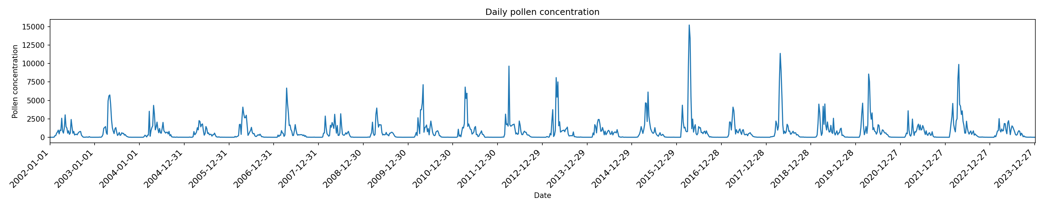

Figure 1a: Global overview pollen diagram for Ljubljana, Slovenia, illustrating the seasonal abundance and distribution of major pollen taxa in the region.

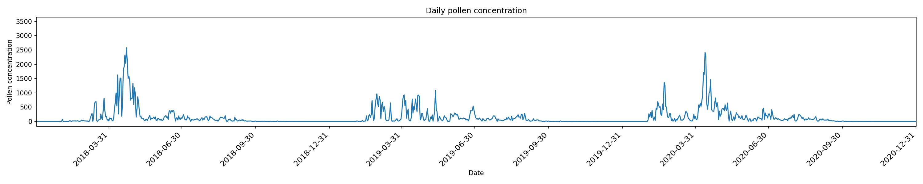

Based on the provided filename and context, a possible caption for the figure could be: "Figure 1b: Global overview pollen analysis for Ljubljana, Slovenia, highlighting regional patterns of tree pol...

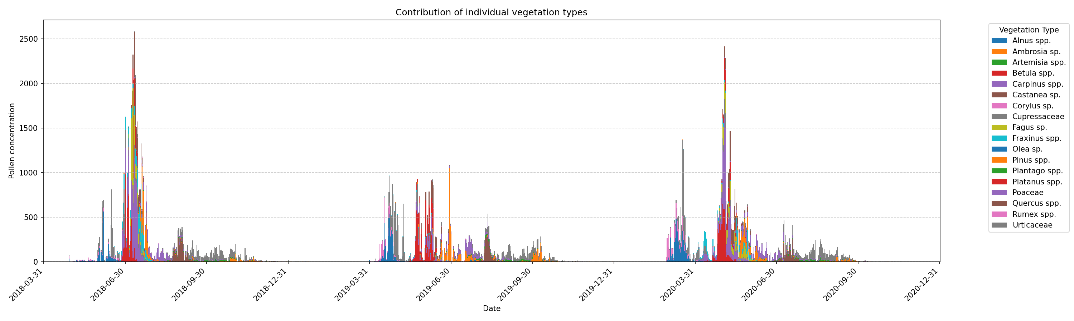

"Figure 1c: Global Overview of Pollen Records for Ljubljana, Slovenia, illustrating seasonal patterns and species composition over the past [number] years."

## Data Completeness Assessment

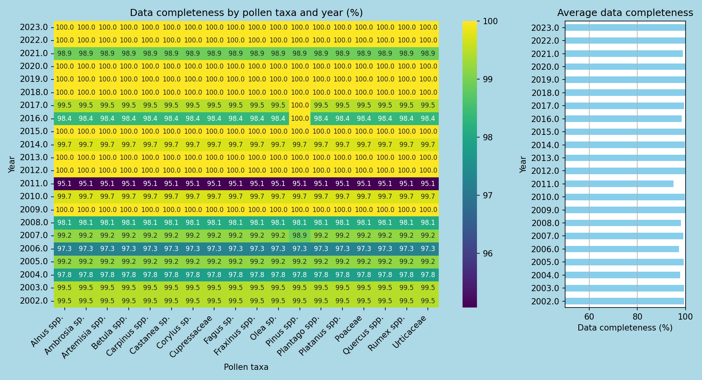

Figure 1: Annual pollen data completeness assessment for Ljubljana, Slovenia, illustrating the percentage of collected pollen samples that were successfully identified and matched to their respective ...

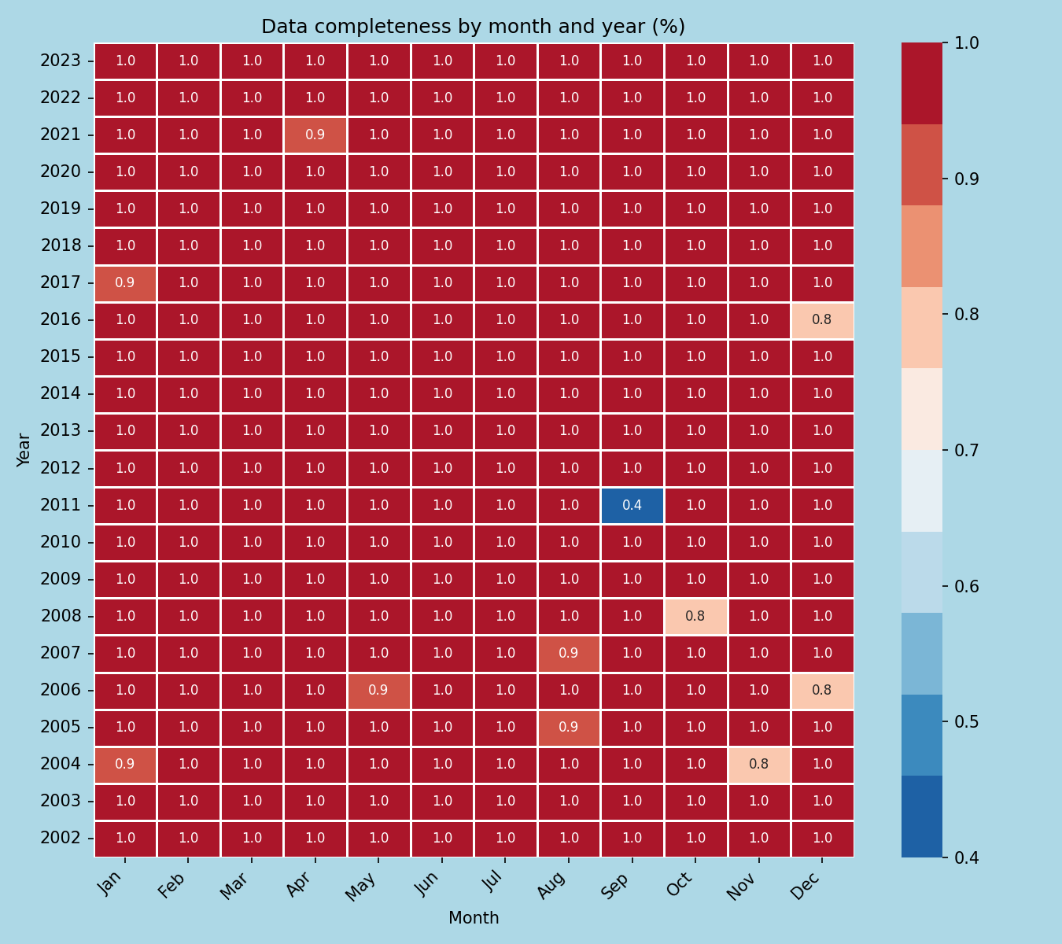

"Figure 1: Monthly pollen data completeness assessment for Ljubljana, Slovenia, illustrating the overall completeness of pollen records from [number] sampling sites over a period of [timeframe]." Alt...

## AUC and Confidence Interval Analysis

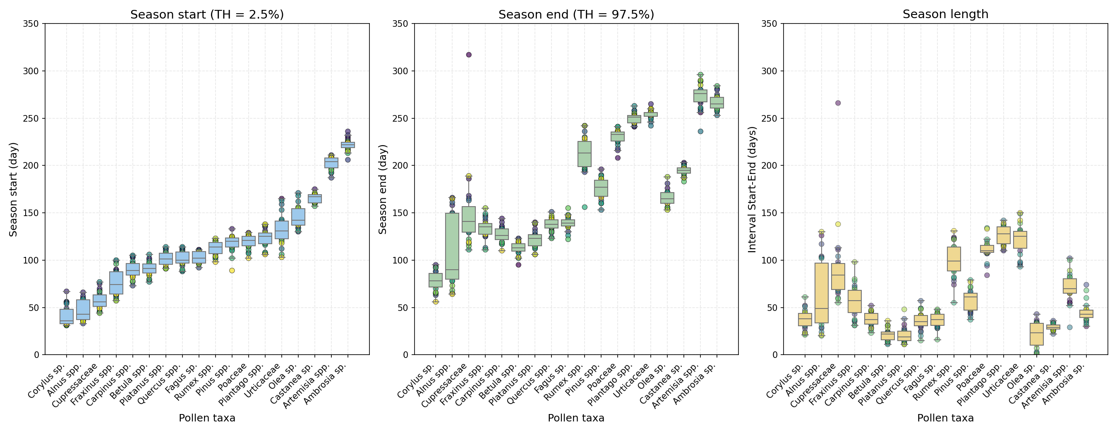

"Figure 1. Receiver Operating Characteristic (ROC) curve with confidence intervals for pollen analysis in Ljubljana, Slovenia, illustrating the diagnostic performance of [pollen species/analysis metho...

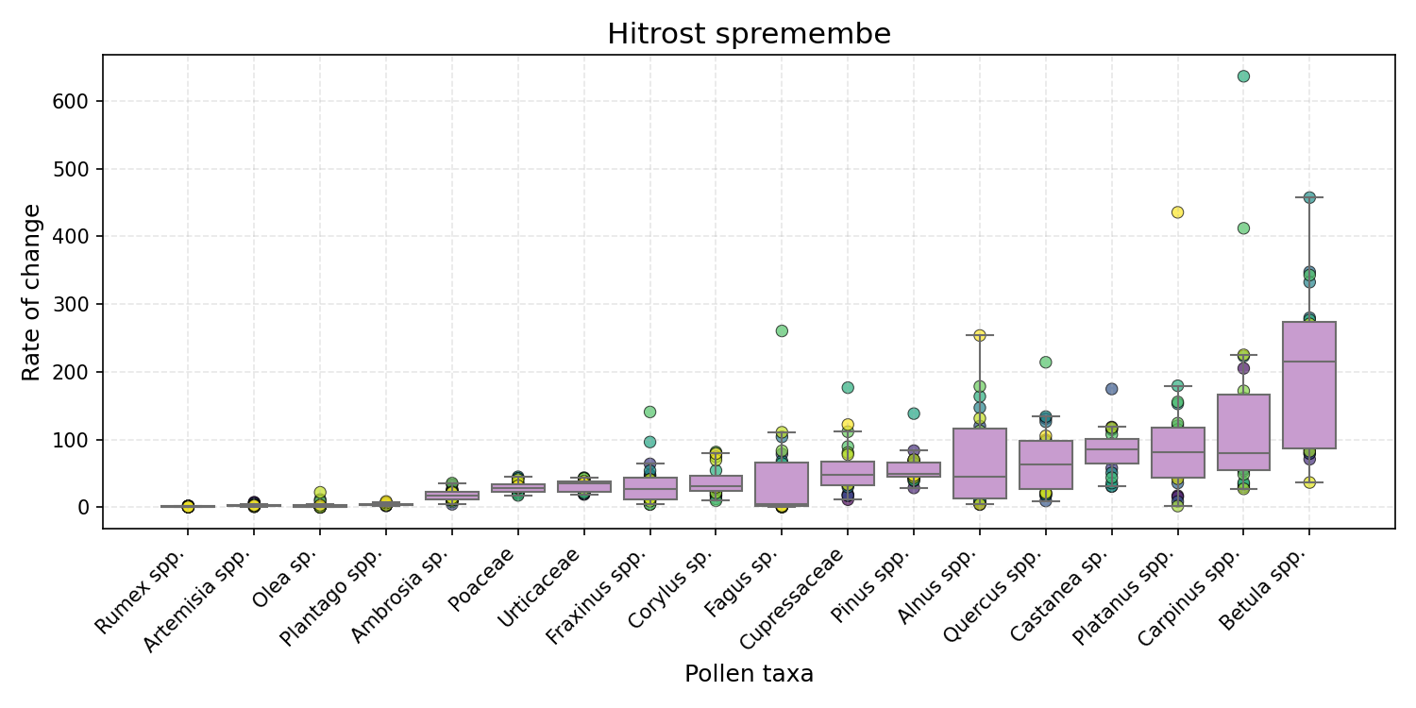

"Figure 1. Pollen analysis results from Ljubljana, Slovenia, showing the Area Under the Curve (AUC) of pollen counts for the region, with a confidence interval indicating the range of expected values....

## Type-Specific Analysis

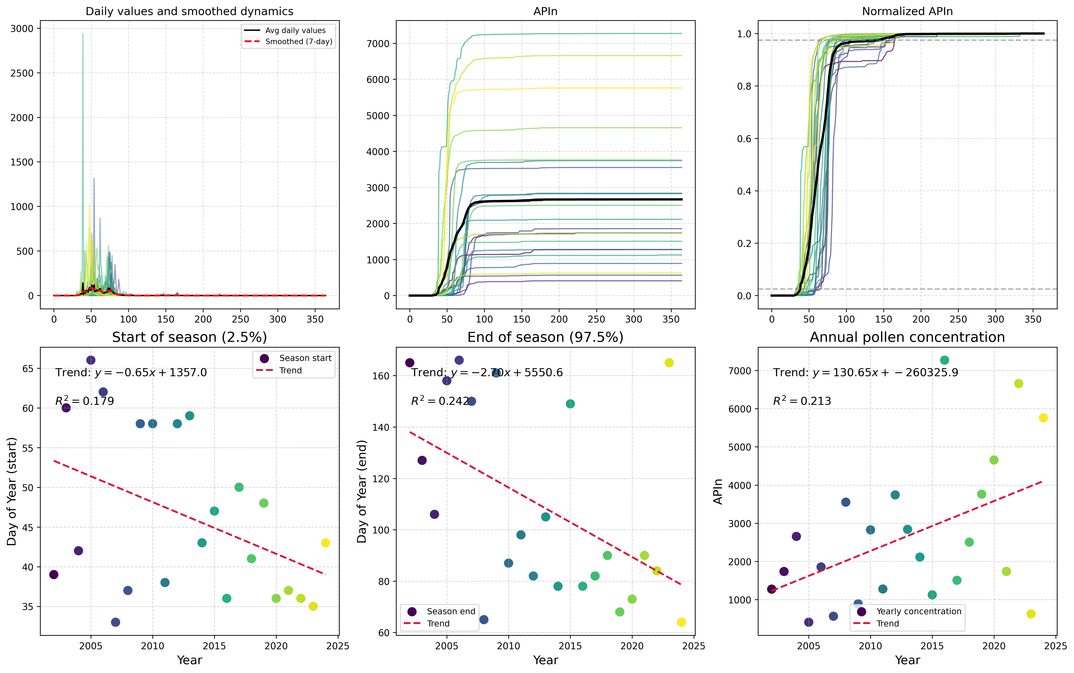

"Figure 1: Type-specific pollen analysis for Alnus spp. in Ljubljana, Slovenia, showing the distribution of tree pollen grains across different seasons."

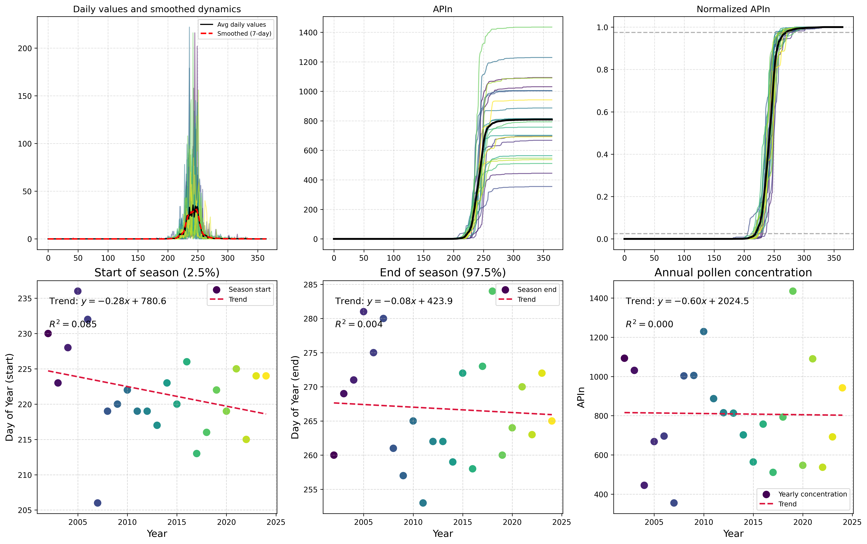

"Figure 1: Type-specific pollen analysis for Ambrosia species in Ljubljana, Slovenia. The figure displays a detailed pollen morphology comparison of Ambrosia sp., highlighting characteristic features ...

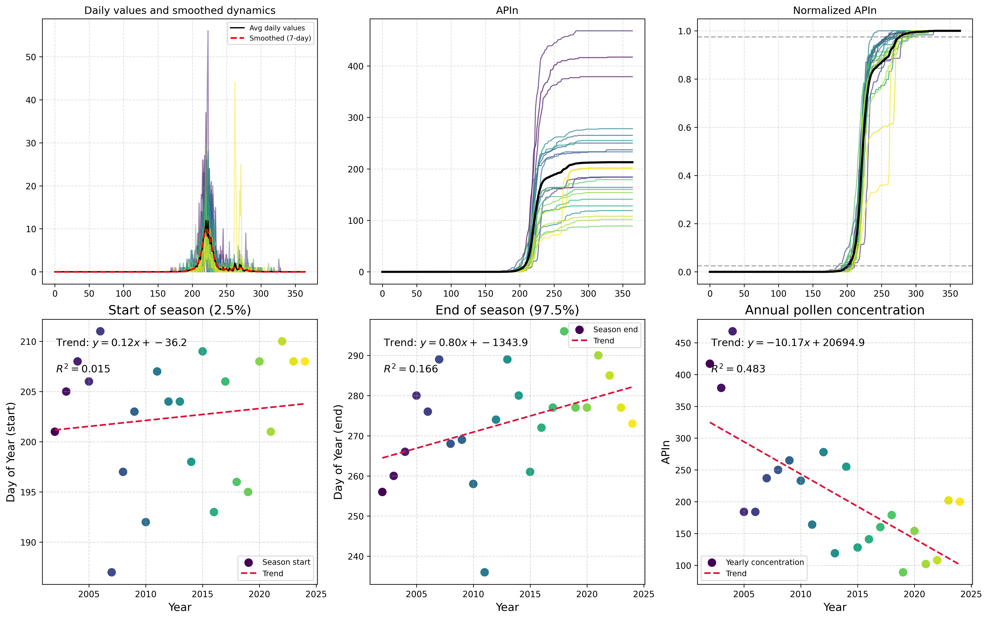

"Figure 1: Type-specific pollen analysis for Artemisia spp. in Ljubljana, Slovenia, showing the presence of characteristic pollen morphotypes indicative of this plant species."

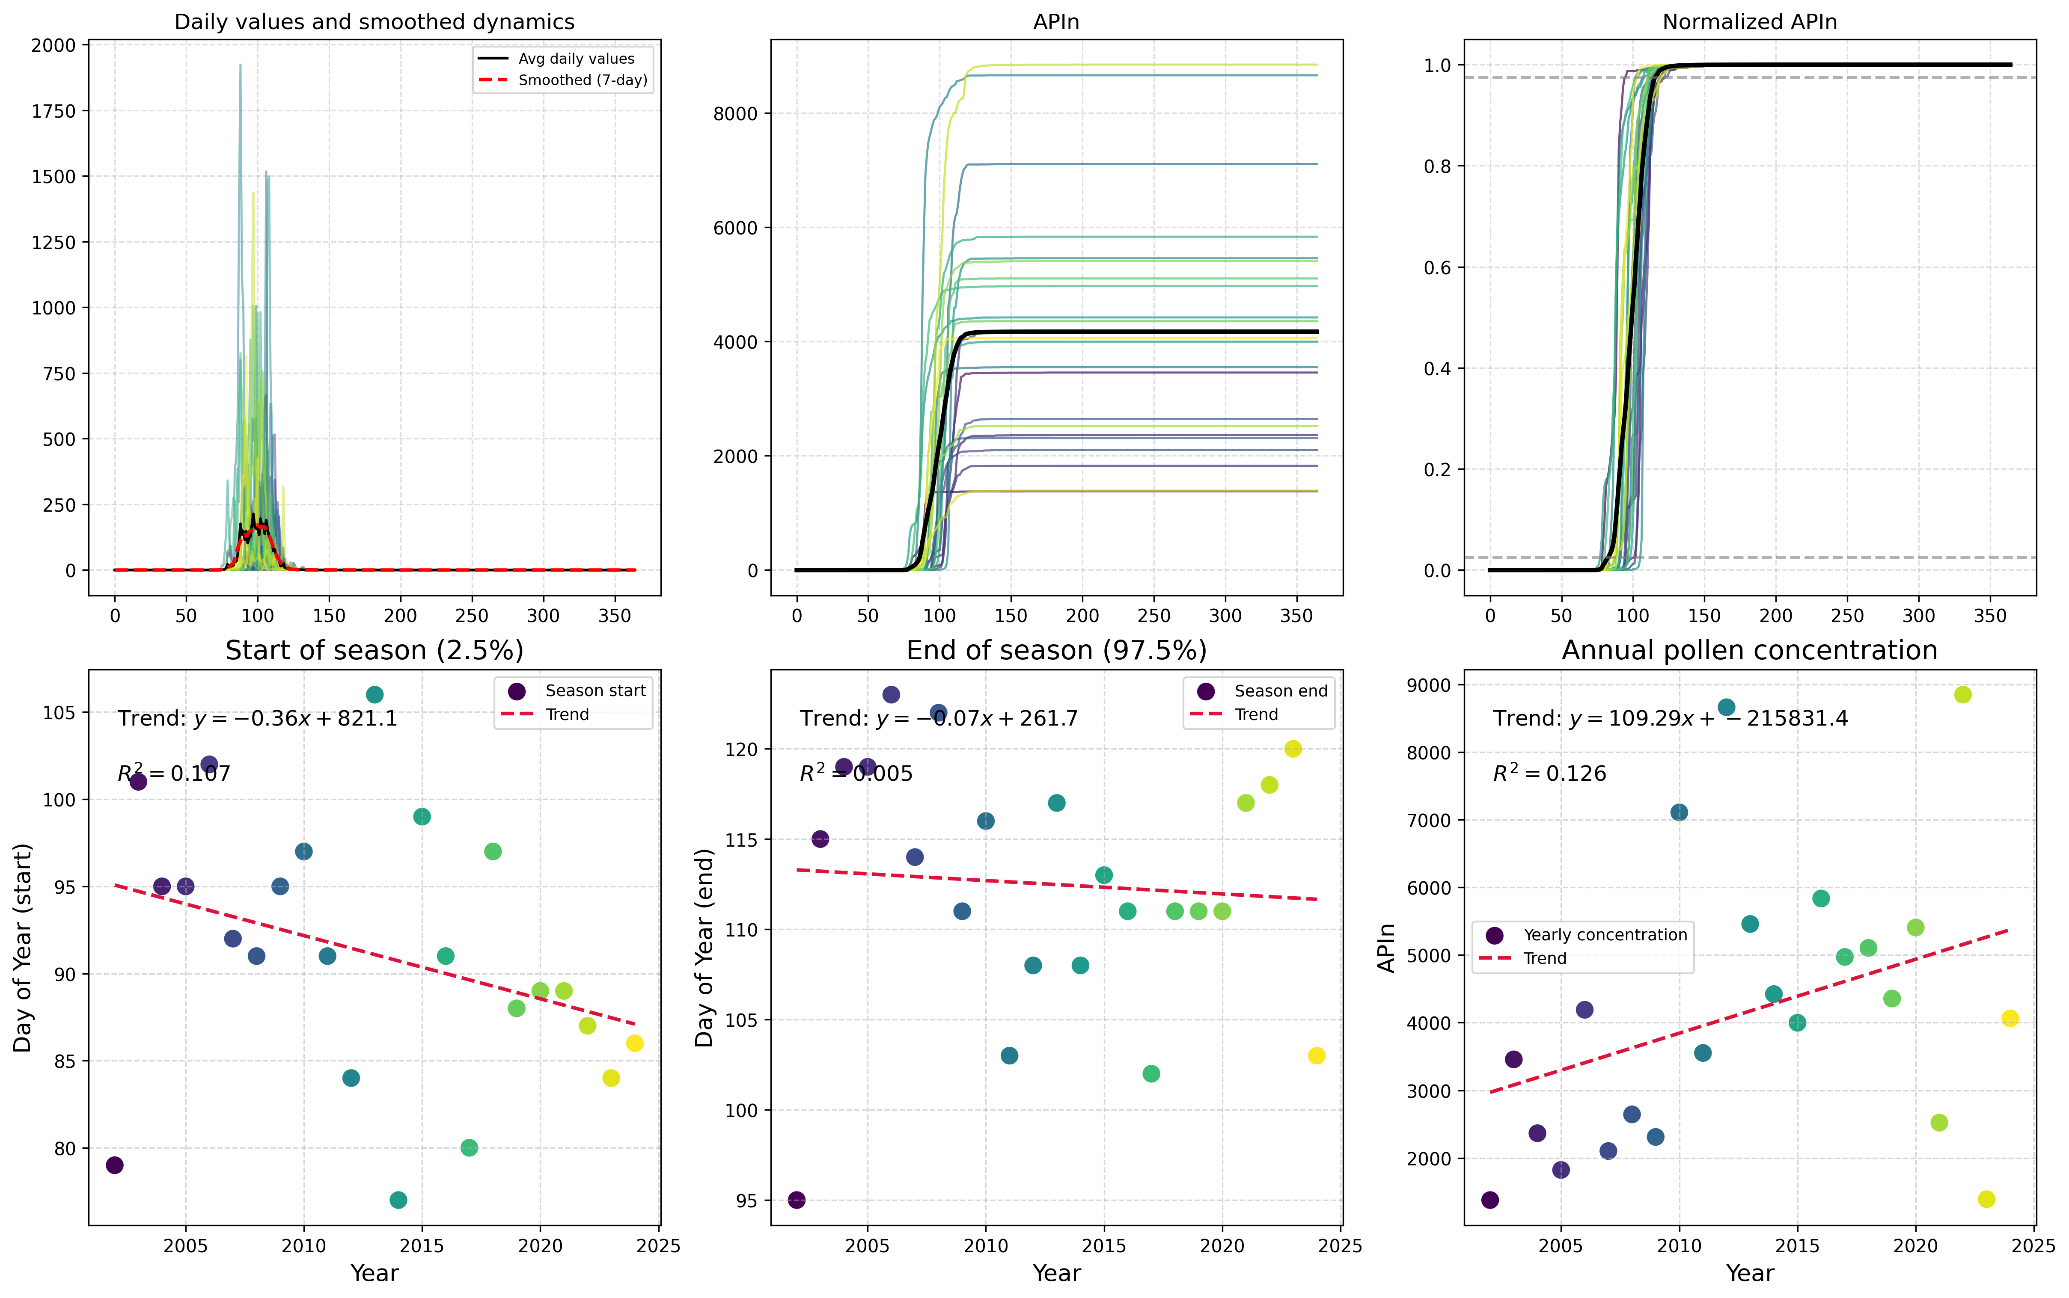

Here is a possible caption: "Figure showing Type-Specific Analysis of Betula spp. pollen from Ljubljana, highlighting the morphological characteristics and potential identification features." This c...

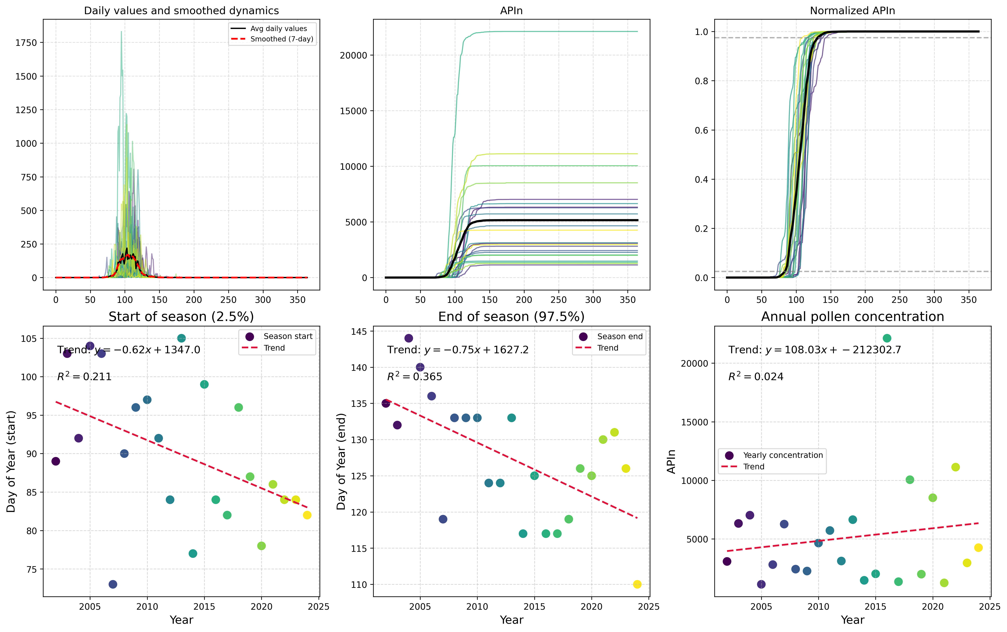

Here is a possible caption: "Figure showing Type-Specific Analysis for Carpinus spp. in Ljubljana, highlighting pollen morphology and size distribution." This caption provides a brief description of...

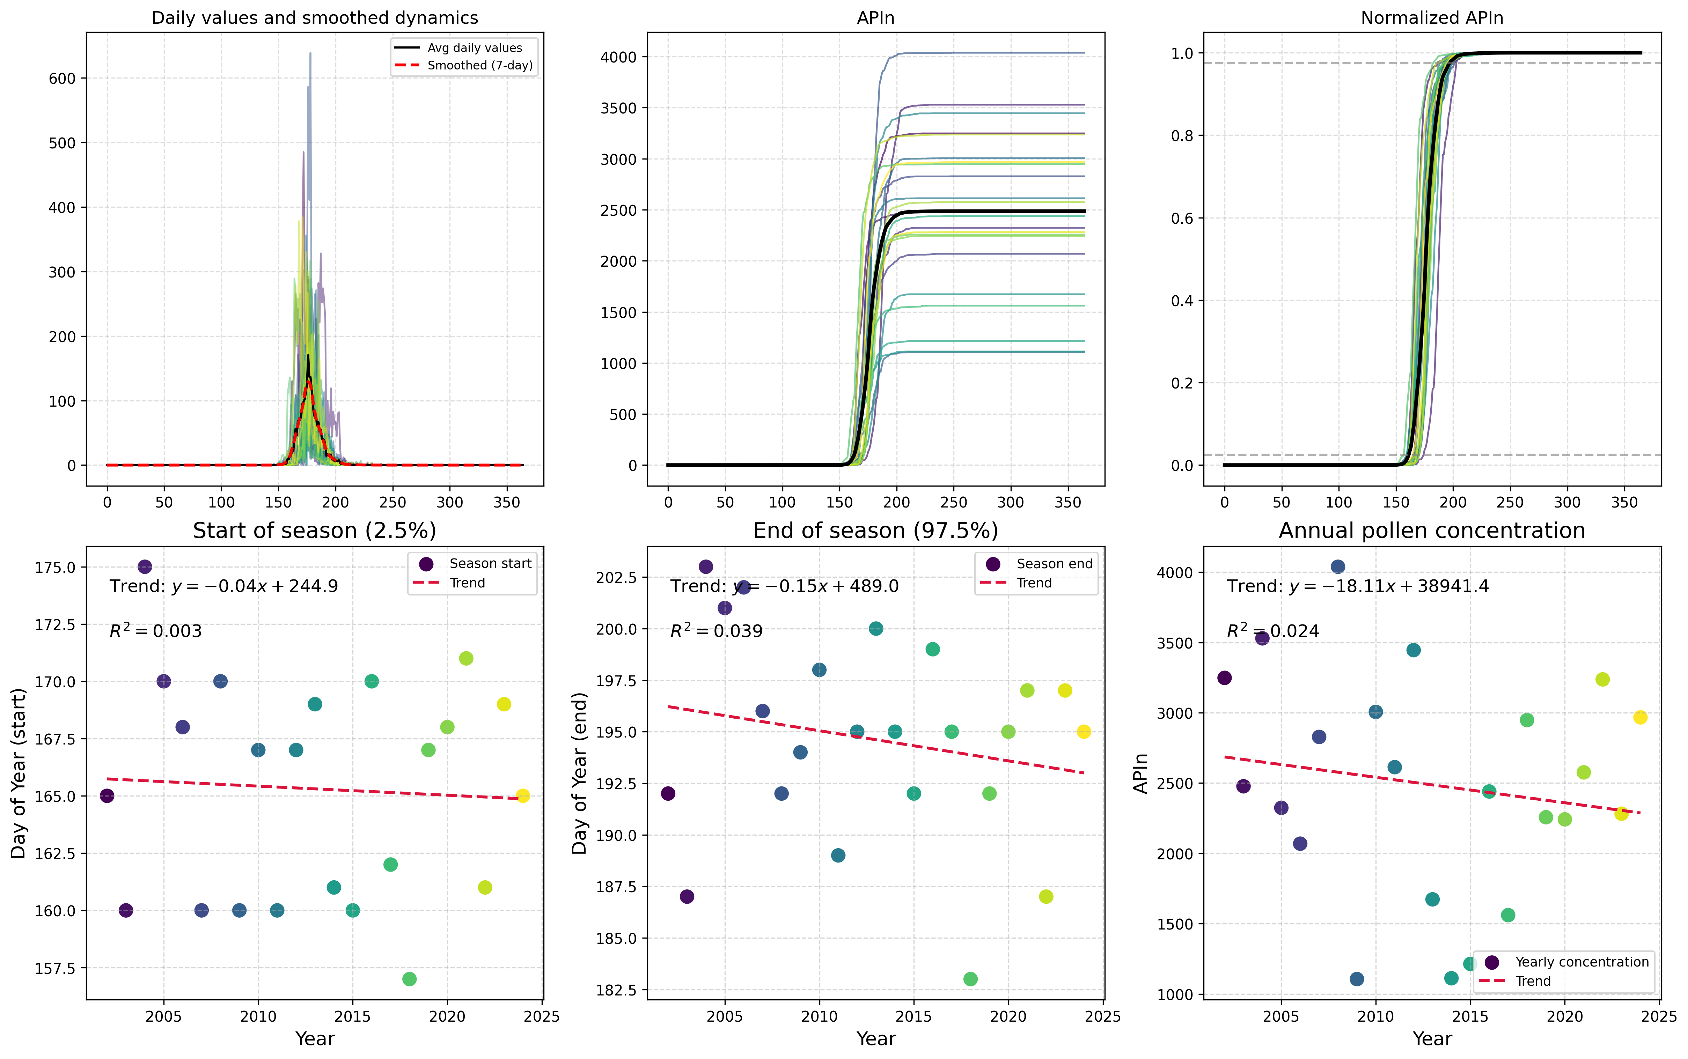

"Figure 1: Type-specific analysis of Castanea pollen from Ljubljana, Slovenia, showing morphological characteristics and microspore features indicative of the species." Alternatively, if multiple pan...

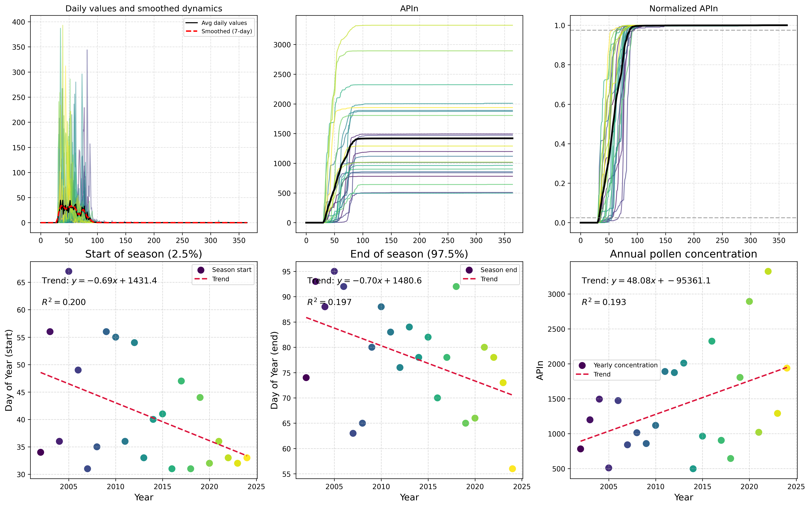

Here is a possible caption: "Figure showing Type-Specific Analysis for Corylus sp. in Ljubljana, revealing [insert key finding or visualization purpose, e.g. 'pollen morphology', 'species distributio...

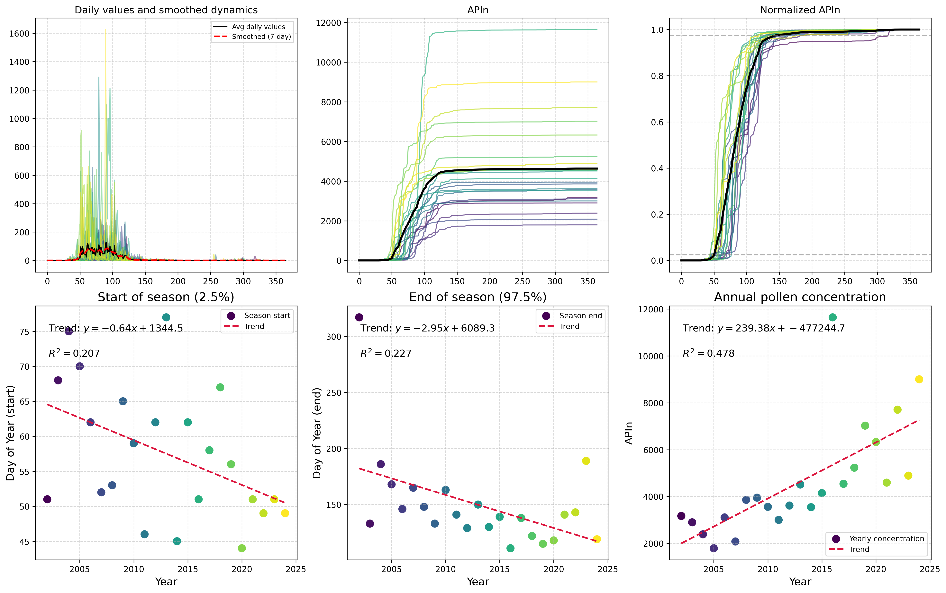

"Figure showing Type-Specific Analysis of Cupressaceae pollen from Ljubljana, highlighting the morphological characteristics and distribution patterns of species-specific pollen grains." Alternativel...

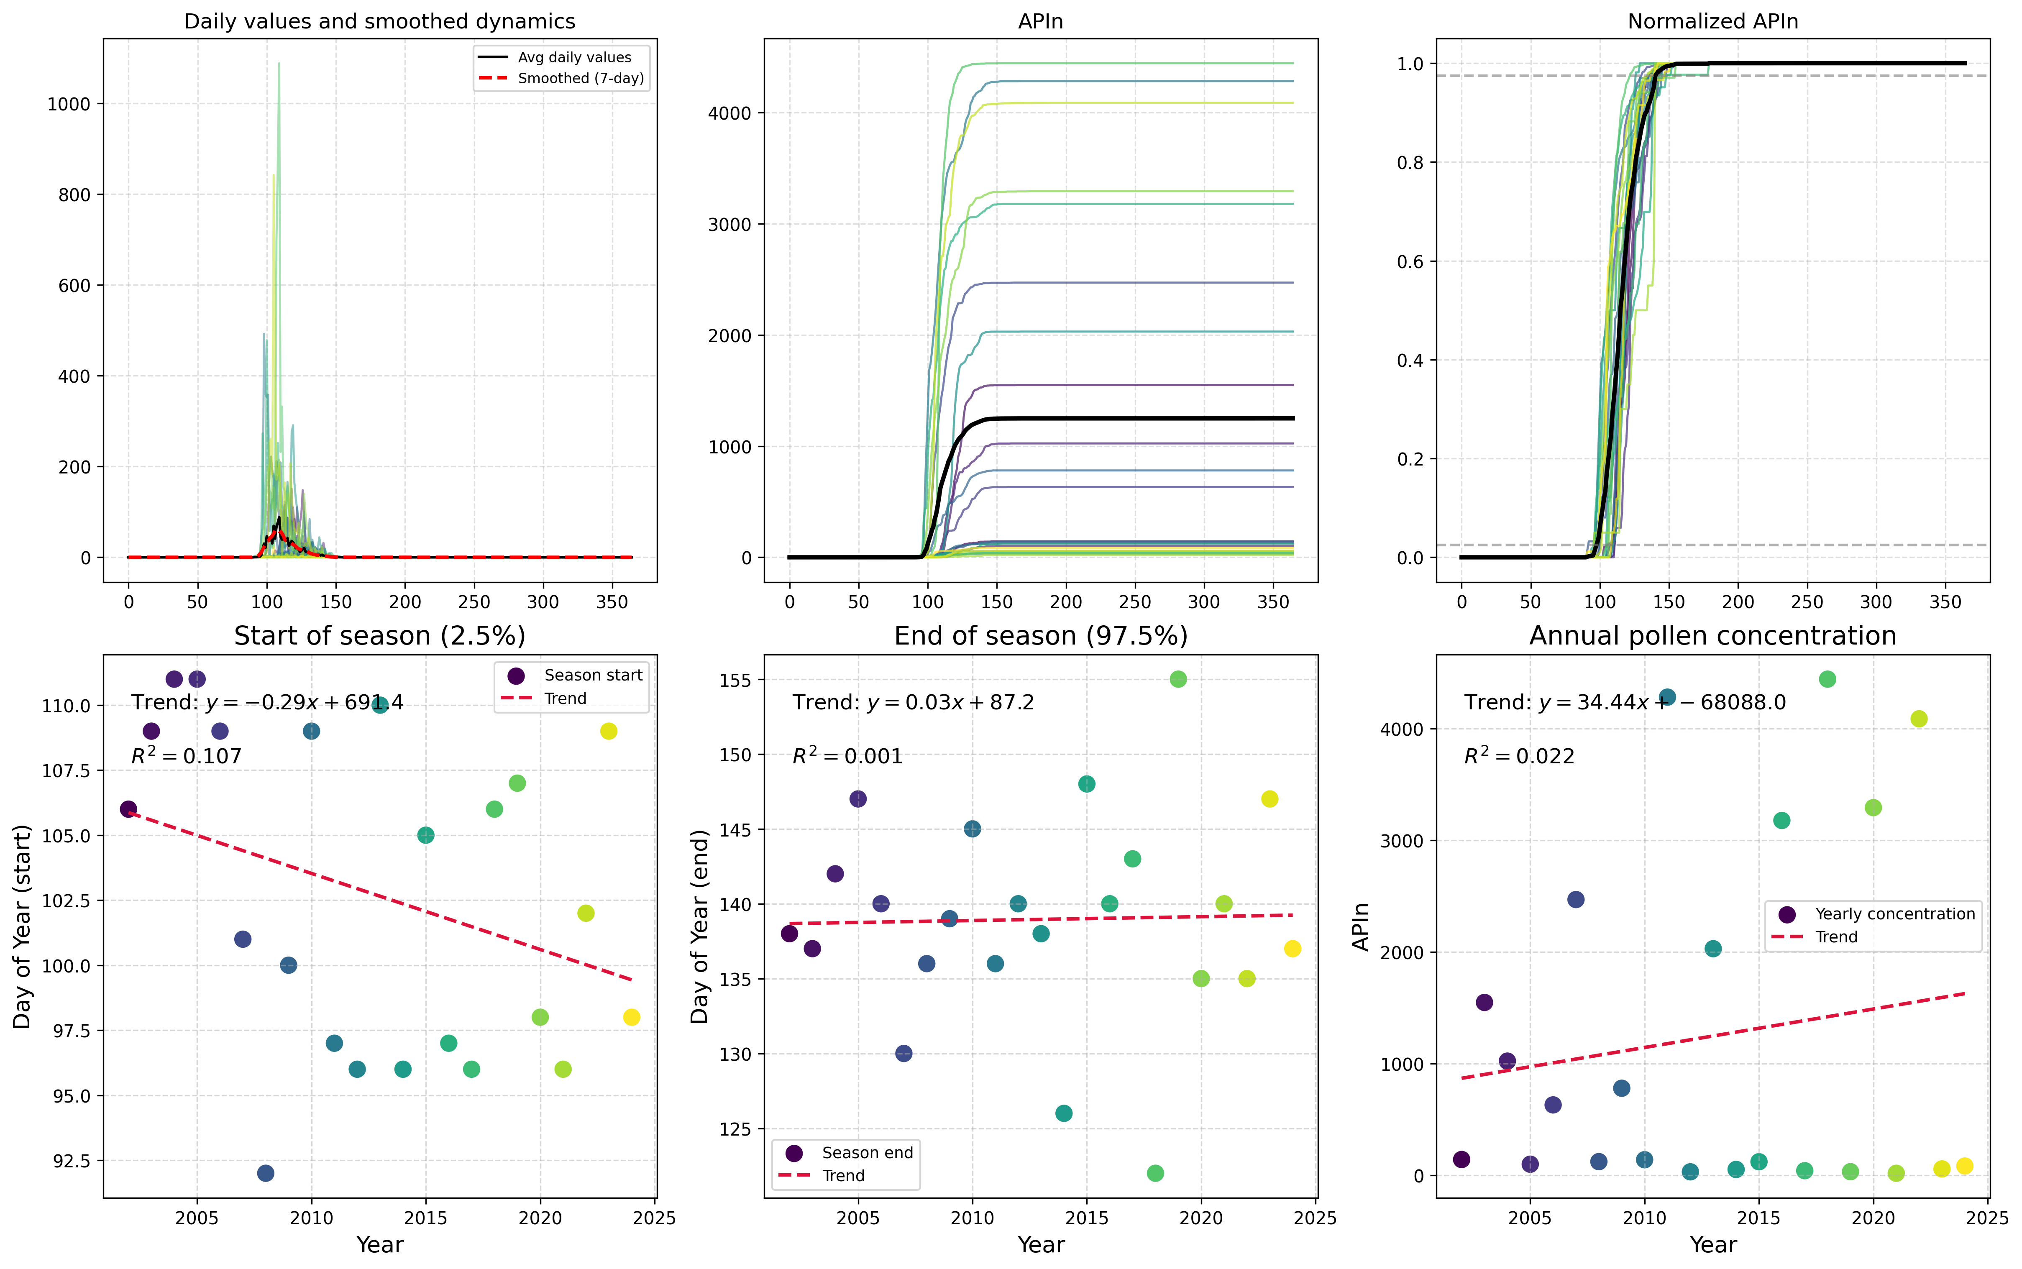

Here is a possible caption: "Figure showing Type-Specific Analysis of Fagus pollen from Ljubljana, highlighting morphological characteristics and features indicative of the species." This caption pr...

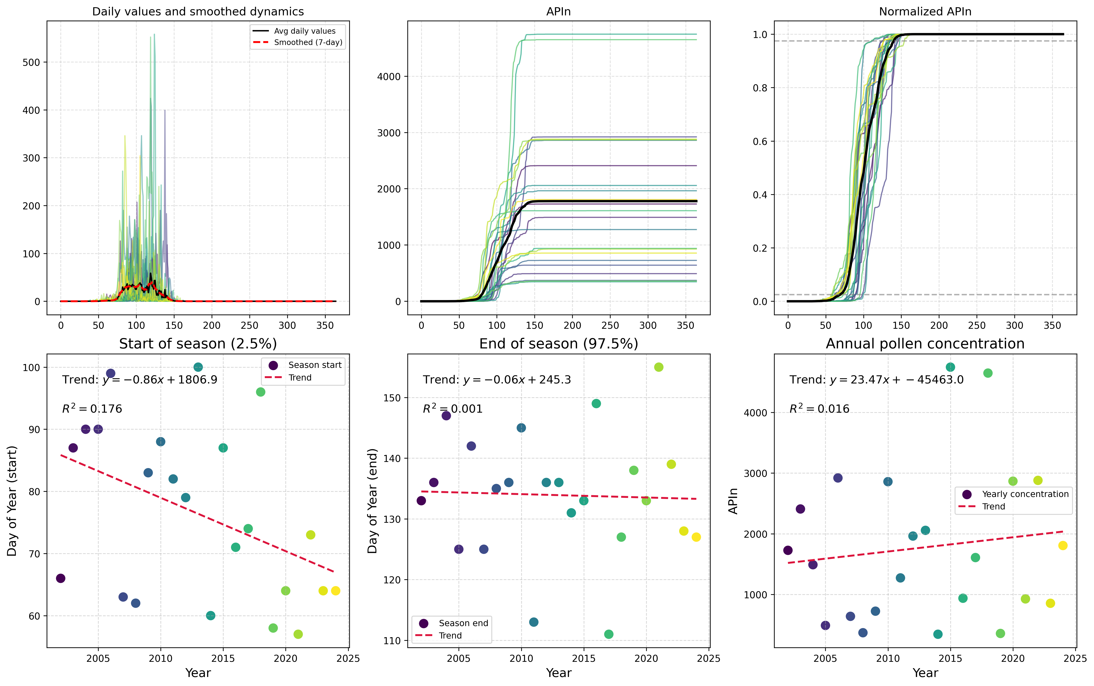

"Figure showing Type-Specific Analysis of pollen from Fraxinus spp. in Ljubljana, highlighting species-specific characteristics and morphological features." Alternatively, if multiple panels are pres...

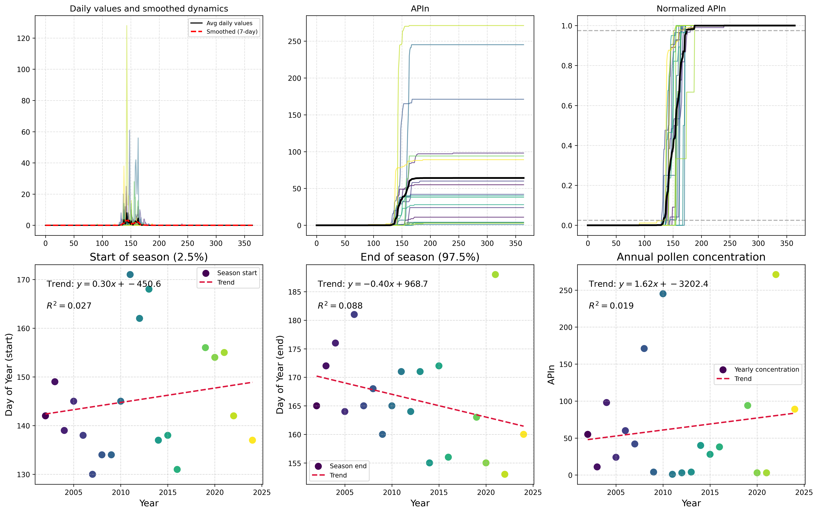

Here is a possible caption: "Figure showing Type-Specific Analysis for Olea sp. in Ljubljana, demonstrating pollen morphology and characteristics consistent with the species." This caption provides ...

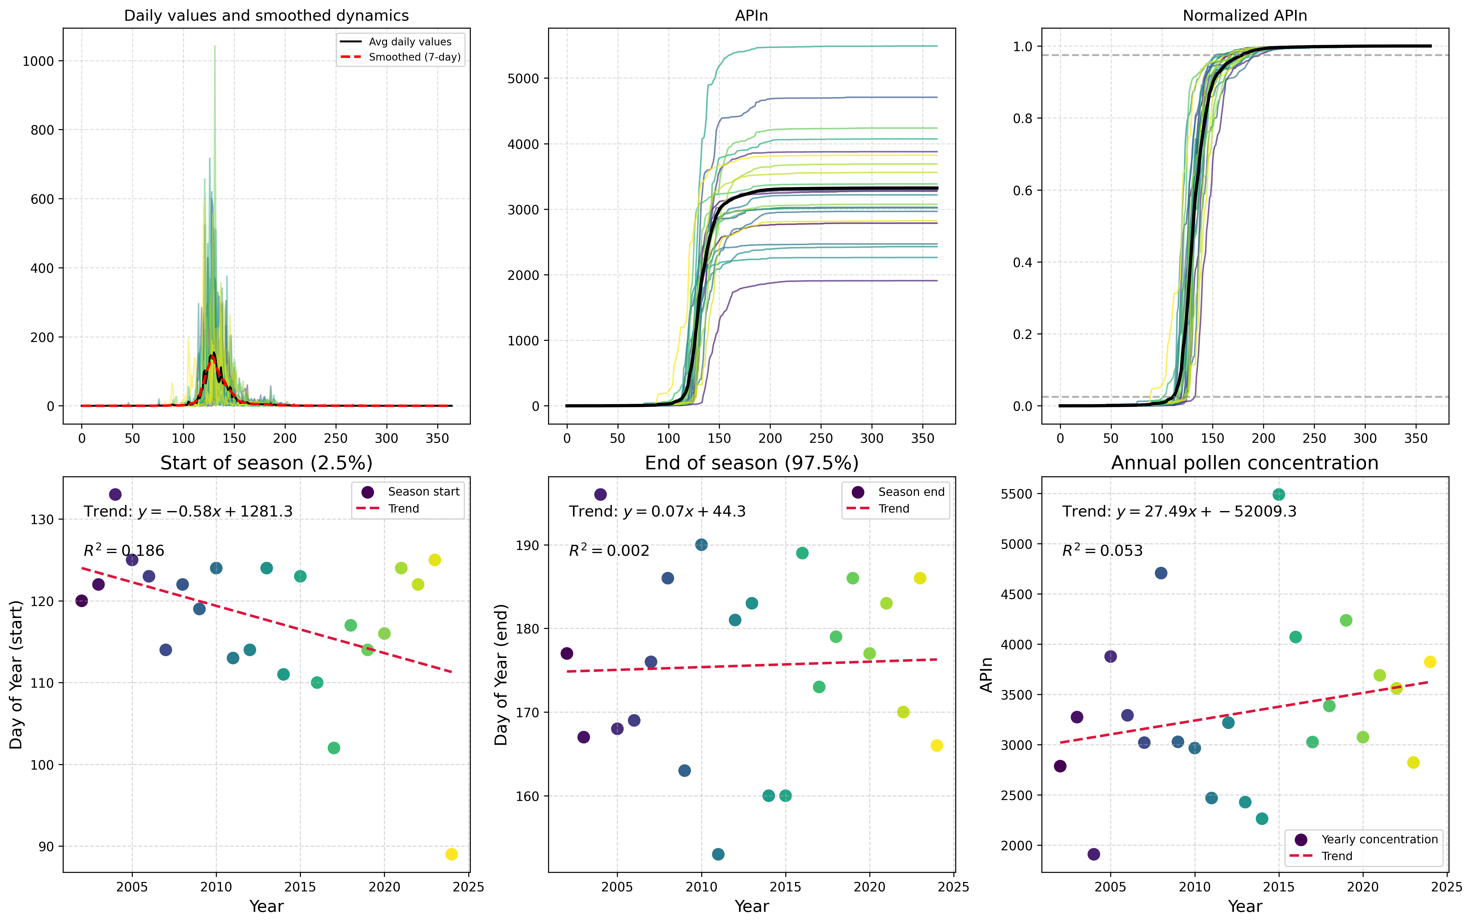

"Figure 1: Type-Specific Pollen Morphology of Pinus spp. from Ljubljana, Slovenia, highlighting characteristic features of the pollen grains." Alternatively, if there are multiple panels: "Figure 1:...

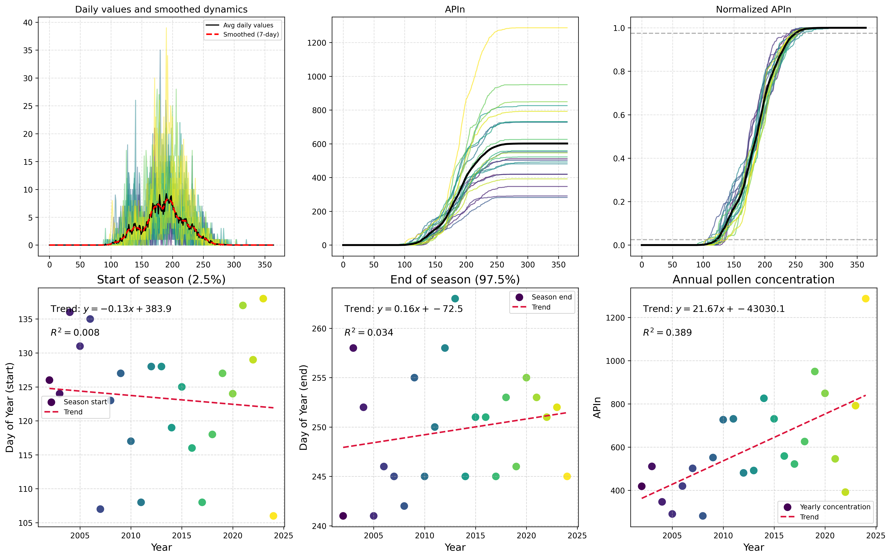

Here is a possible caption: "Figure showing Type-Specific Analysis of Plantago spp. pollen from Ljubljana, highlighting morphological characteristics and potential identification features." Alternat...

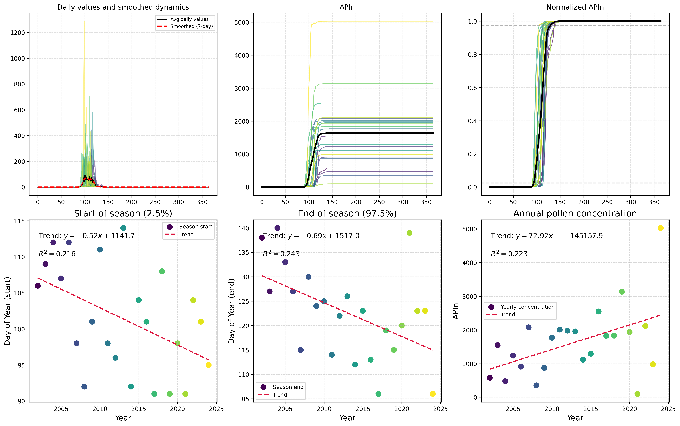

Here is a possible caption: "Figure showing Type-Specific Analysis for Platanus spp. in Ljubljana, demonstrating pollen morphology and distribution patterns." Alternatively, if the image shows multi...

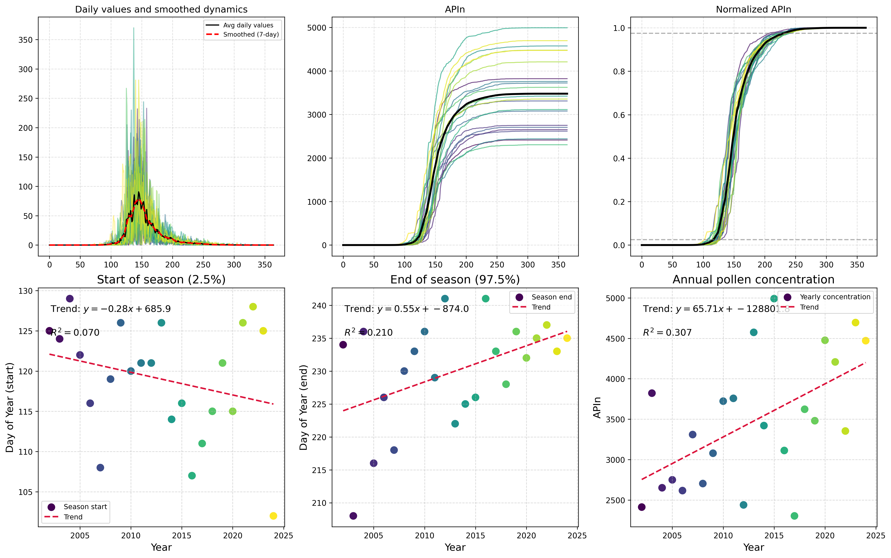

"Figure 1: Type-specific pollen analysis for Poaceae in Ljubljana, Slovenia, showing the relative abundance of various grass species and their distribution patterns across the region." Alternatively,...

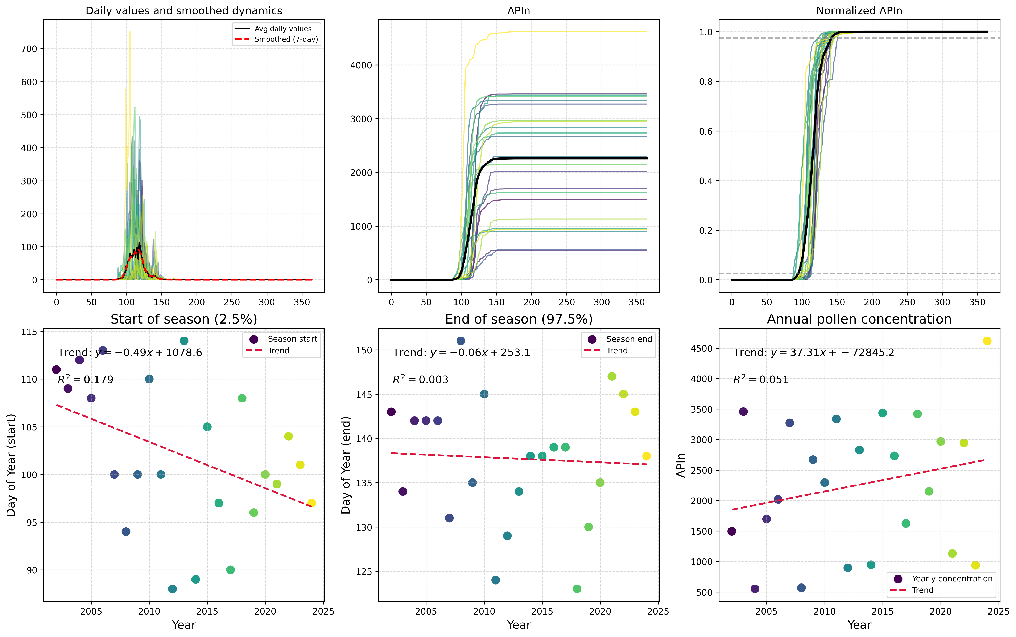

Here is a possible caption for the scientific figure: "Figure showing Type-Specific Analysis of Quercus spp. pollen in Ljubljana, highlighting morphological characteristics and potential identificati...

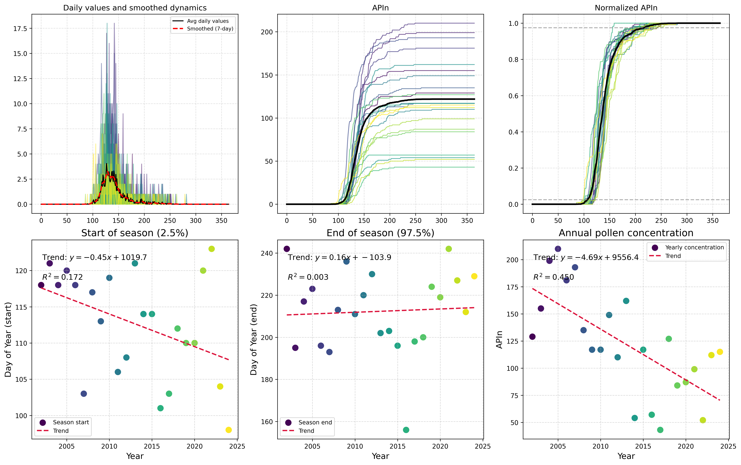

Here is a possible caption: "Figure showing Type-Specific Analysis for Rumex spp. in Ljubljana, highlighting pollen morphology and distribution patterns." Alternatively, if the figure includes multi...

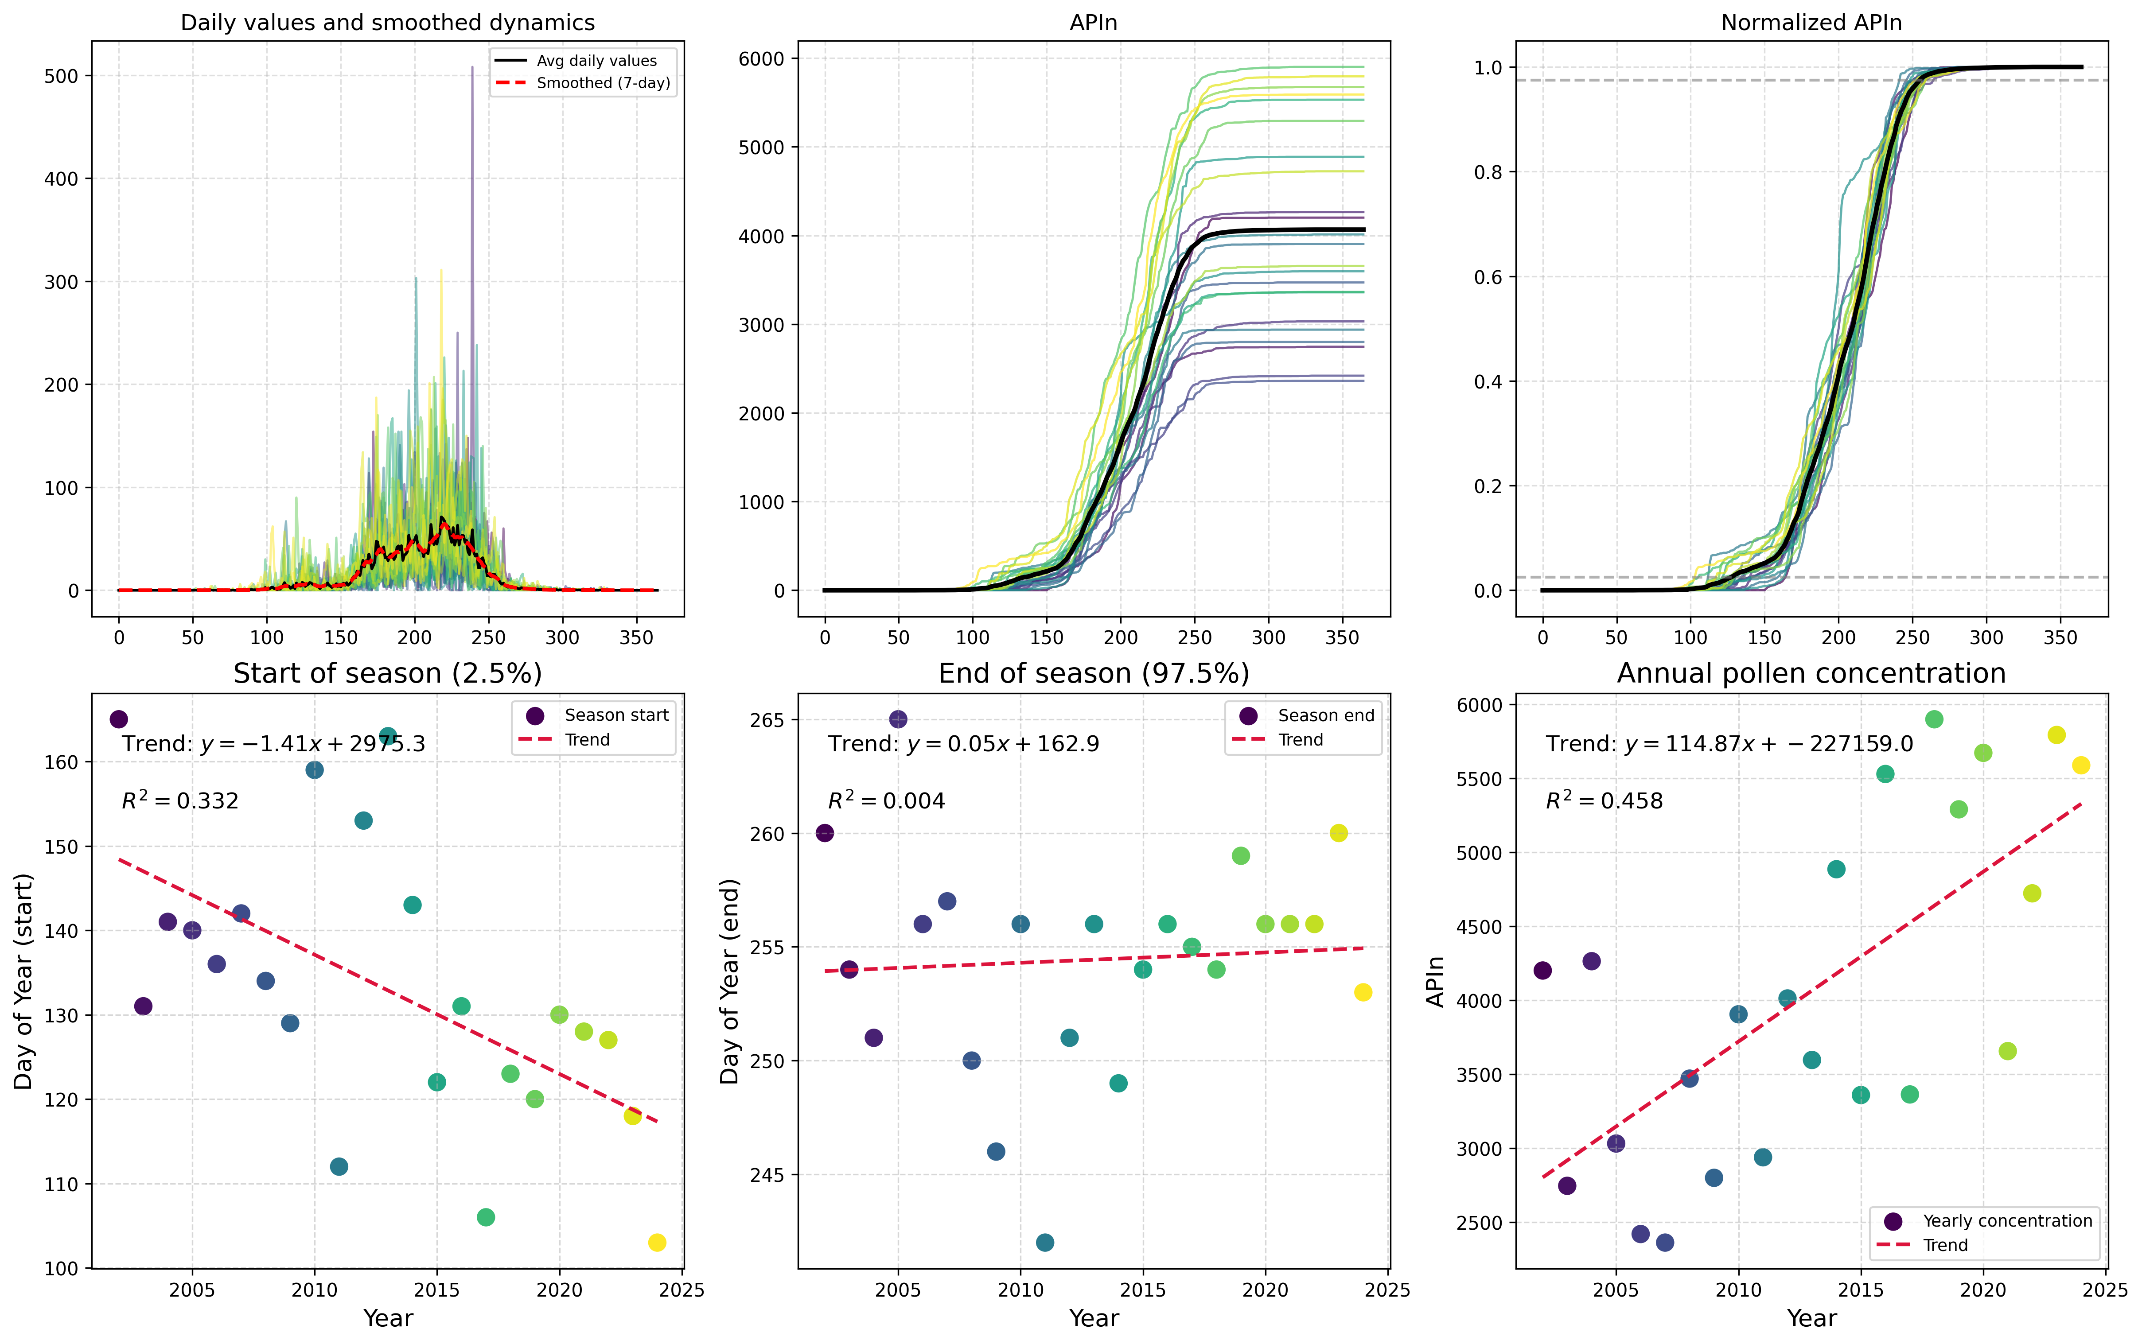

"Figure showing Type-Specific Analysis of Urticaceae pollen from Ljubljana, highlighting morphological characteristics and potential identification features."

# Maribor Analysis Results

This section contains all analysis results for Maribor, including global overviews, data completeness assessments, statistical analyses, and type-specific results.

## Global Overview Analysis

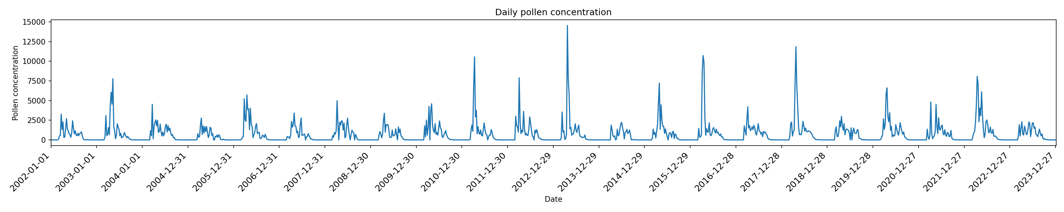

Based on the filename and context, a possible caption for the figure could be: "Figure 1a: Global overview pollen diagram for Maribor, displaying a comprehensive representation of regional pollen pat...

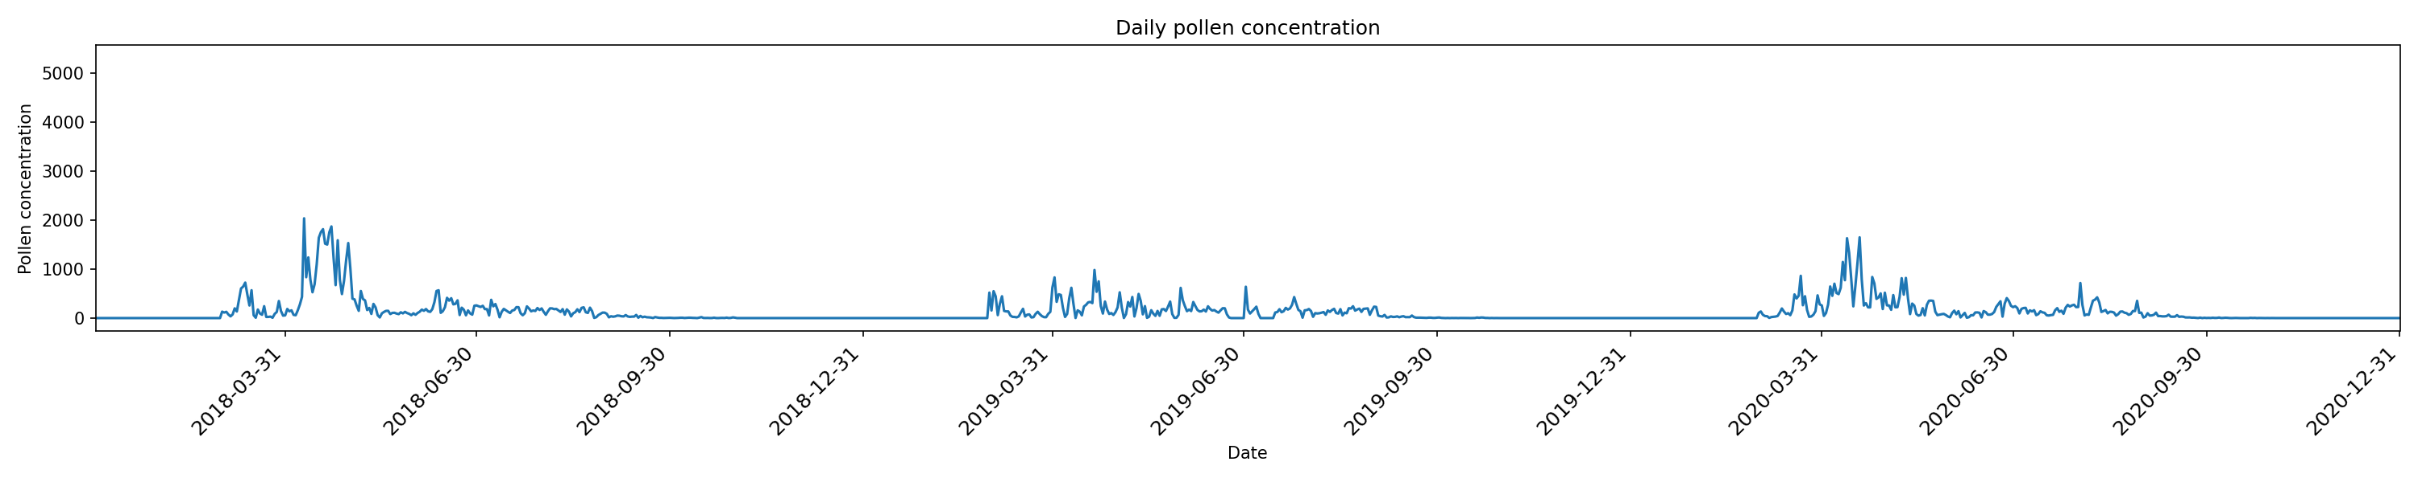

Based on the filename and context provided, here is a possible caption: "Figure 1b: Global overview pollen analysis for Maribor, showing regional distribution patterns of major pollen species during ...

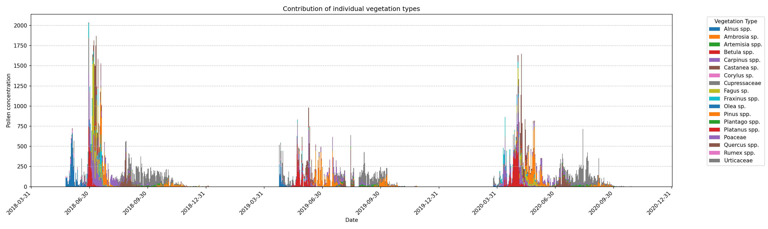

Based on the filename and context provided, a possible caption for the scientific figure could be: "Figure 1c: Global Overview Analysis of pollen records from Maribor, showing regional patterns of po...

## Data Completeness Assessment

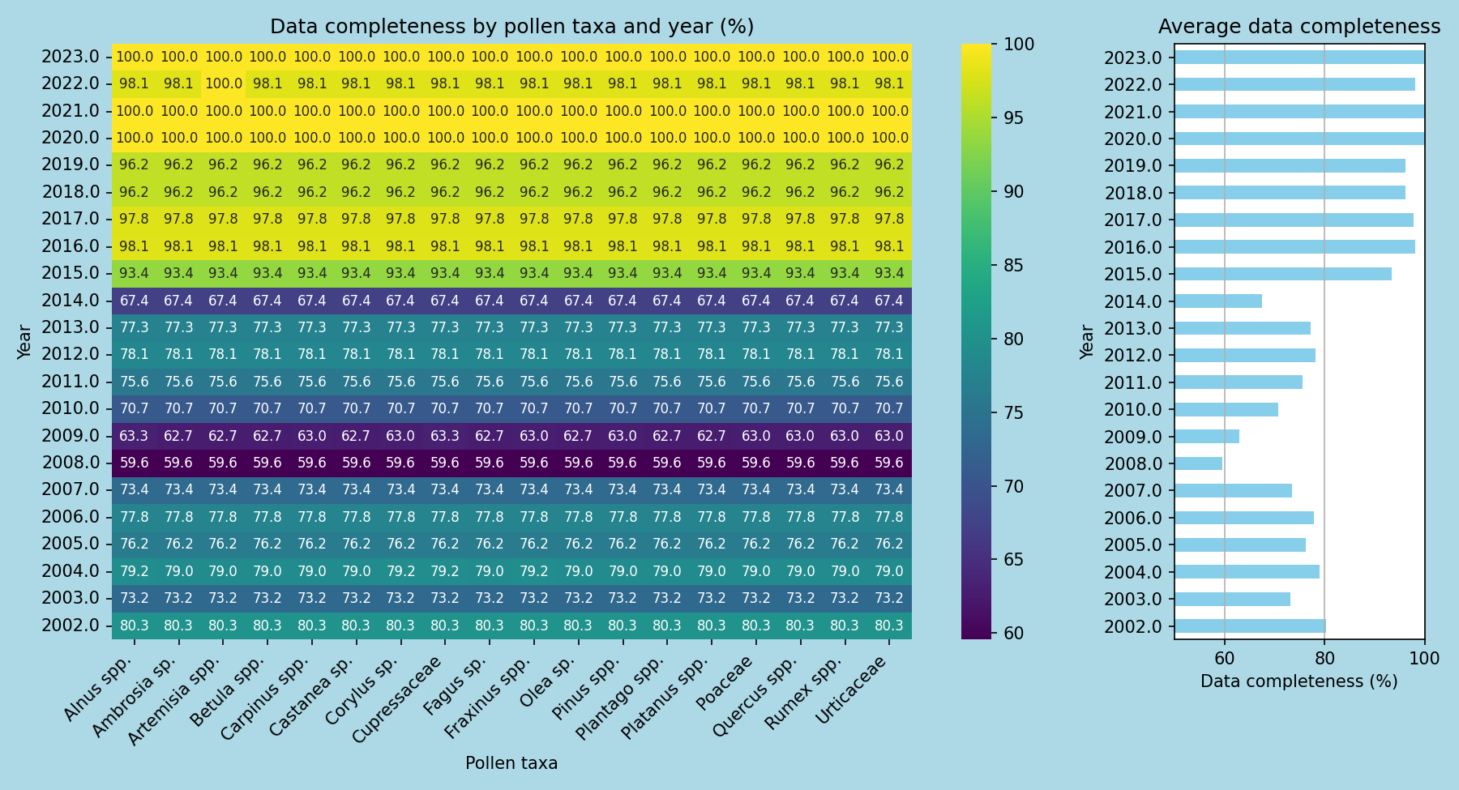

Here is a possible caption: "Figure showing annual pollen data completeness assessment for Maribor, highlighting the percentage of sampled species with complete pollen records over the past year." T...

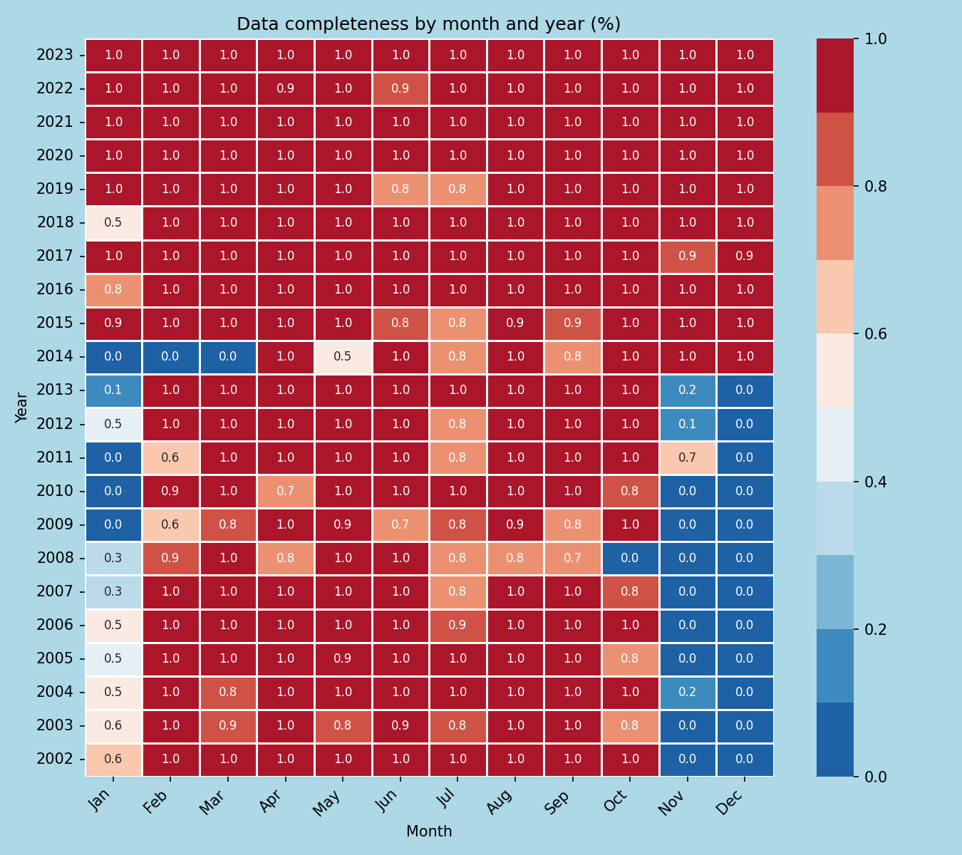

"Figure 1: Monthly pollen data completeness assessment for Maribor, Slovenia, illustrating the percentage of monthly samples with complete pollen records (left panel) and the corresponding seasonal tr...

## AUC and Confidence Interval Analysis

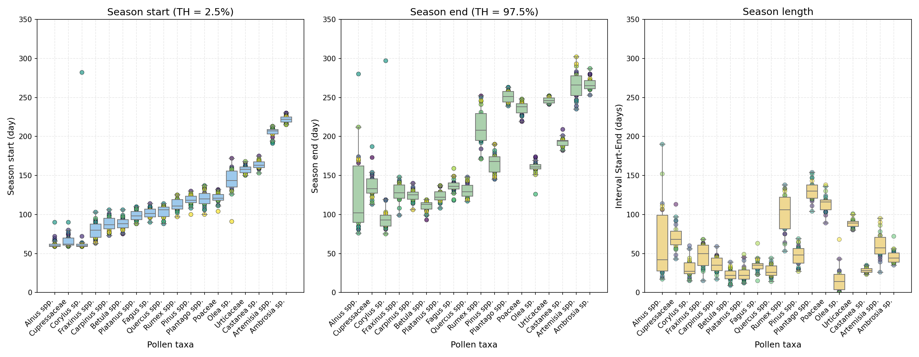

"Figure 1: Receiver Operating Characteristic (ROC) curve with confidence intervals for pollen identification in Maribor, illustrating the accuracy of the analysis at different thresholds." Alternativ...

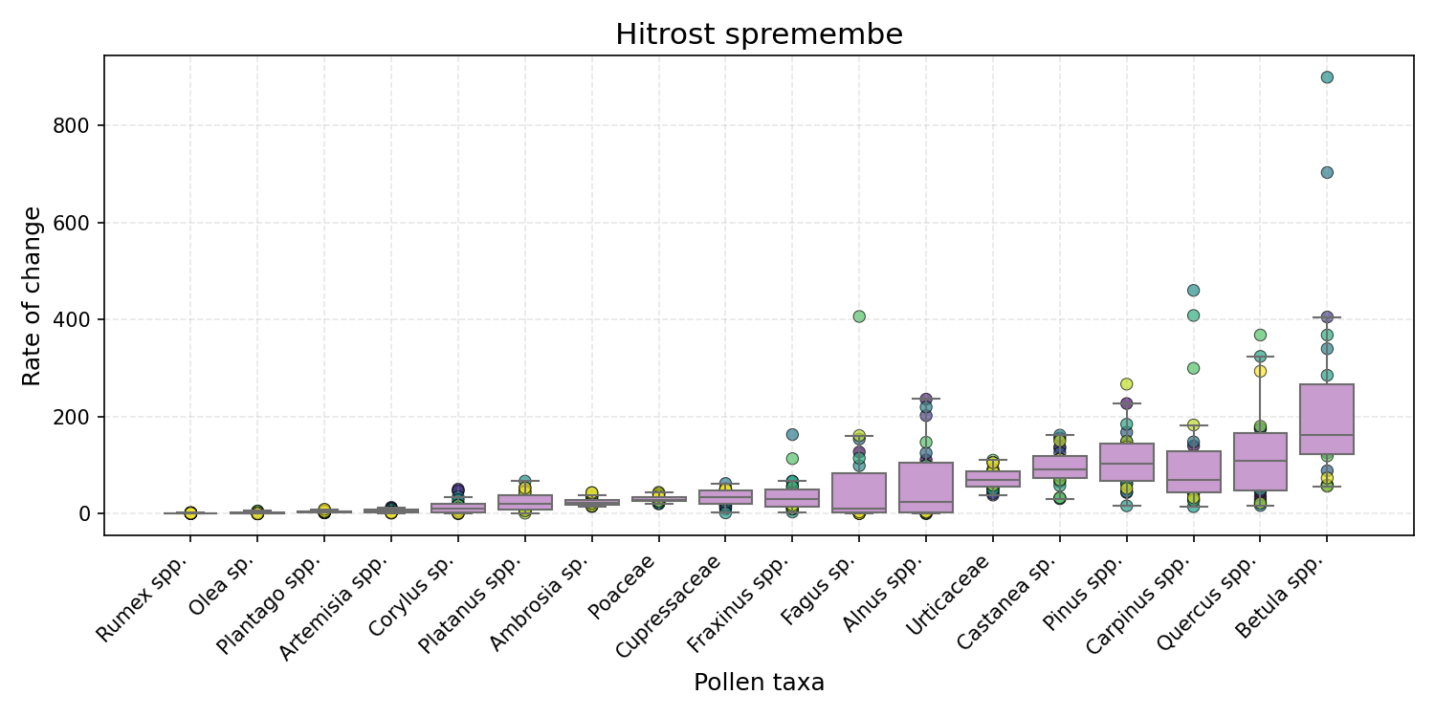

"Figure 1: Receiver Operating Characteristic (ROC) curve with confidence interval analysis for pollen identification in Maribor, illustrating the area under the curve (AUC) values and corresponding co...

## Type-Specific Analysis

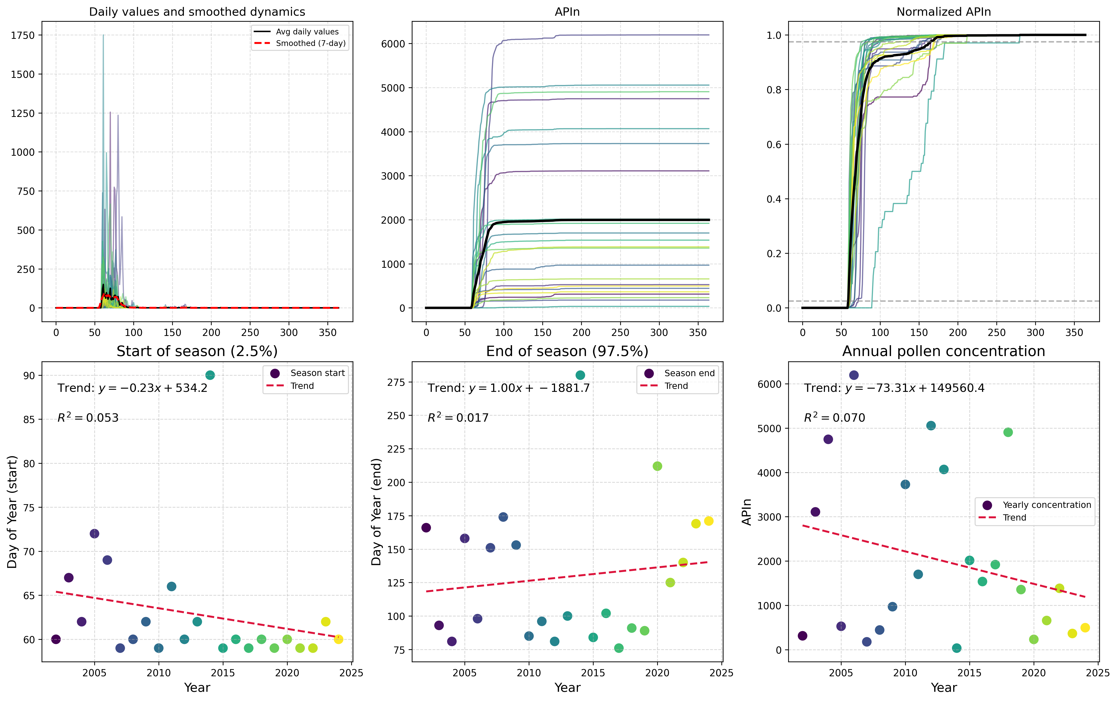

Here is a possible caption: "Figure showing Type-Specific Analysis of Alnus spp. pollen from Maribor, highlighting morphological characteristics and potential identification features." This caption ...

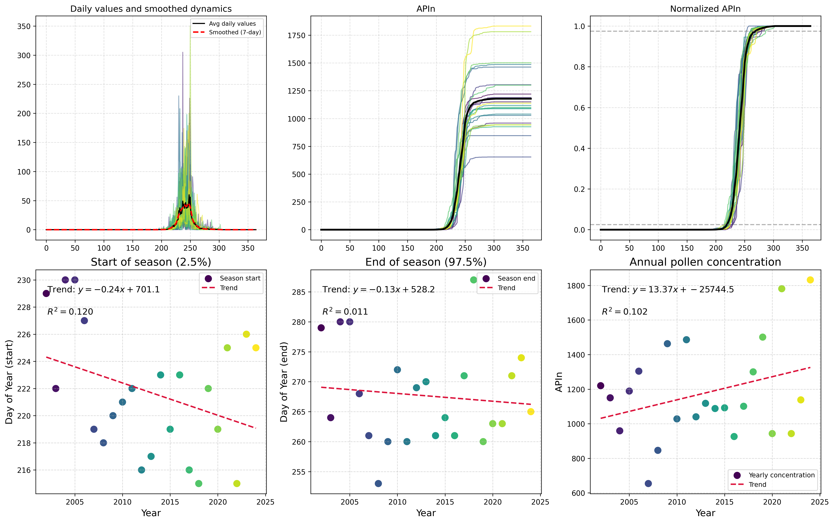

Here is a possible caption: "Figure showing Type-Specific Analysis of Ambrosia pollen from Maribor, highlighting morphological characteristics and potential identification features." This caption pr...

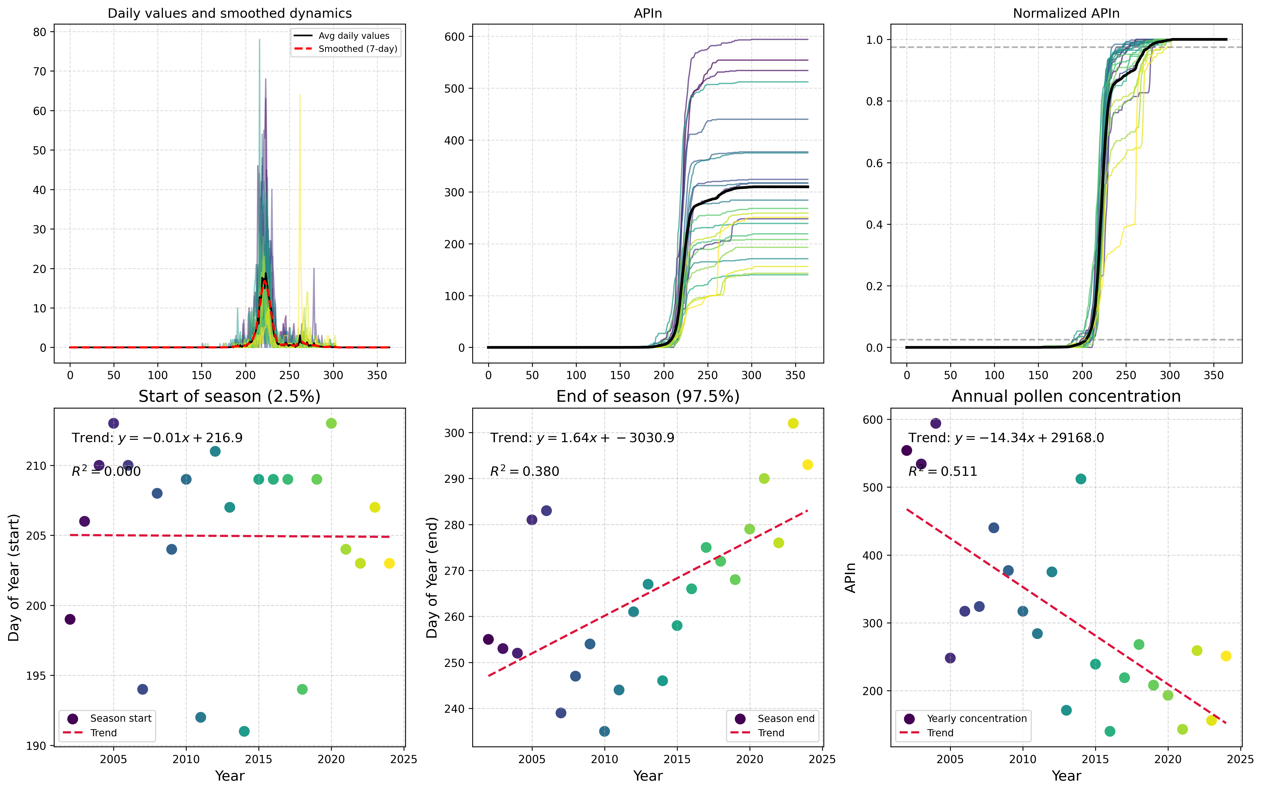

Here is a possible caption: "Figure showing Type-Specific Analysis for Artemisia spp. in Maribor, illustrating pollen morphology and distribution patterns." This caption provides a brief description...

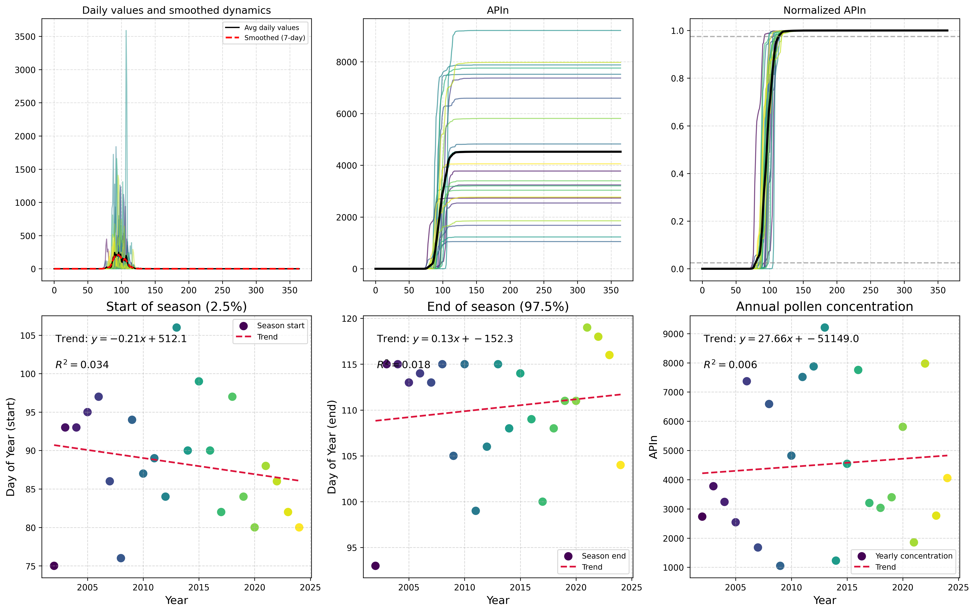

Here is a possible caption: "Figure showing Type-Specific Analysis of Betula spp. pollen from Maribor, highlighting morphological characteristics and potential identification features." This caption...

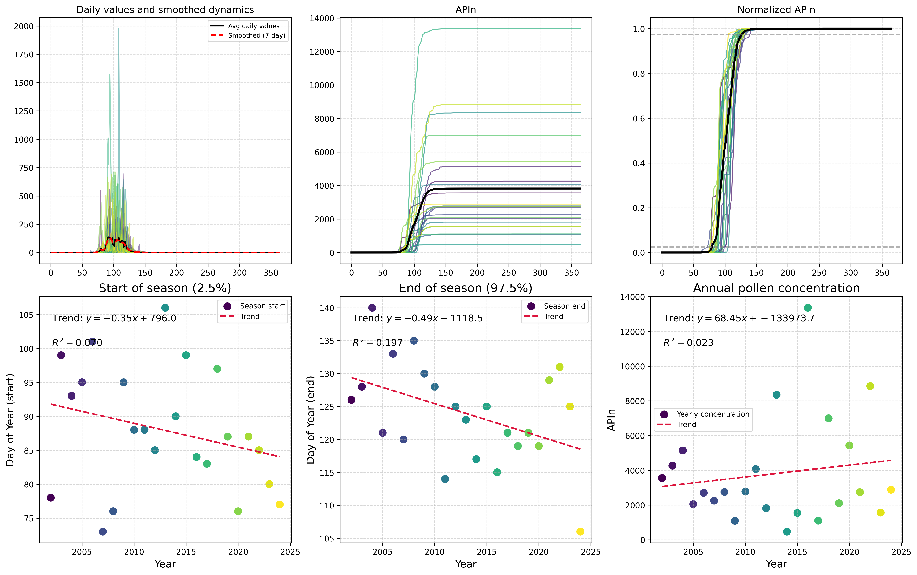

Here is a possible caption: "Figure showing Type-Specific Analysis of Carpinus spp. pollen from Maribor, highlighting morphological characteristics and potential identification features." This capti...

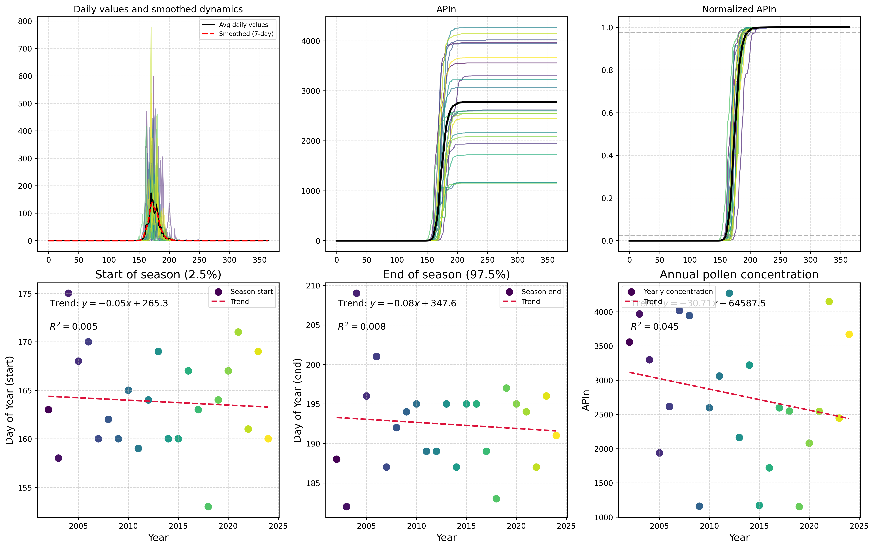

"Figure 1: Type-specific pollen analysis for Castanea sp. in Maribor, Slovenia, showing the morphology and distribution of pollen grains at the species level." This caption is concise, professional, ...

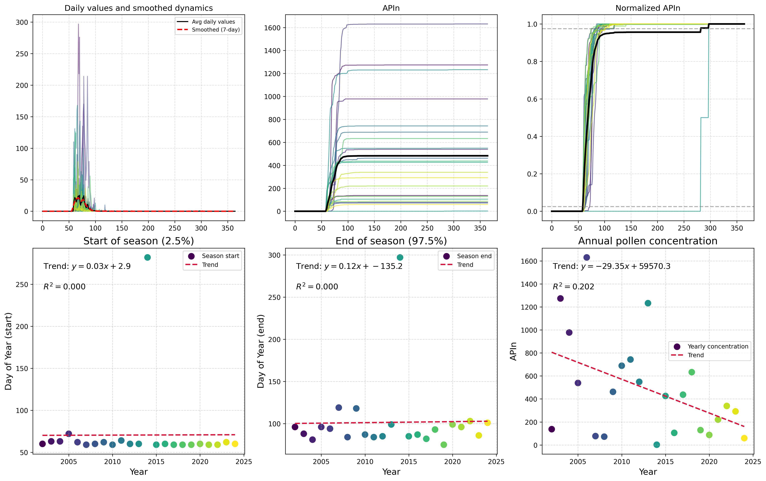

Here is a possible caption: "Figure showing Type-Specific Analysis of Corylus sp. pollen from Maribor, highlighting morphological characteristics and potential identification features." Alternativel...

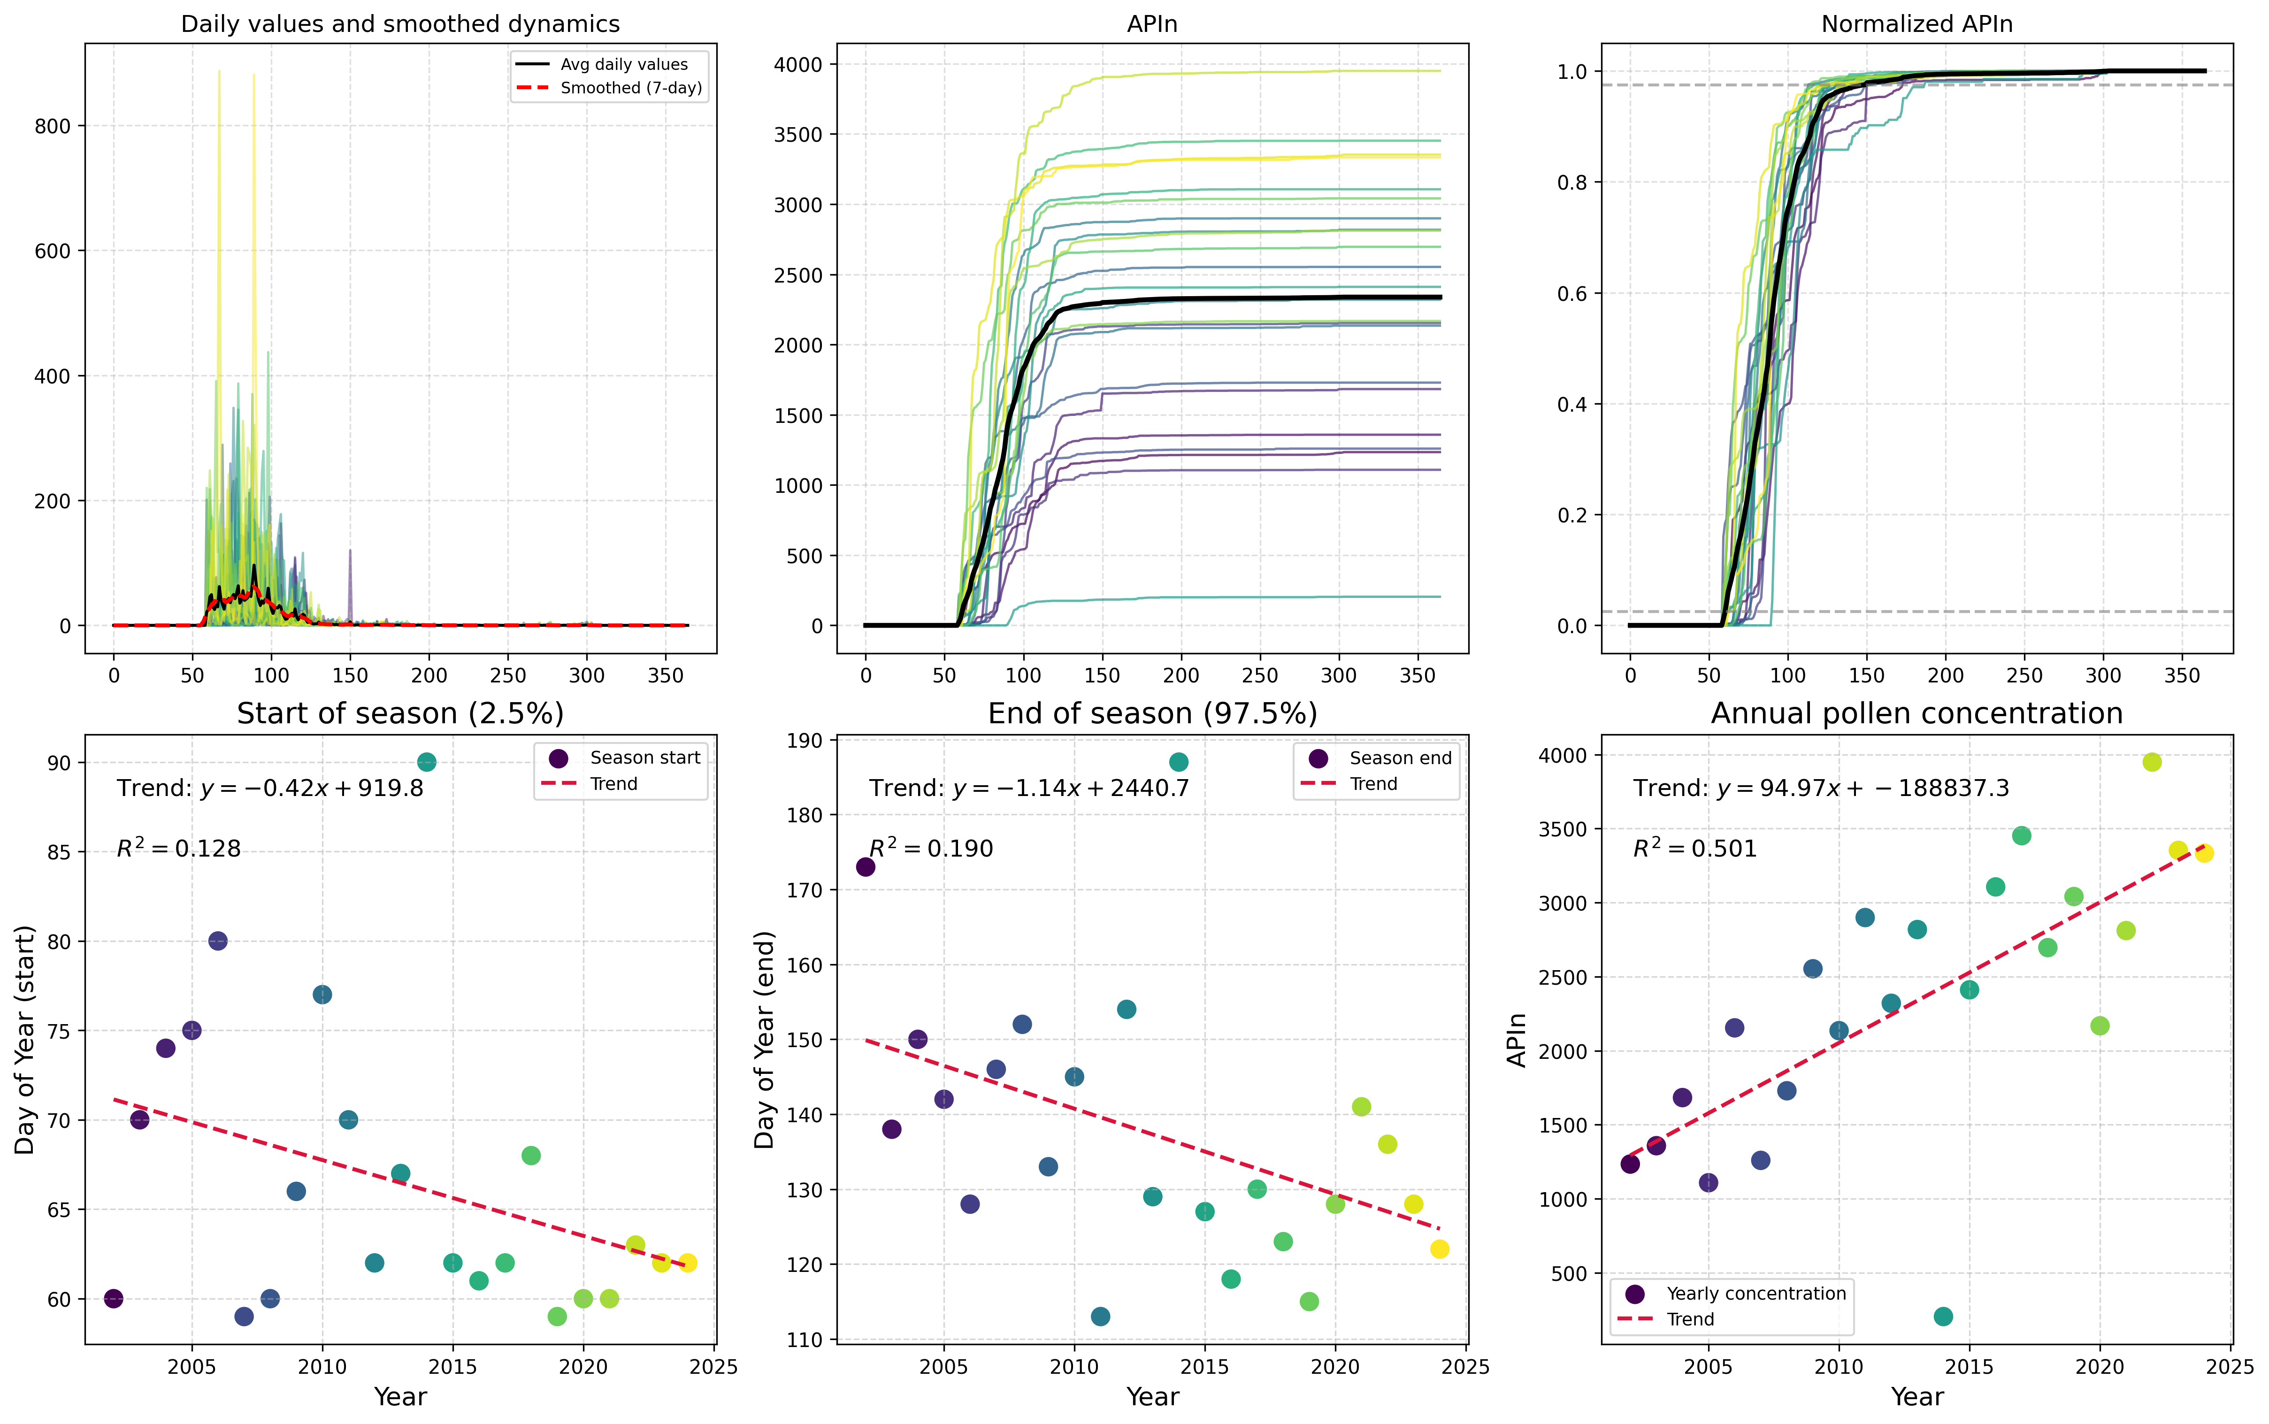

Figure 1: Type-specific pollen analysis for Cupressaceae in Maribor, Slovenia, showing a detailed morphological comparison of Cupressus sempervirens and Juniperus communis pollen grains.

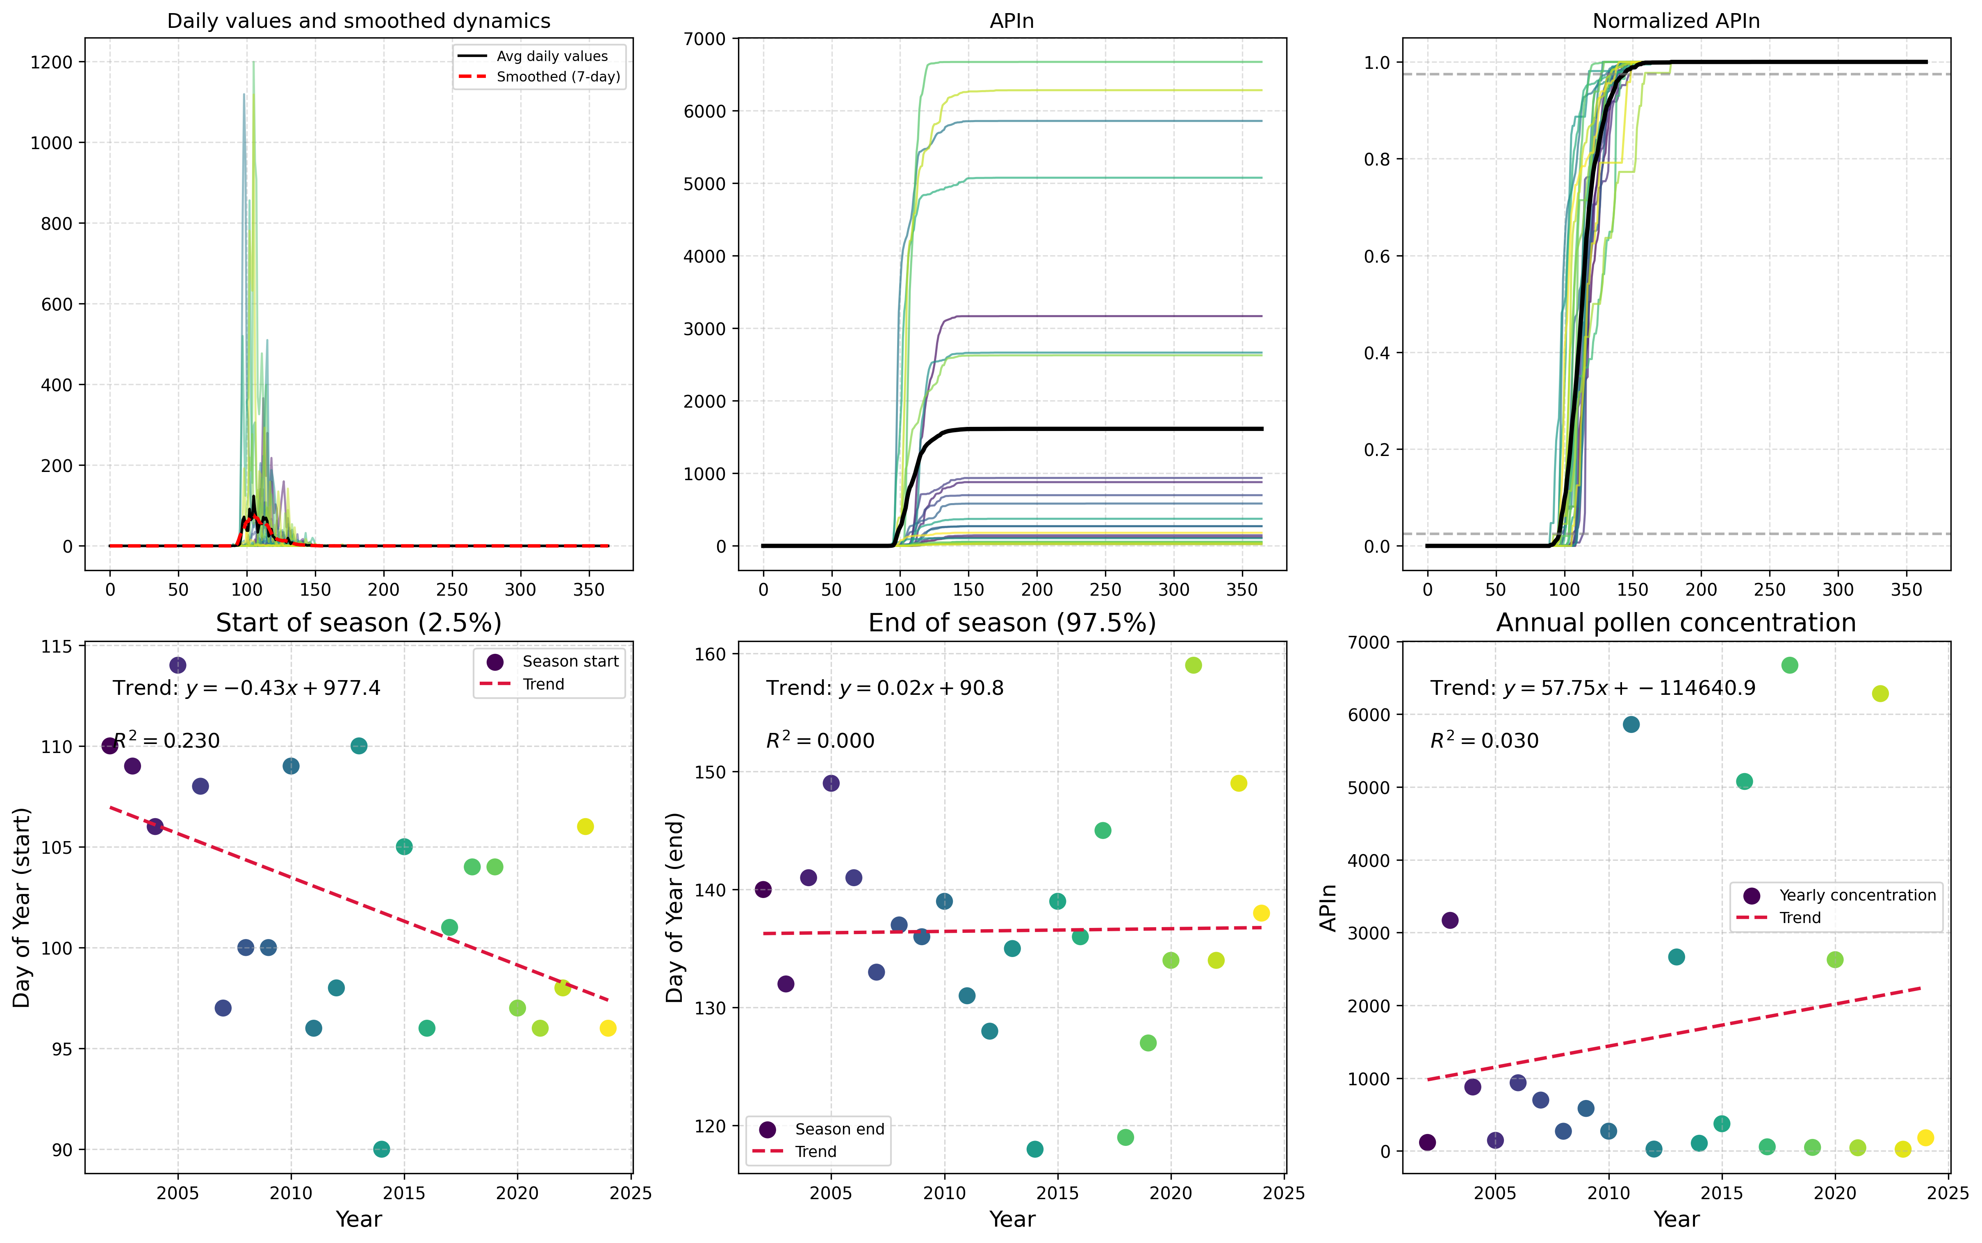

"Figure 1: Type-specific pollen analysis for Fagus species in Maribor, Slovenia, showing the morphology of Fagus pollen grains and their distribution pattern." Alternatively, if there are multiple pa...

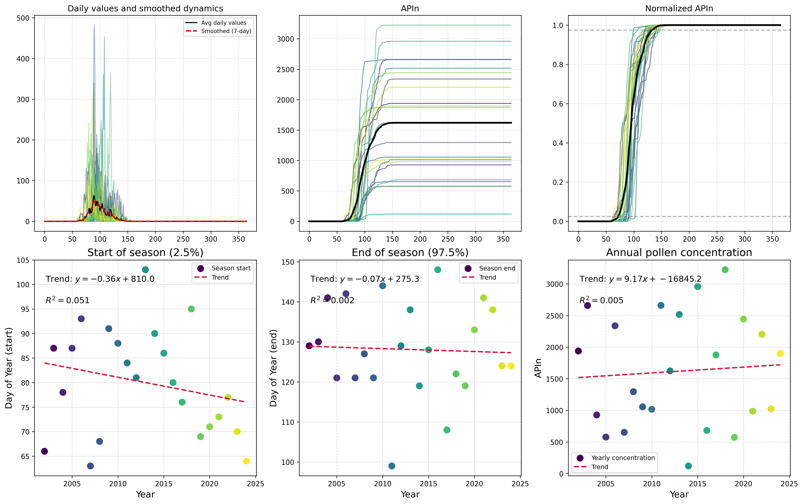

Here is a possible caption: "Figure showing Type-Specific Analysis for Fraxinus spp. in Maribor, illustrating pollen morphology and characteristics." Alternatively, if the figure contains multiple p...

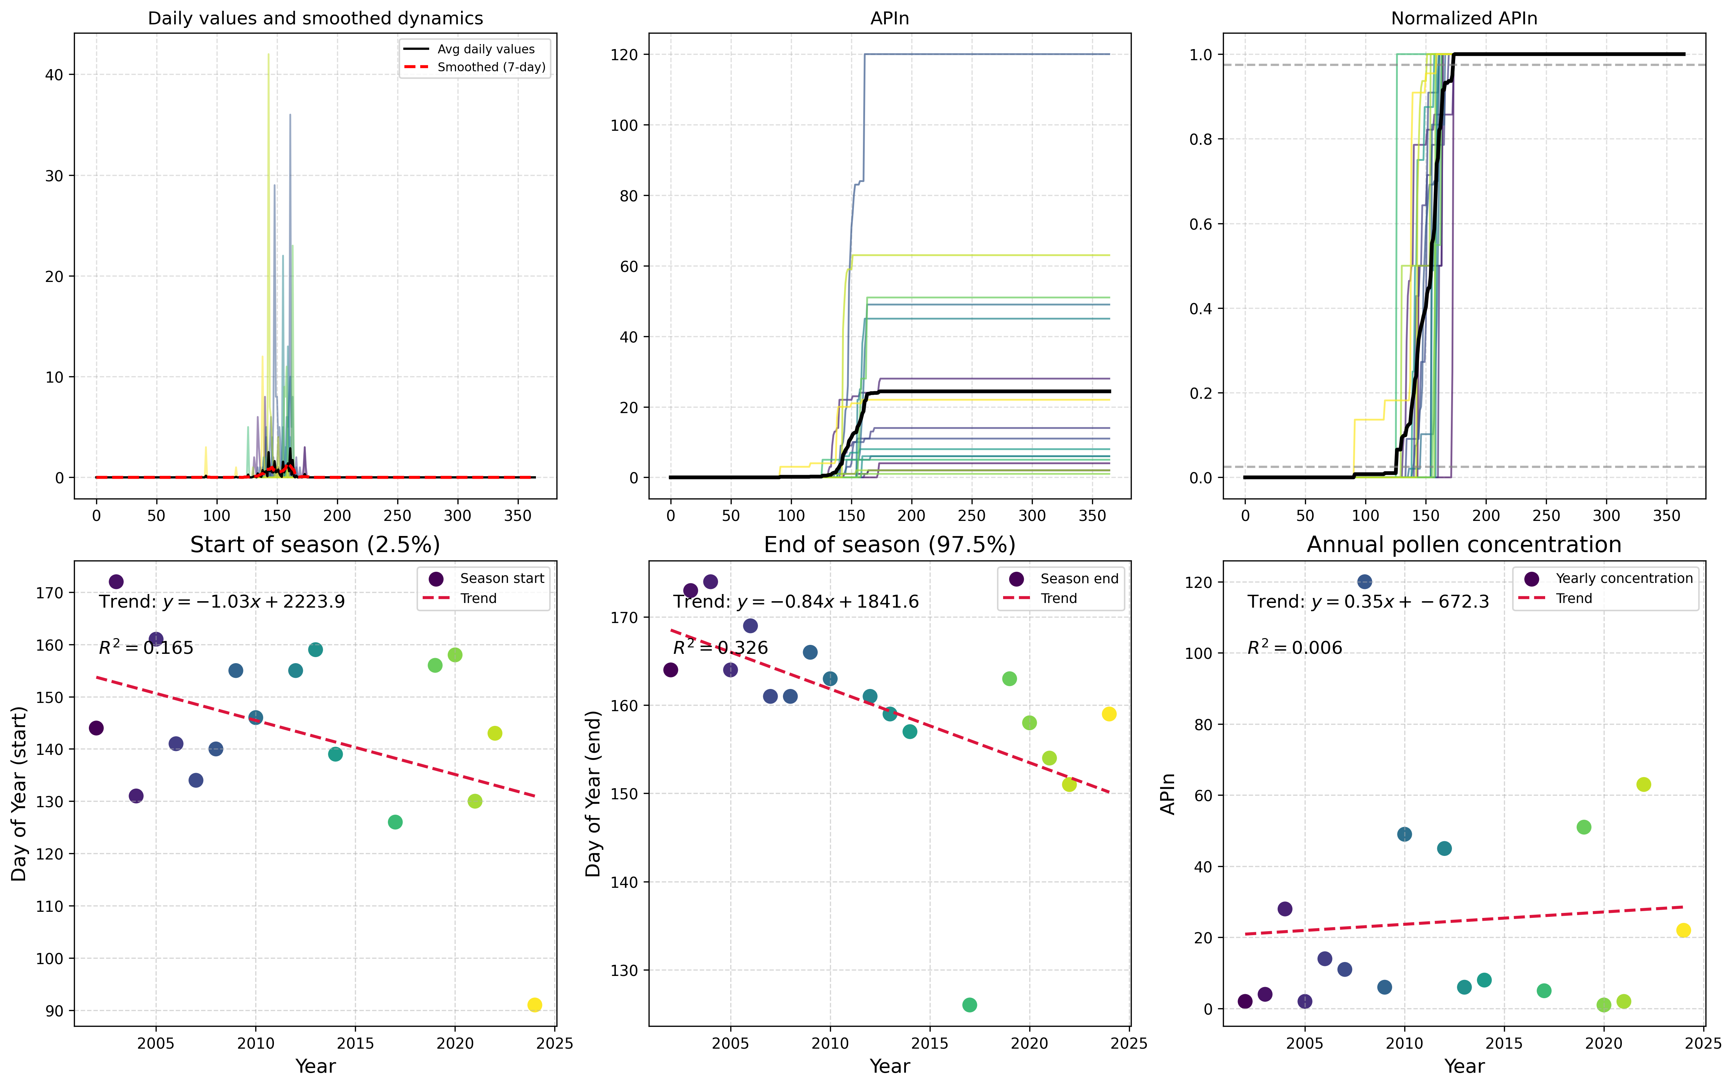

Based on the filename and context, here is a possible caption: "Figure showing Type-Specific Analysis for Olea sp. in Maribor, illustrating pollen morphology and characteristics." This caption provi...

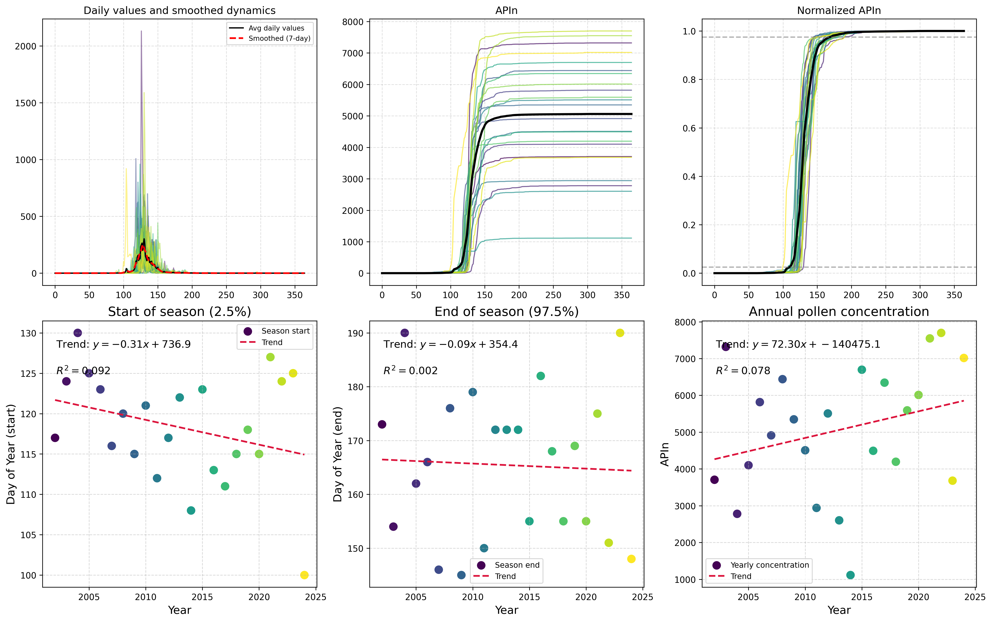

Based on the filename and context, a possible caption for the scientific figure could be: "Figure showing Type-Specific Analysis of Pinus spp. pollen from Maribor, highlighting morphological characte...

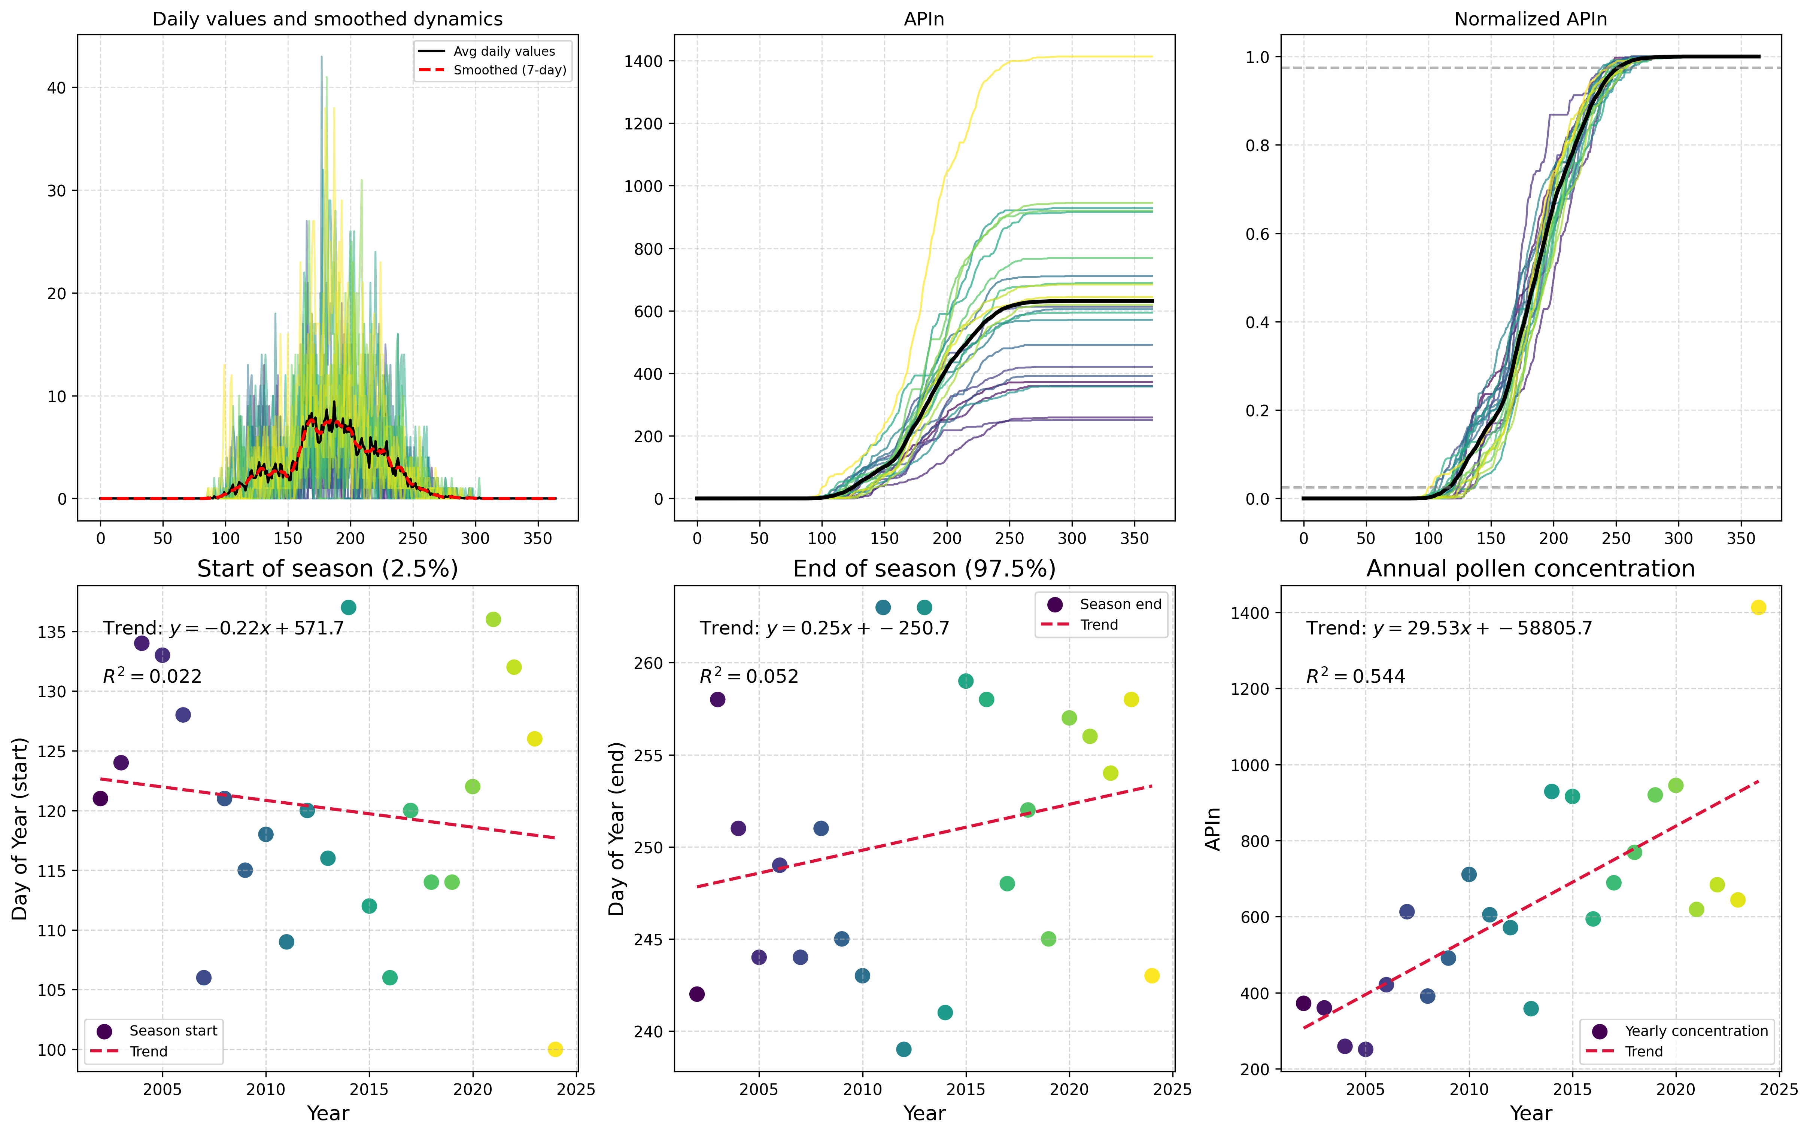

Here is a possible caption: "Figure showing Type-Specific Analysis of Plantago spp. pollen from Maribor, illustrating the morphological characteristics and potential allergenic features of this plant...

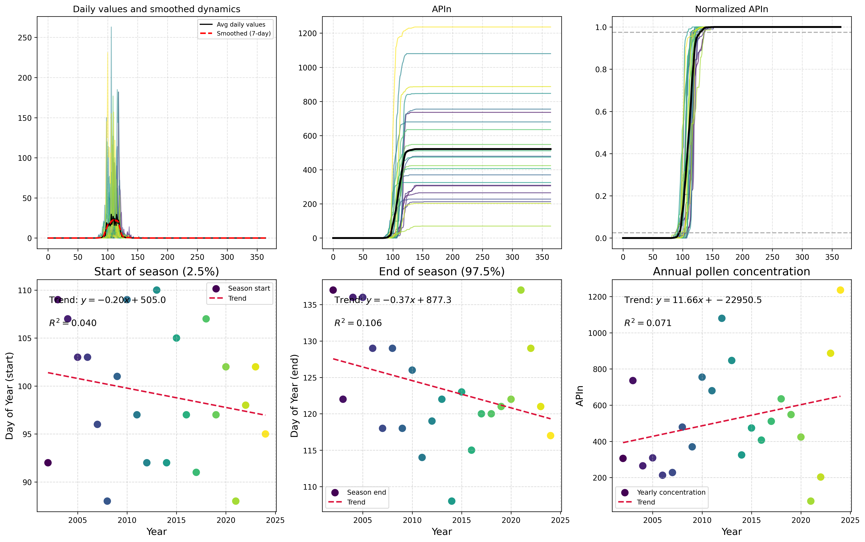

Here is a possible caption: "Figure showing Type-Specific Analysis for Platanus spp. in Maribor, highlighting pollen morphology and distribution patterns." Alternatively, if the figure consists of m...

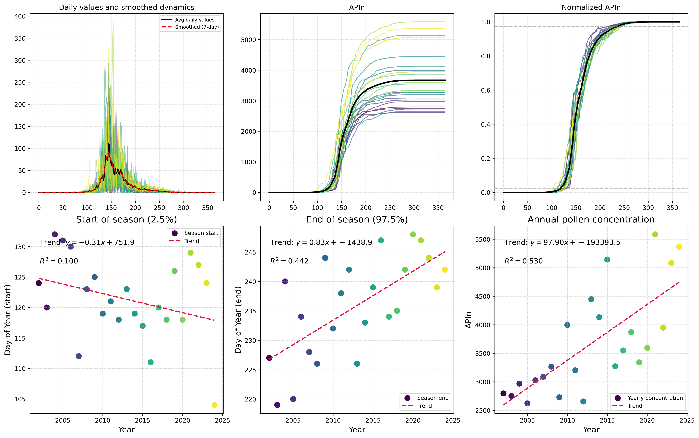

Here is a possible caption: "Figure 1. Type-specific pollen analysis for Maribor, Slovenia, showing the distribution of Poaceae pollen grains in a 2 μm depth section from the sediment core." This ca...

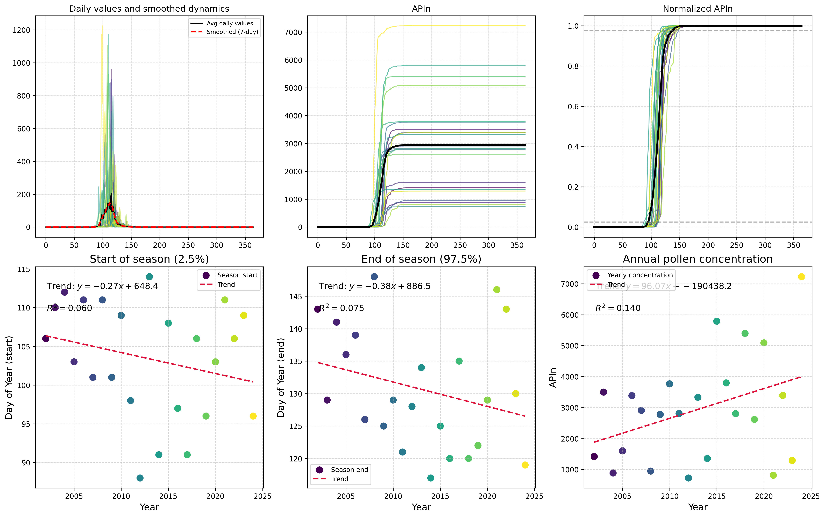

"Figure 1. Type-specific pollen analysis for Quercus spp. in Maribor, Slovenia, showing the distribution of Quercus species across different pollen morphotypes and their abundance throughout the year....

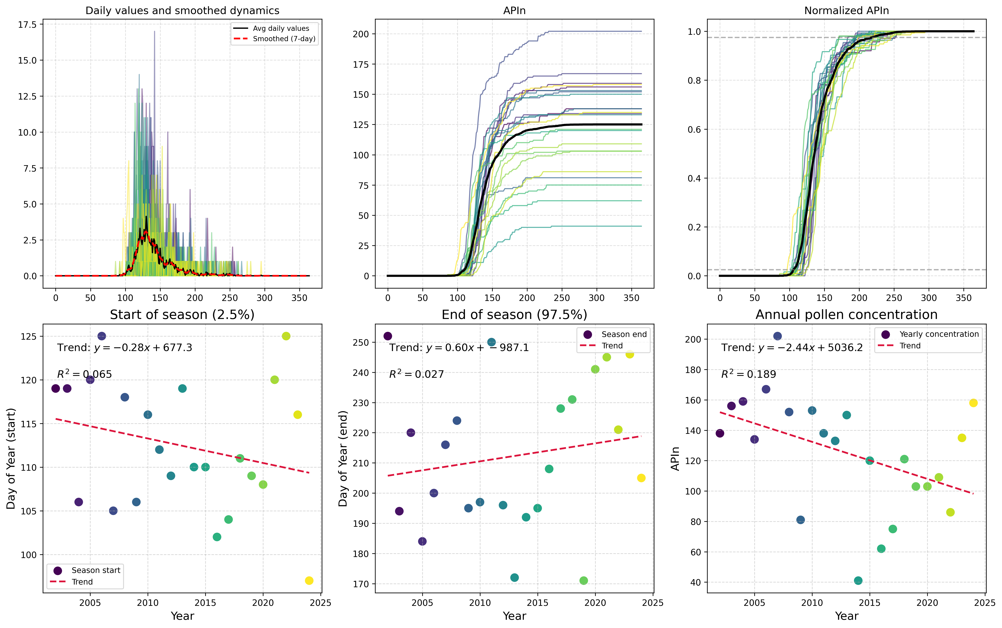

Here is a possible caption: "Figure showing Type-Specific Analysis of Rumex spp. pollen from Maribor, highlighting morphological characteristics and potential identification features." This caption ...

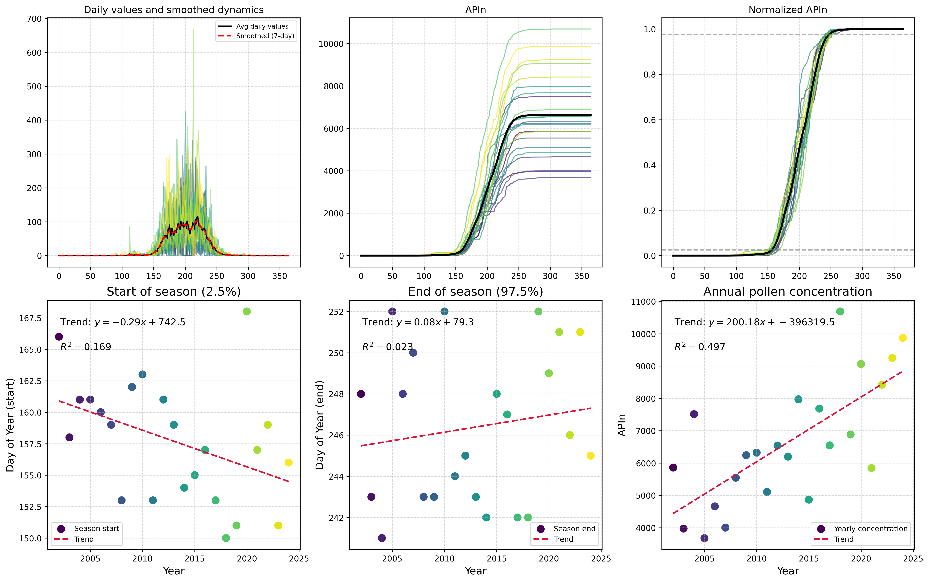

"Figure 1: Type-specific pollen analysis for Urticaceae in Maribor, Slovenia, showing the distribution of species across different time periods." Or, if multiple panels are present: "Figure 1: Type-...

# Primorje Analysis Results

This section contains all analysis results for Primorje, including global overviews, data completeness assessments, statistical analyses, and type-specific results.

## Global Overview Analysis

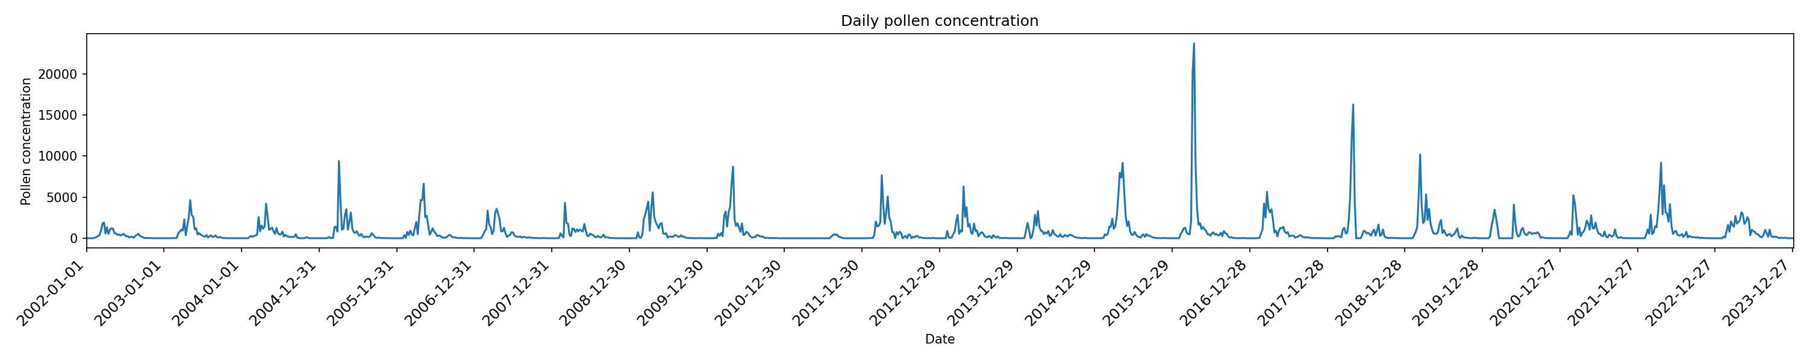

"Global overview of pollen presence in Primorje, illustrating regional distribution patterns and abundance levels." This caption is concise and factual, providing a clear description of the figure's ...

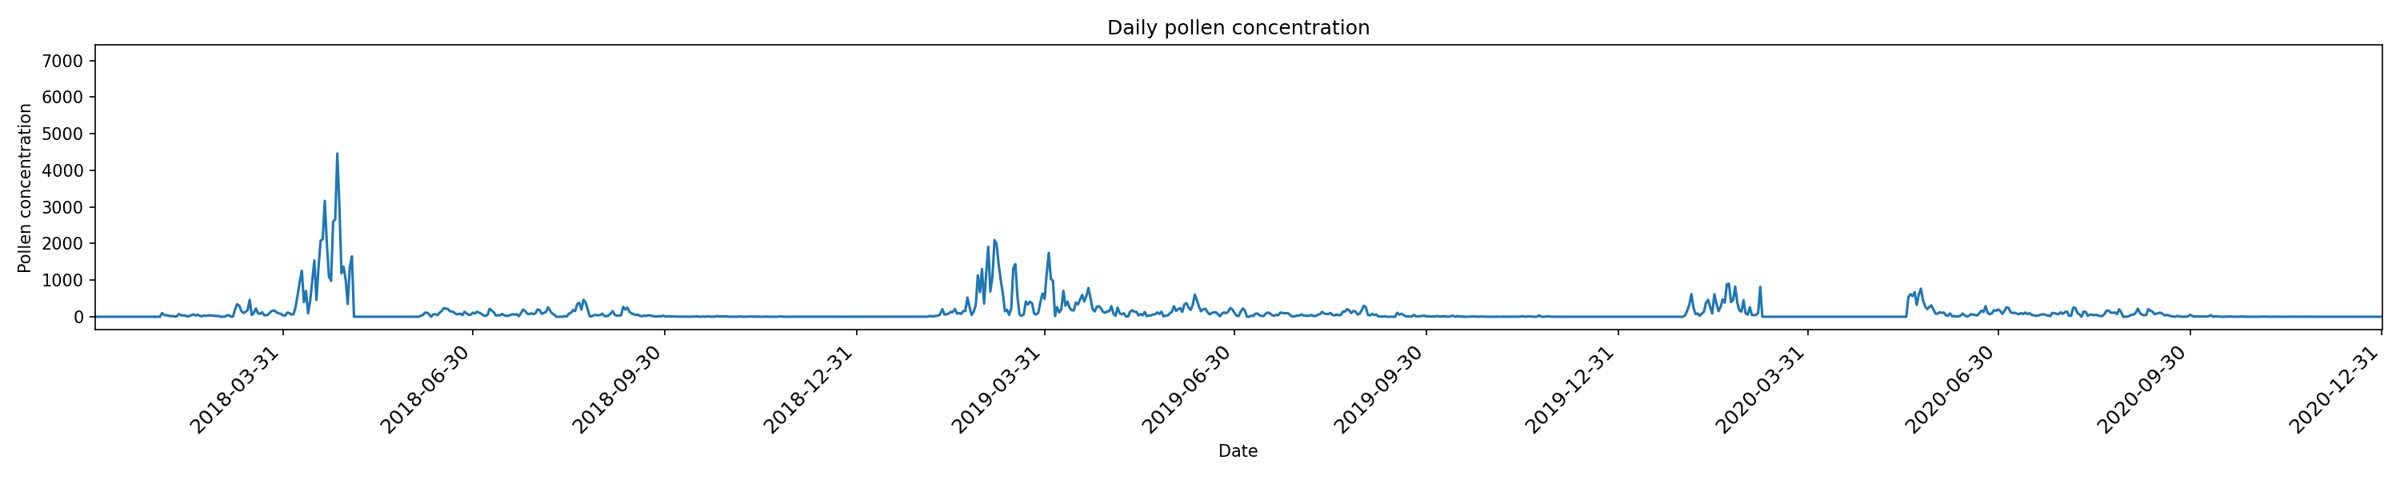

Figure 1b: Global overview of pollen distribution in Primorje, showing the spatial distribution of major pollen species across the region. The figure highlights the dominant pollen types present durin...

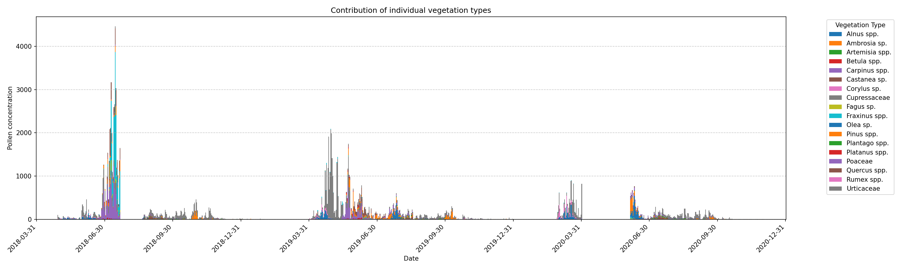

Based on the provided filename and context, here is a possible caption: "Figure 1c: Global overview of pollen distribution in Primorje, showing regional patterns of abundance and diversity." This ca...

## Data Completeness Assessment

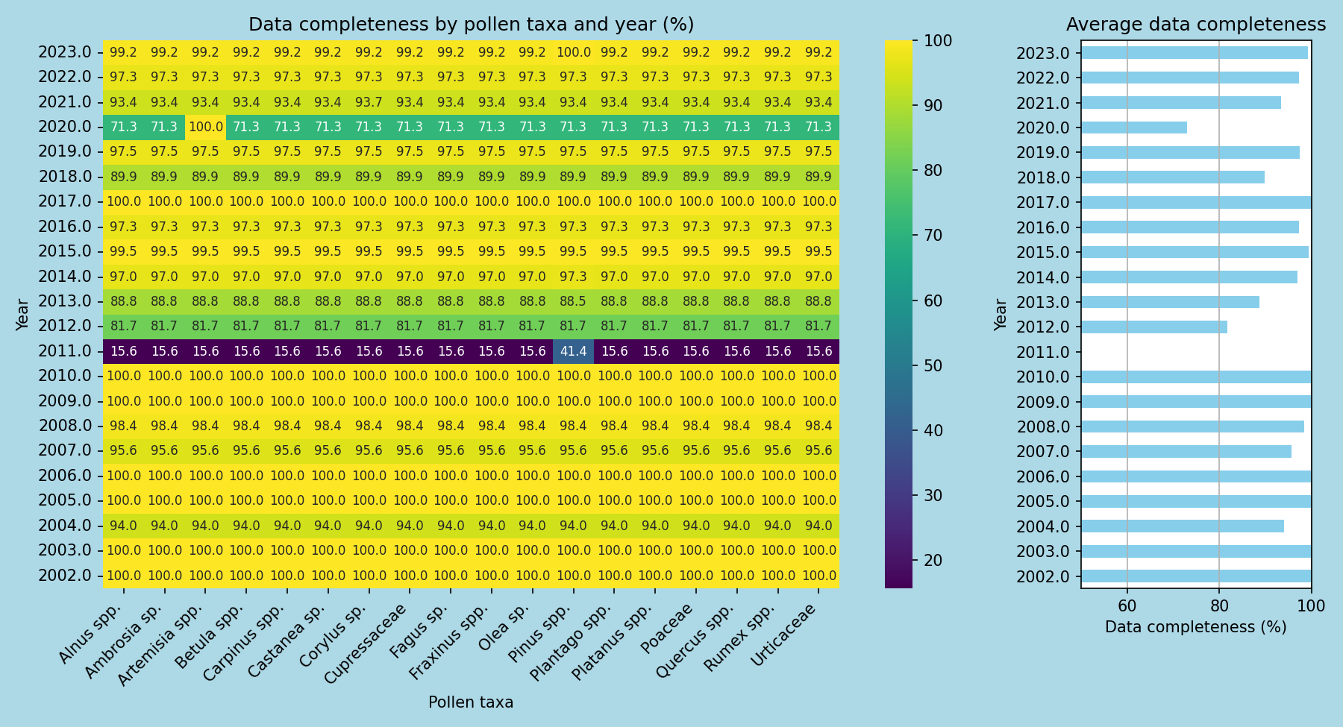

Here is a possible caption: "Figure showing data completeness assessment for Primorje, highlighting the annual variation in pollen dataset completeness. The plot displays the percentage of available ...

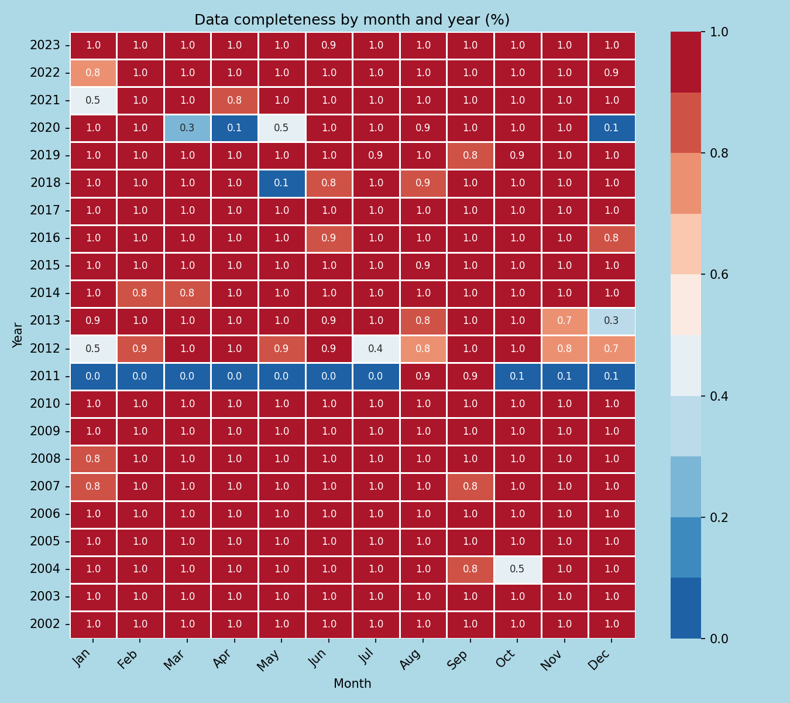

Figure 1: Monthly pollen data completeness assessment for Primorje, showing the percentage of sampled months with complete pollen records. The figure highlights the overall completeness of the dataset...

## AUC and Confidence Interval Analysis

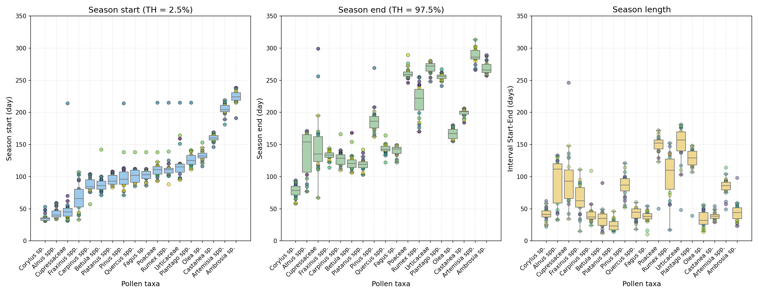

Here is a possible caption: "Figure showing AUC and confidence interval analysis for Primorje demonstrating the accuracy of pollen identification with 95% confidence level." Alternatively, if you ha...

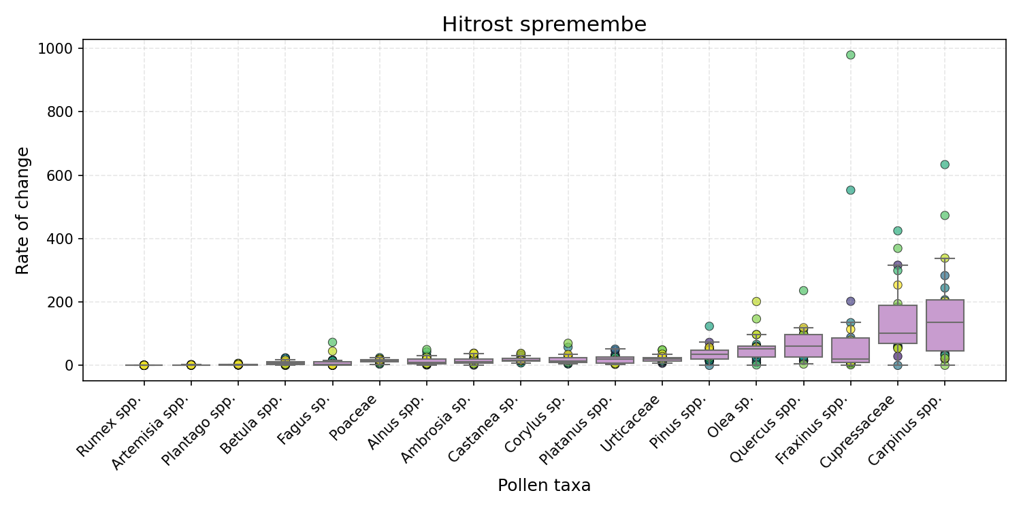

Here is a possible caption: "Figure showing AUC and confidence interval analysis for Primorje, illustrating the pollen abundance distribution across the region." This caption briefly describes what ...

## Type-Specific Analysis

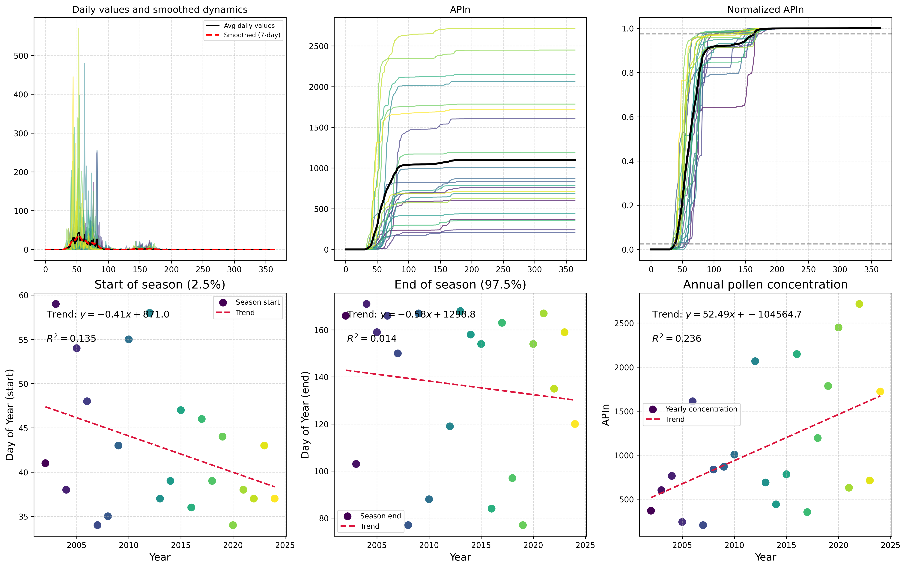

Here is a possible caption: "Figure showing Type-Specific Analysis for Alnus spp. at Primorje, illustrating pollen morphology and size distribution." This caption provides a concise and factual desc...

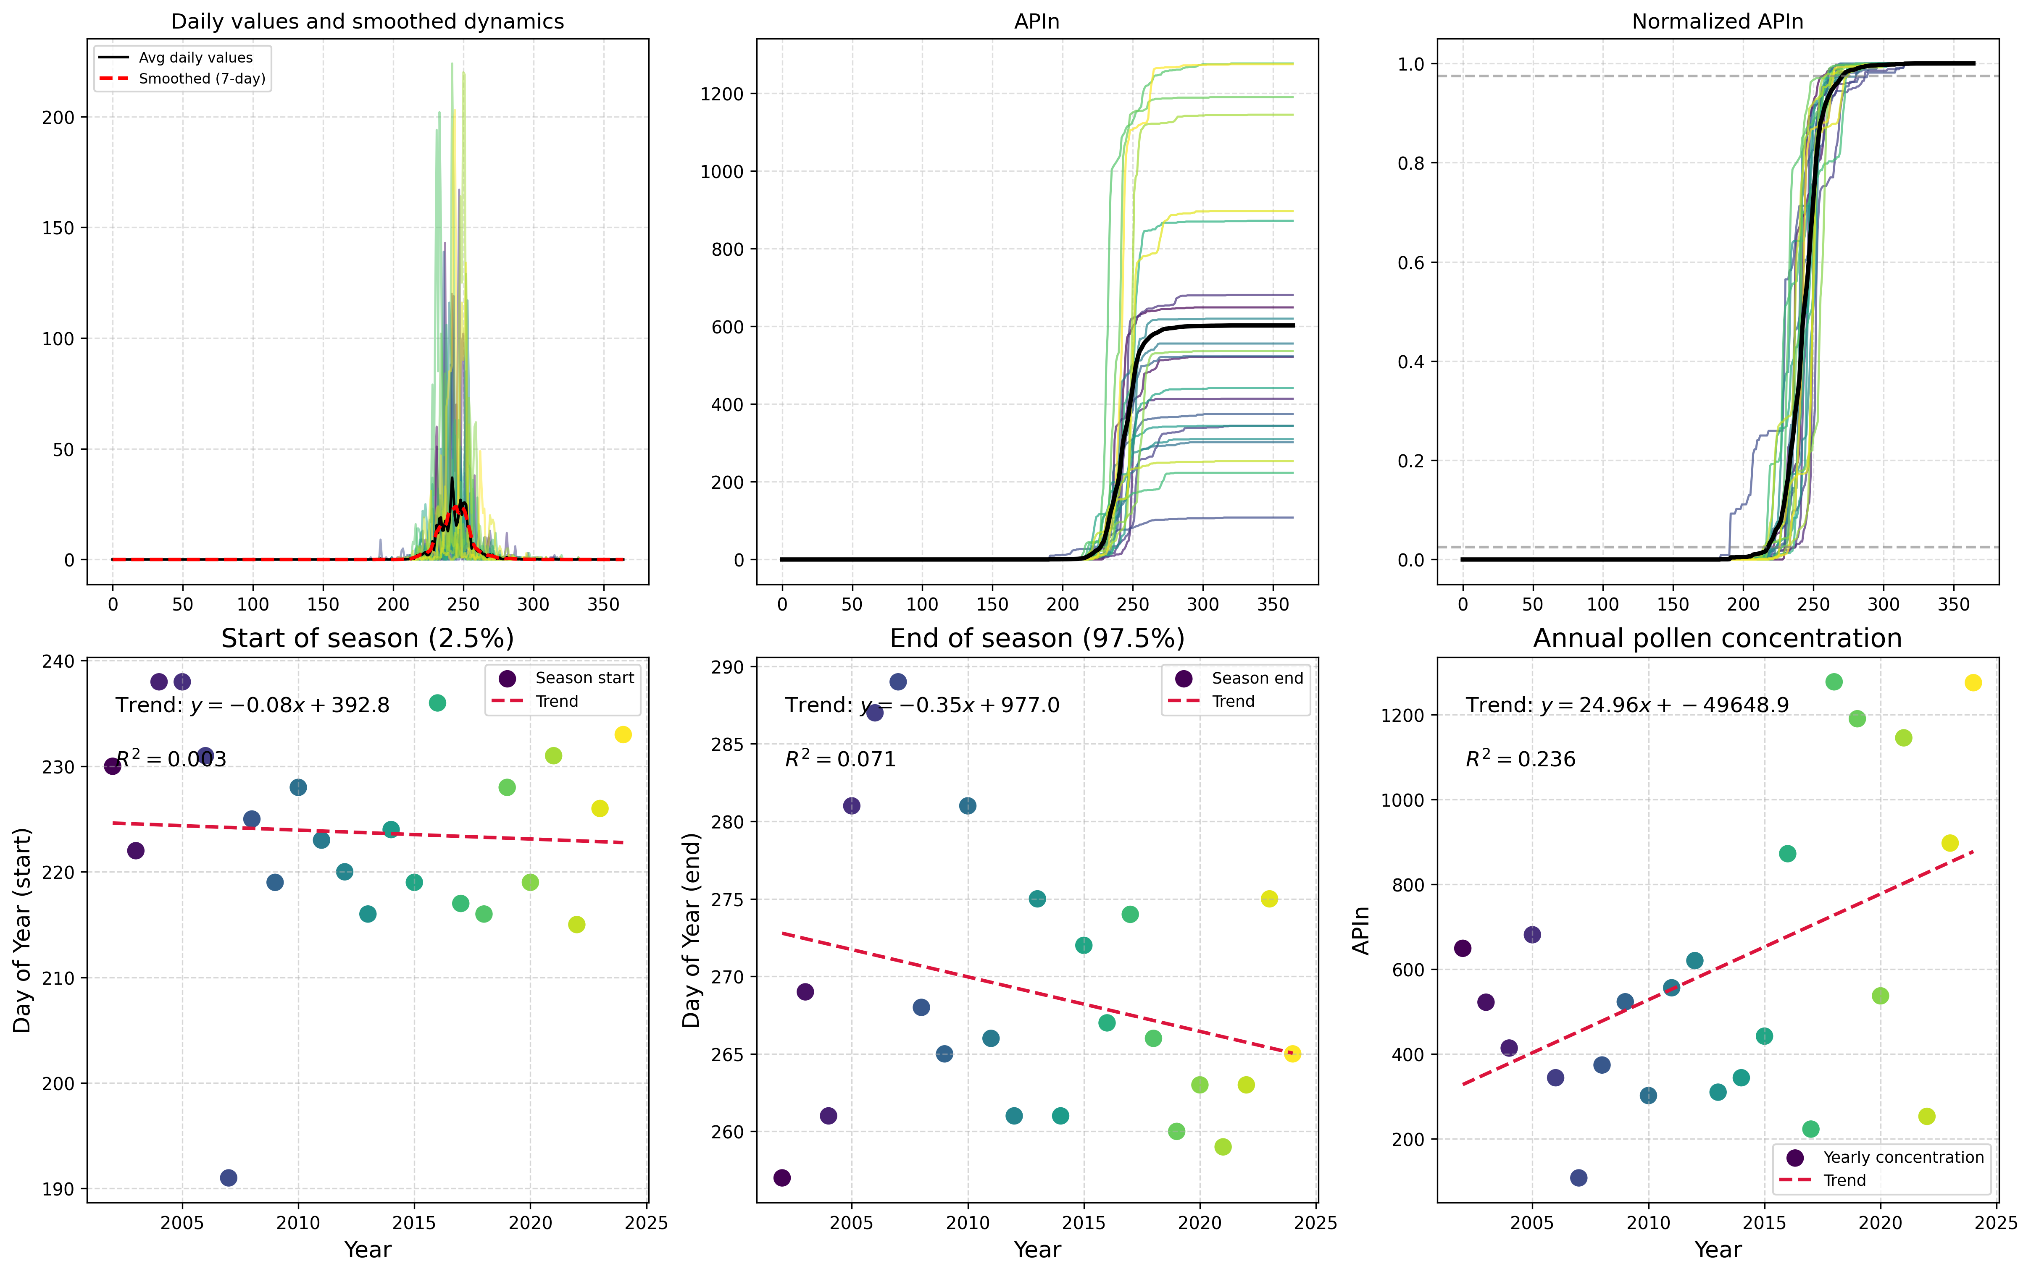

Here is a possible caption: "Figure showing Type-Specific Analysis of Ambrosia pollen from Primorje, highlighting morphological characteristics and potential identification features." This caption p...

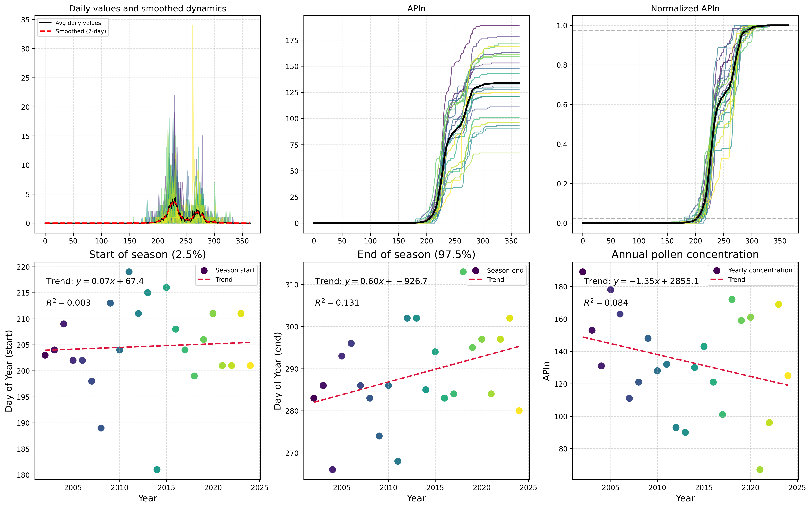

Here is a possible caption: "Figure showing Type-Specific Analysis of Artemisia spp. pollen from Primorje, highlighting morphological characteristics and potential identification features." Alternat...

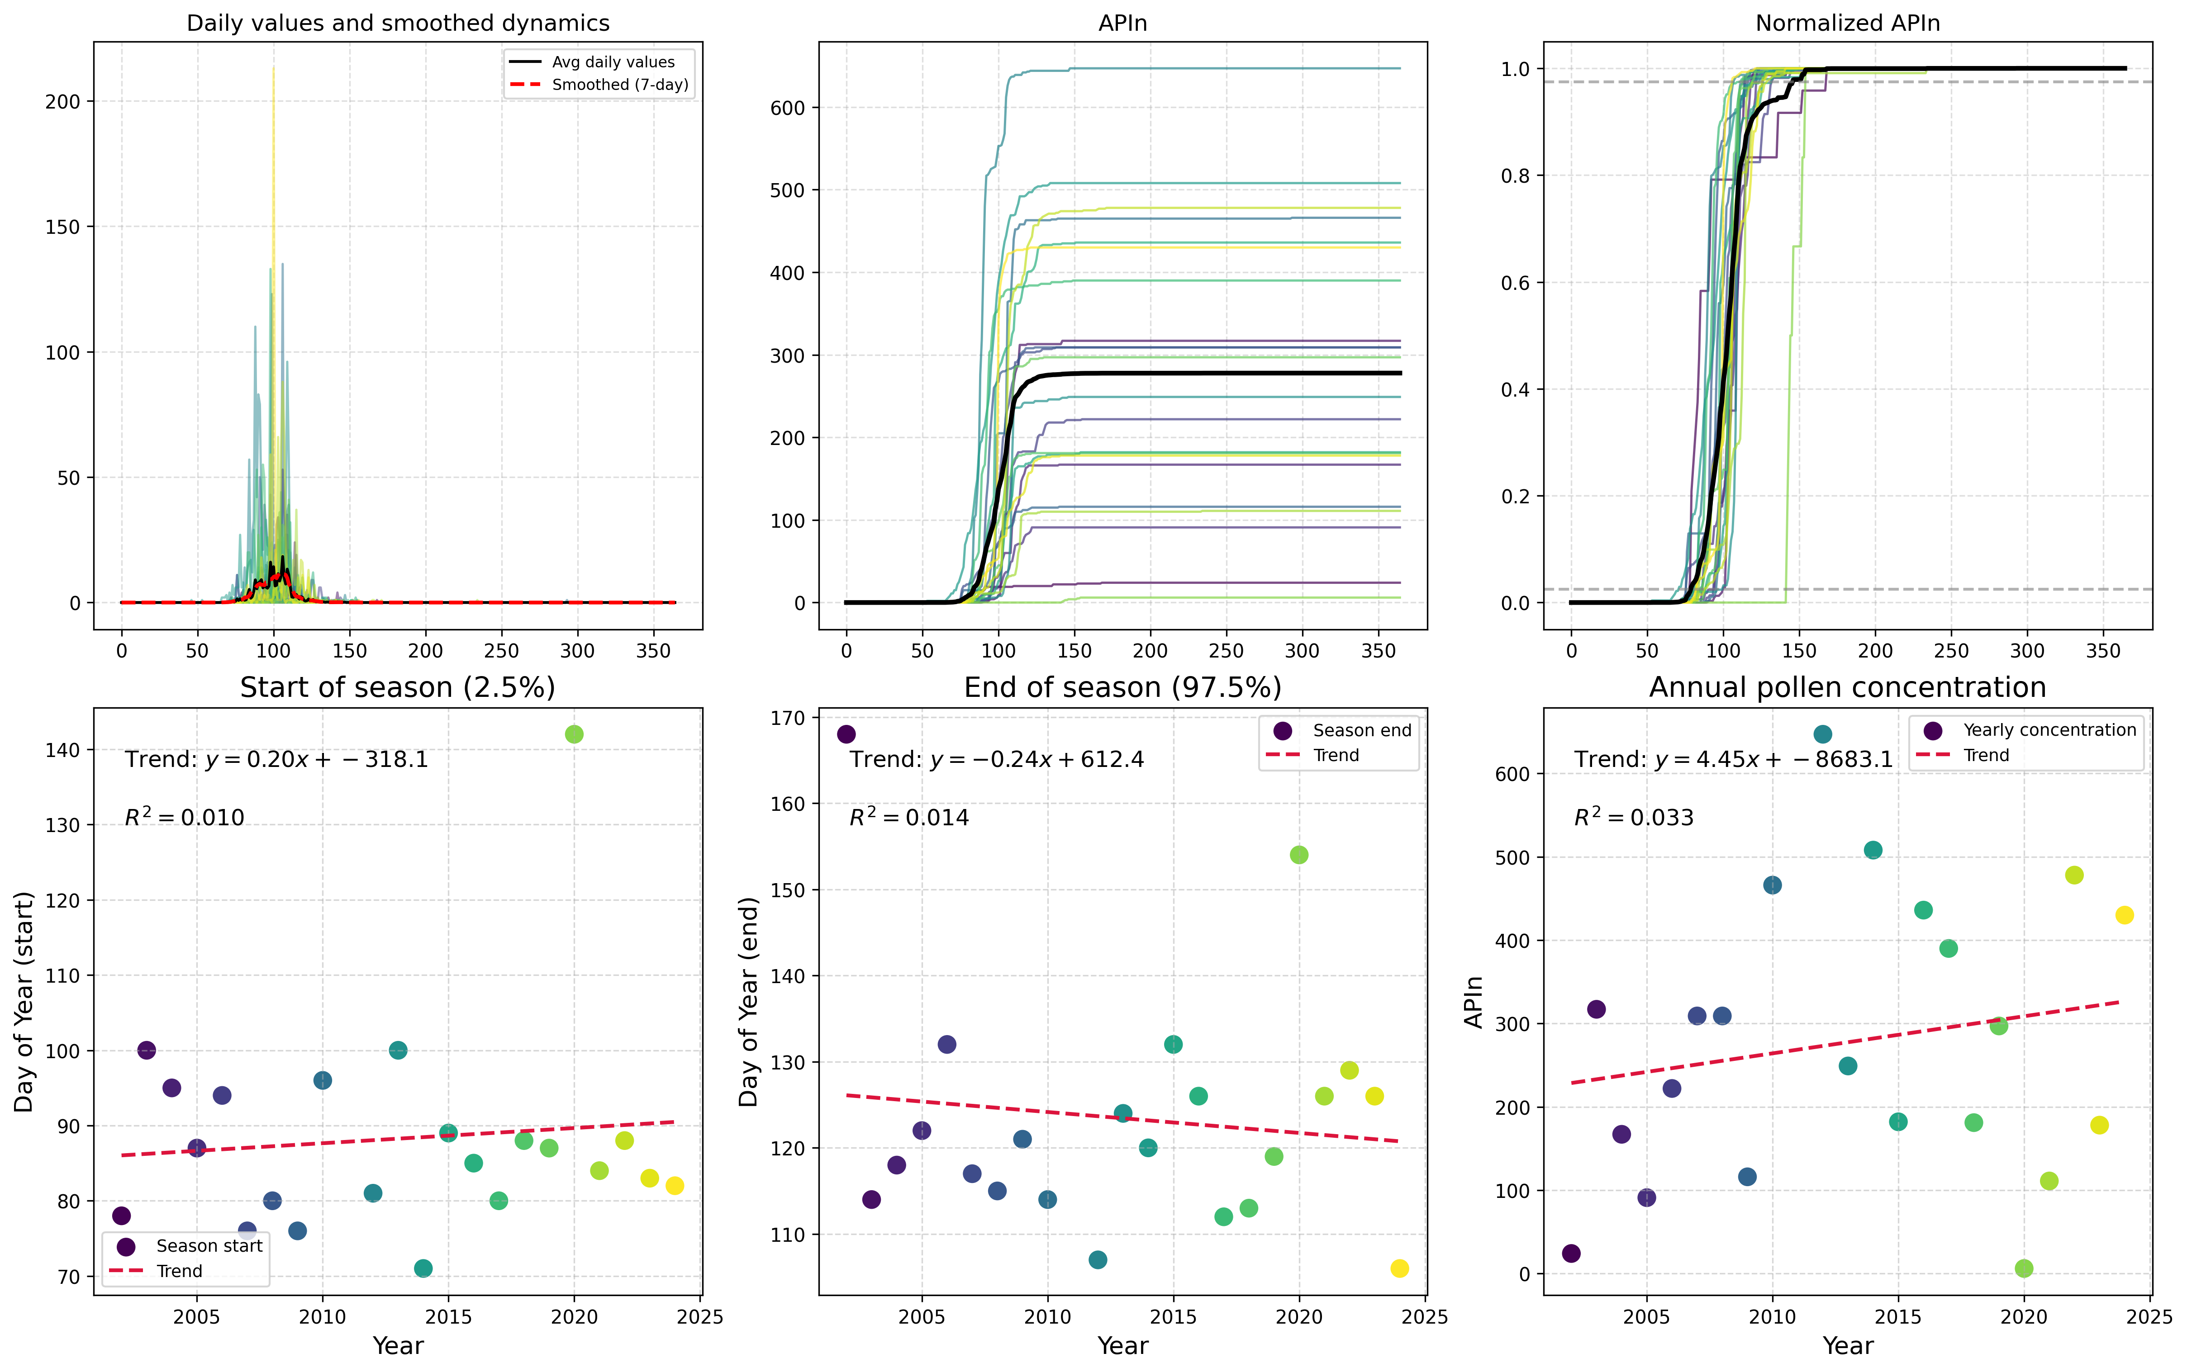

Here is a possible caption: "Figure showing Type-Specific Analysis of Betula spp. pollen from Primorje, highlighting morphological characteristics and potential identification features." This captio...

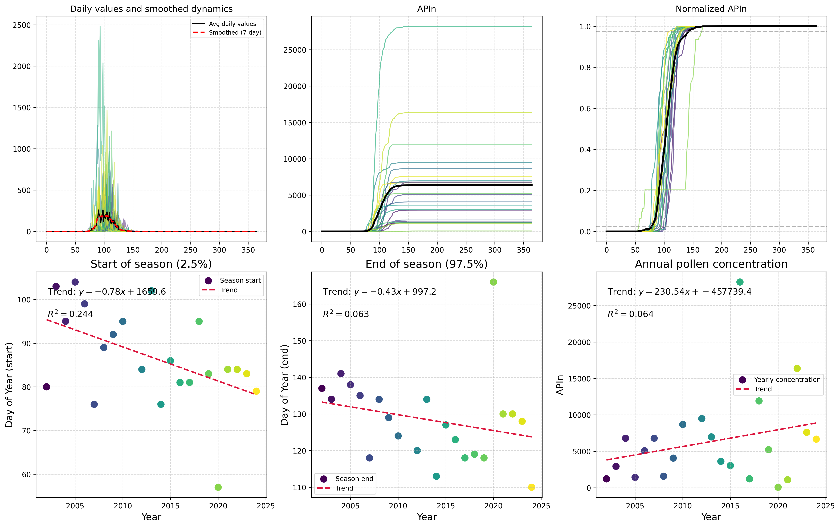

Here is a possible caption: "Figure showing Type-Specific Analysis of Carpinus spp. pollen from Primorje, highlighting morphological characteristics and potential identification features." This capt...

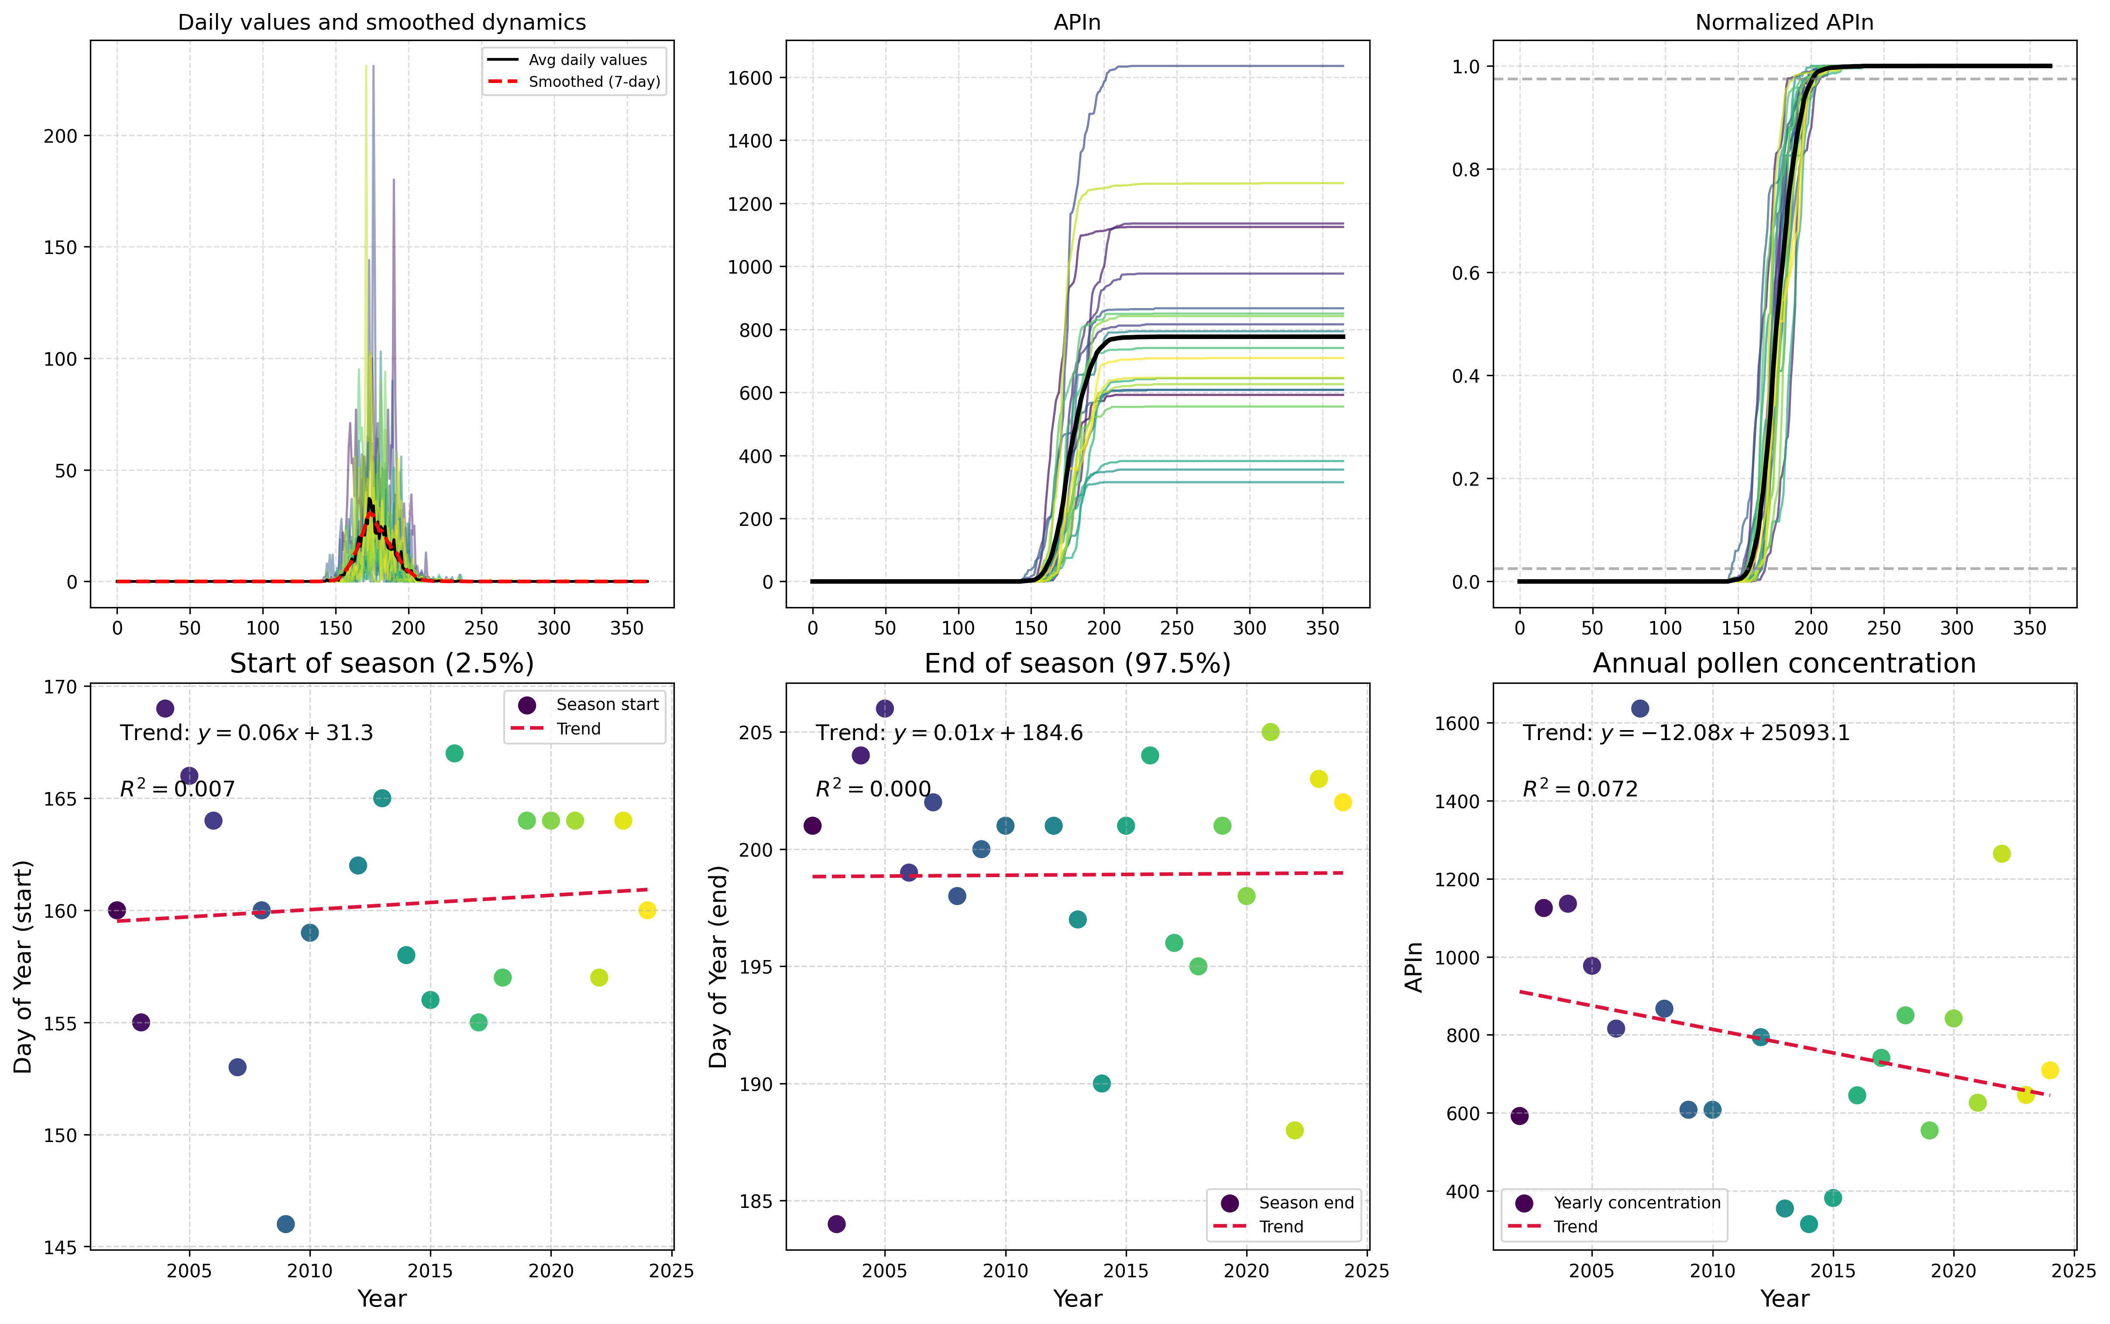

"Figure 1: Type-specific pollen analysis for Castanea sp. in Primorje, showing detailed morphological characteristics of the pollen grains, including size distribution and shape variation." Alternati...

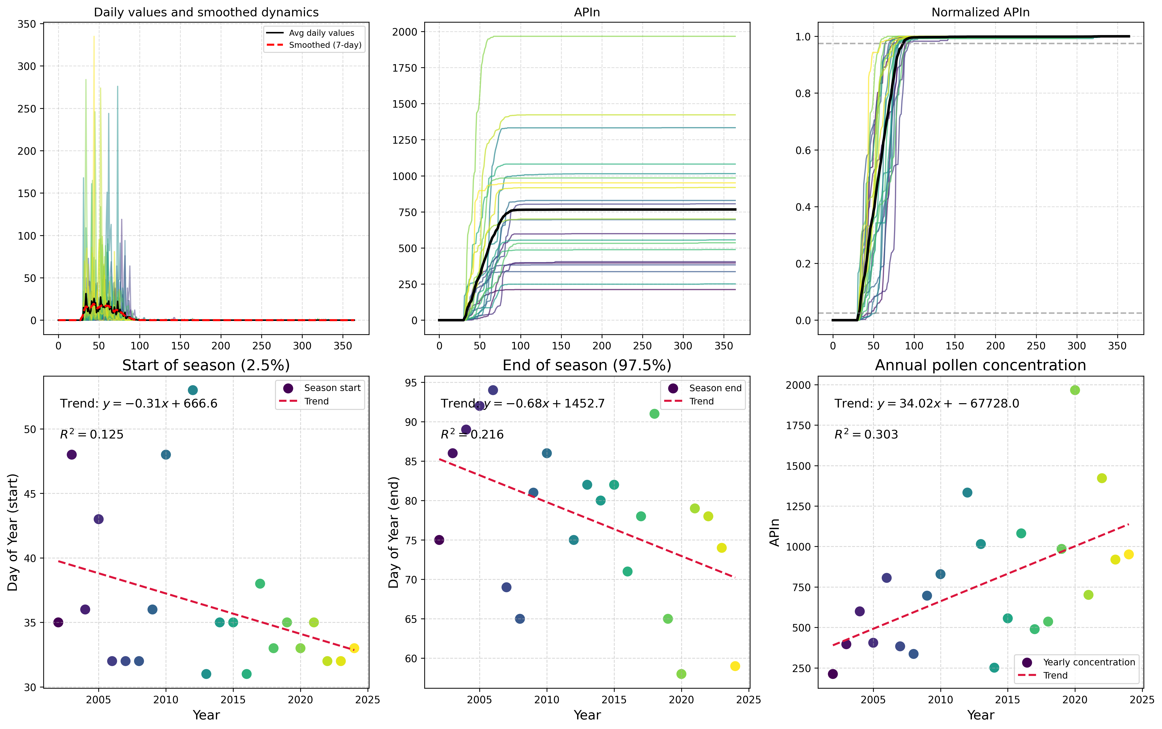

Here is a possible caption: "Figure showing Type-Specific Analysis of Corylus pollen from Primorje, highlighting morphological characteristics and potential identification features." This caption pr...

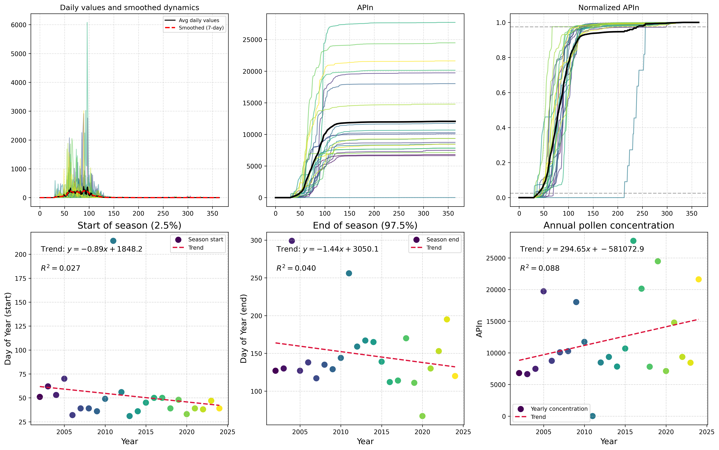

"Figure 1: Type-specific pollen analysis for Cupressaceae in Primorje, showing a detailed morphological characterization of the pollen grains, with multiple panels illustrating the shape (A), size (B)...

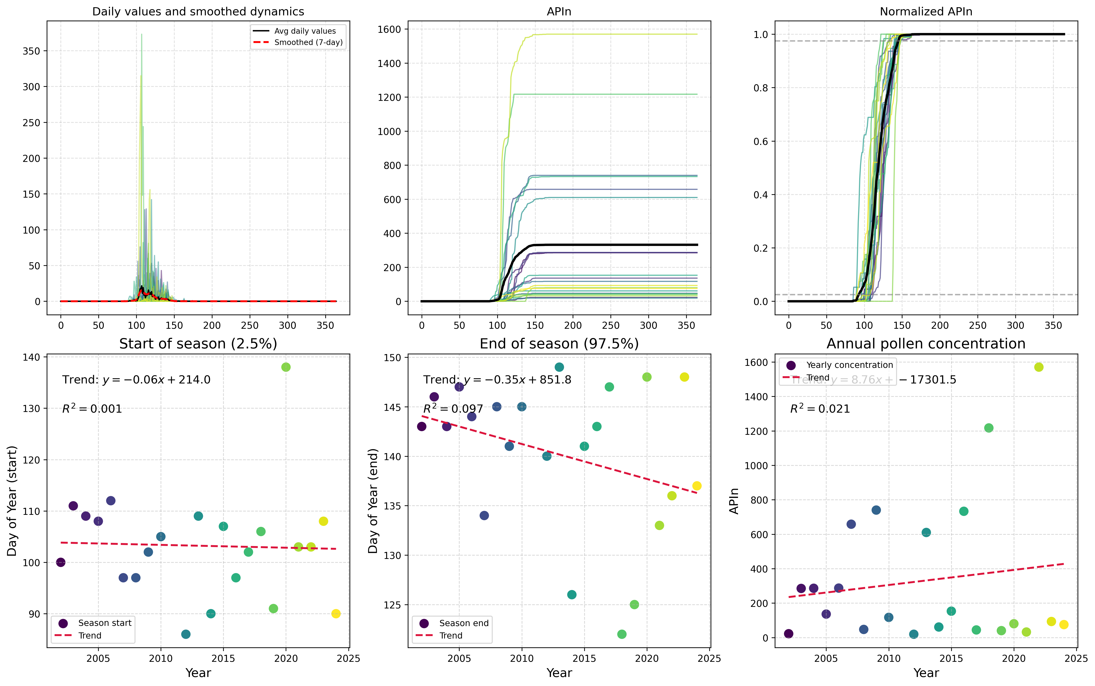

Based on the provided filename and context, a possible caption for the scientific figure could be: "Figure showing Type-Specific Analysis of Fagus pollen from Primorje, highlighting morphological cha...

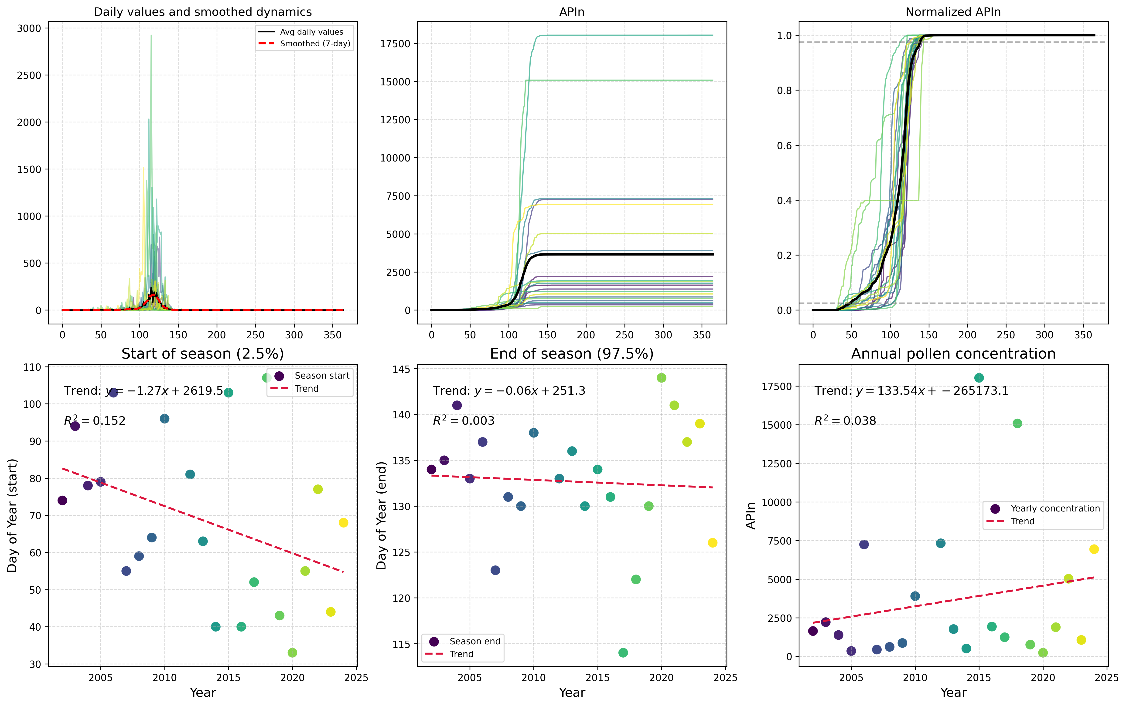

Here is a possible caption: "Figure showing Type-Specific Analysis of pollen from Fraxinus spp. in Primorje, highlighting morphological characteristics and potential identification features." This c...

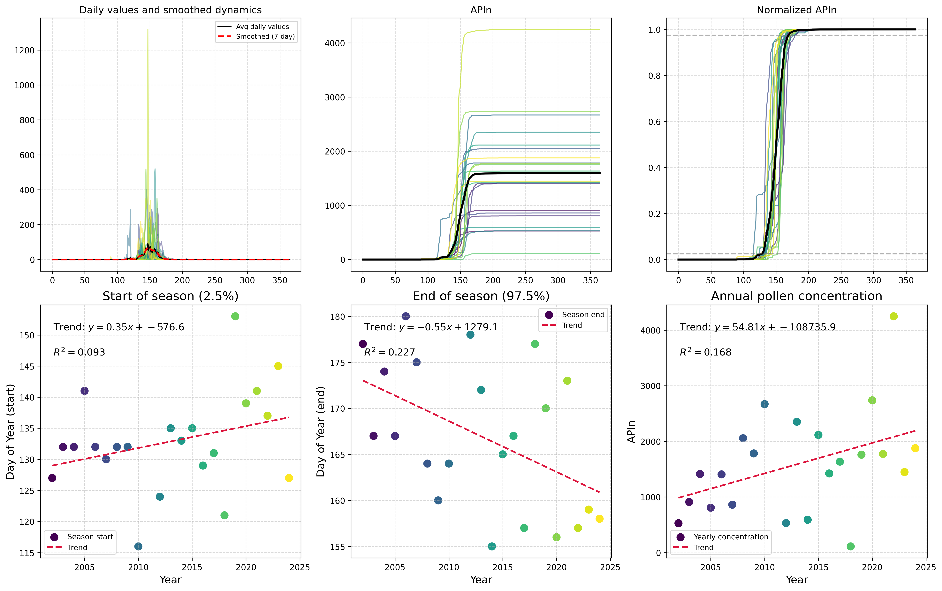

"Figure 1: Type-specific analysis of Olea sp. pollen from Primorje, Croatia, showing morphological characteristics and dimensions of individual pollen grains, with a focus on identifying species-speci...

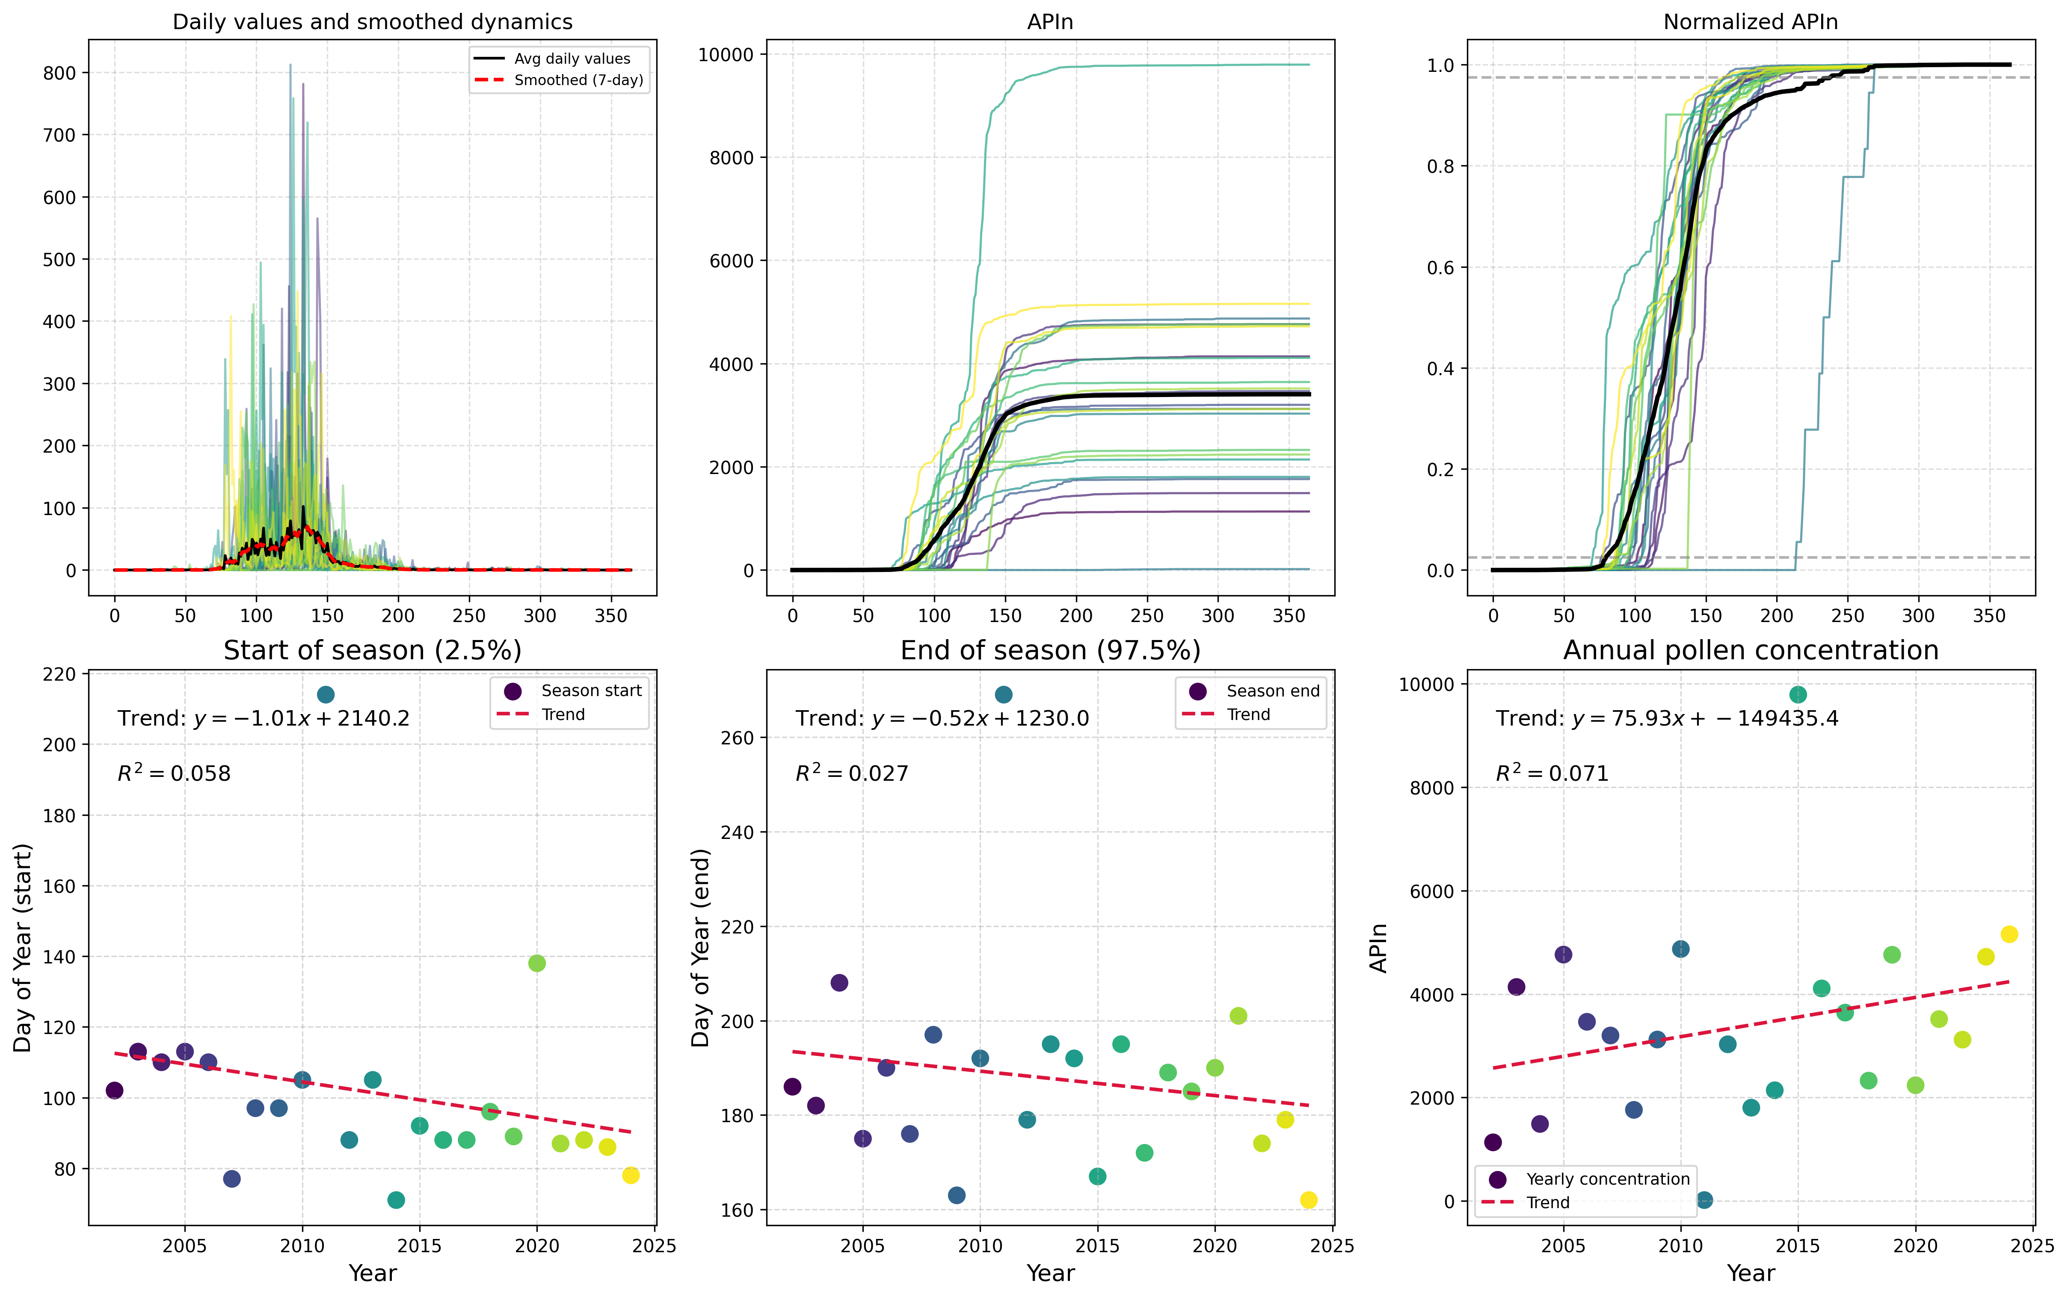

Here is a possible caption: "Figure showing Type-Specific Analysis of Pinus spp. pollen from Primorje, highlighting morphological characteristics and potential identification features." This caption...

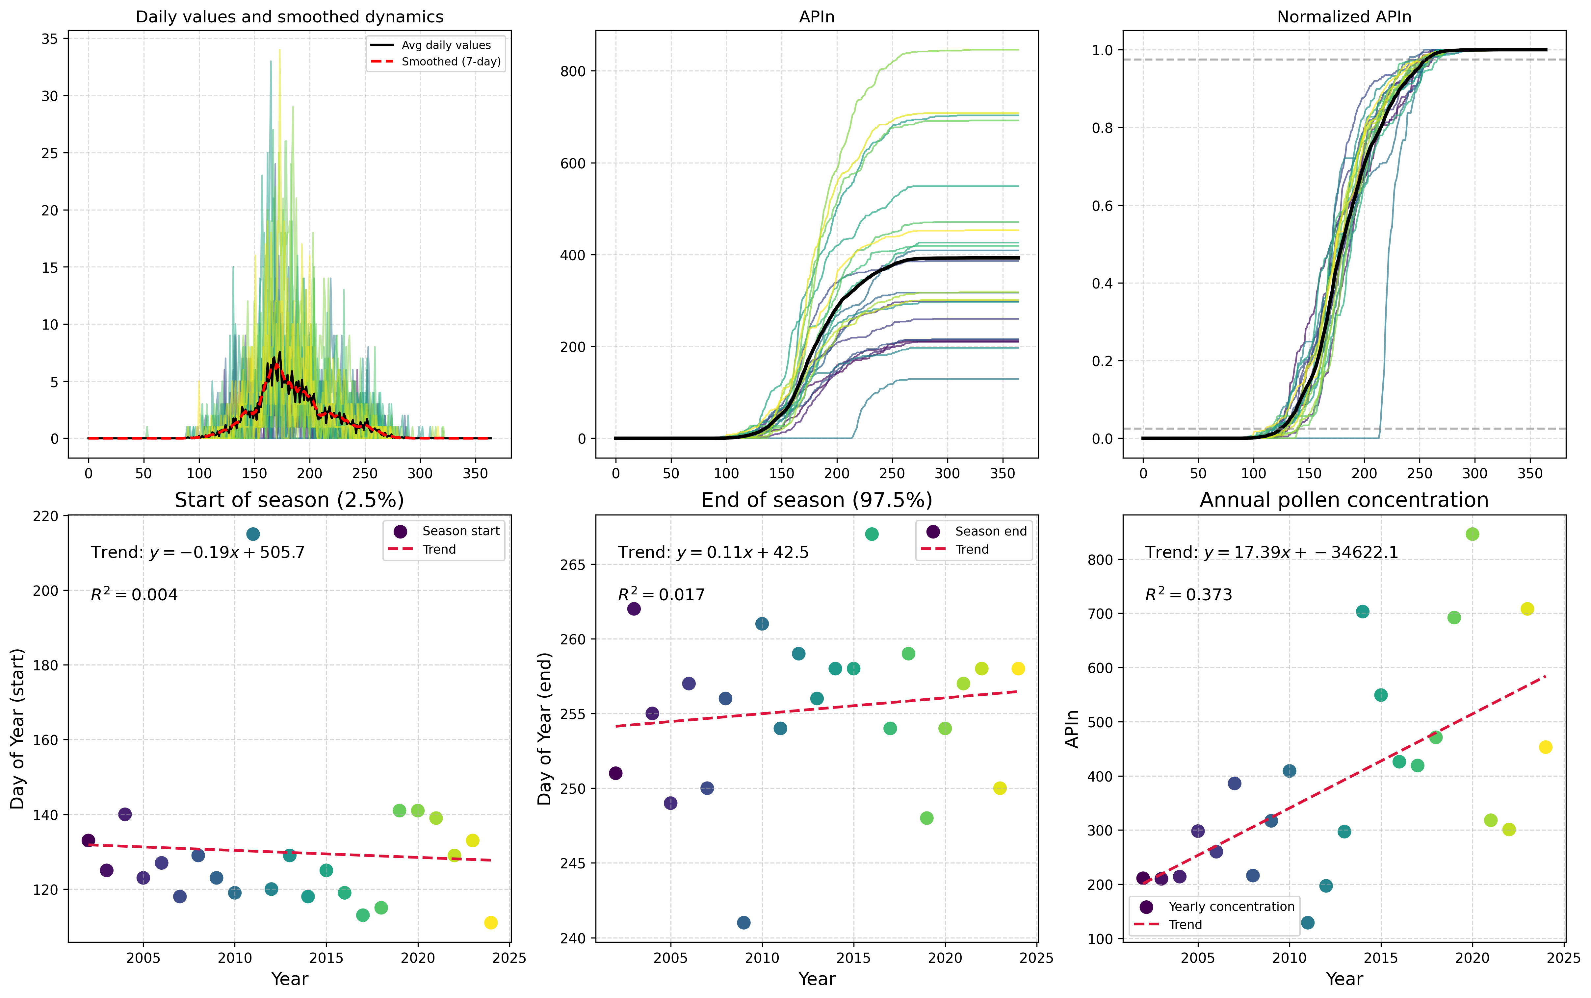

"Figure 1: Type-specific pollen analysis for Plantago spp. in Primorje, showing the distribution of pollen grains across different size classes and morphological characteristics." Alternatively, if t...

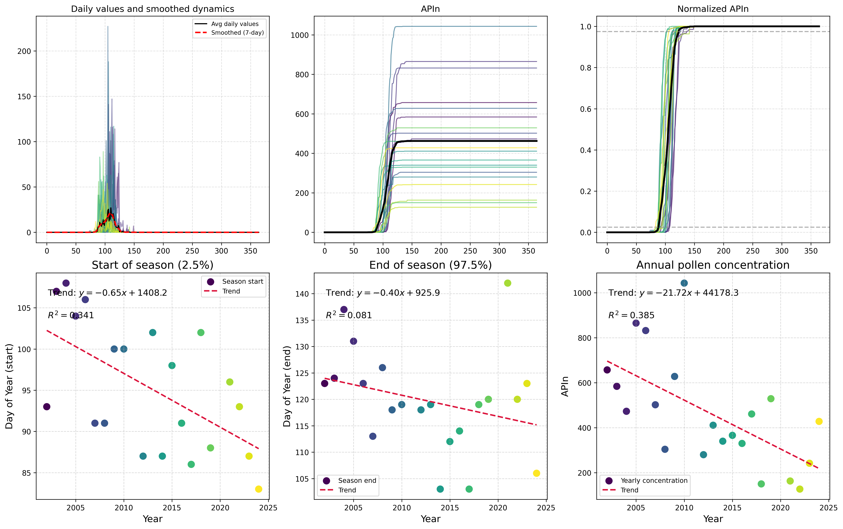

Here is a possible caption: "Figure showing Type-Specific Analysis of Platanus spp. pollen from Primorje, highlighting the morphological characteristics and potential identification features." Alter...

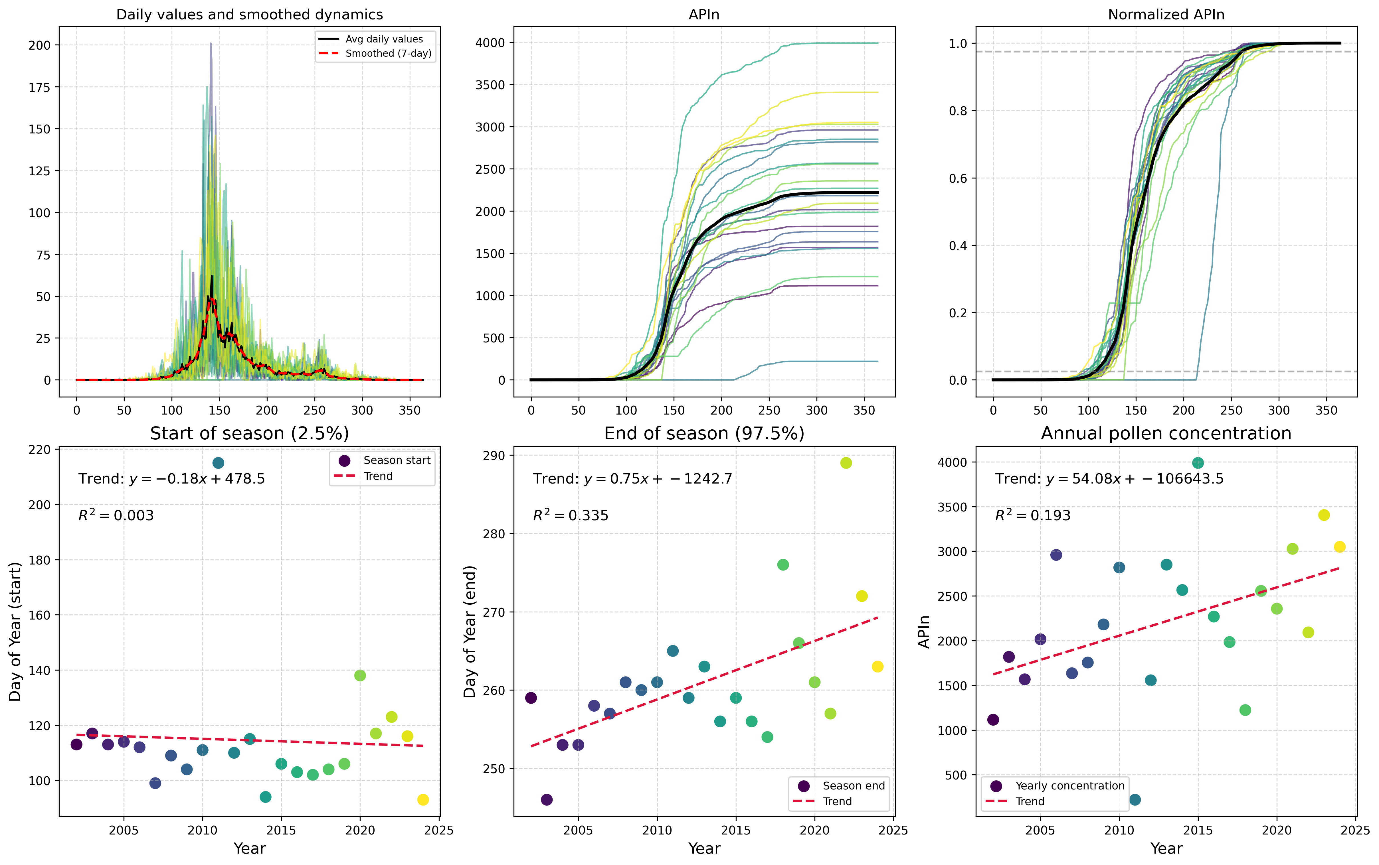

"Figure showing Type-Specific Analysis of Poaceae pollen from Primorje, highlighting morphological characteristics and potential species identification." This caption is concise, factual, and scienti...

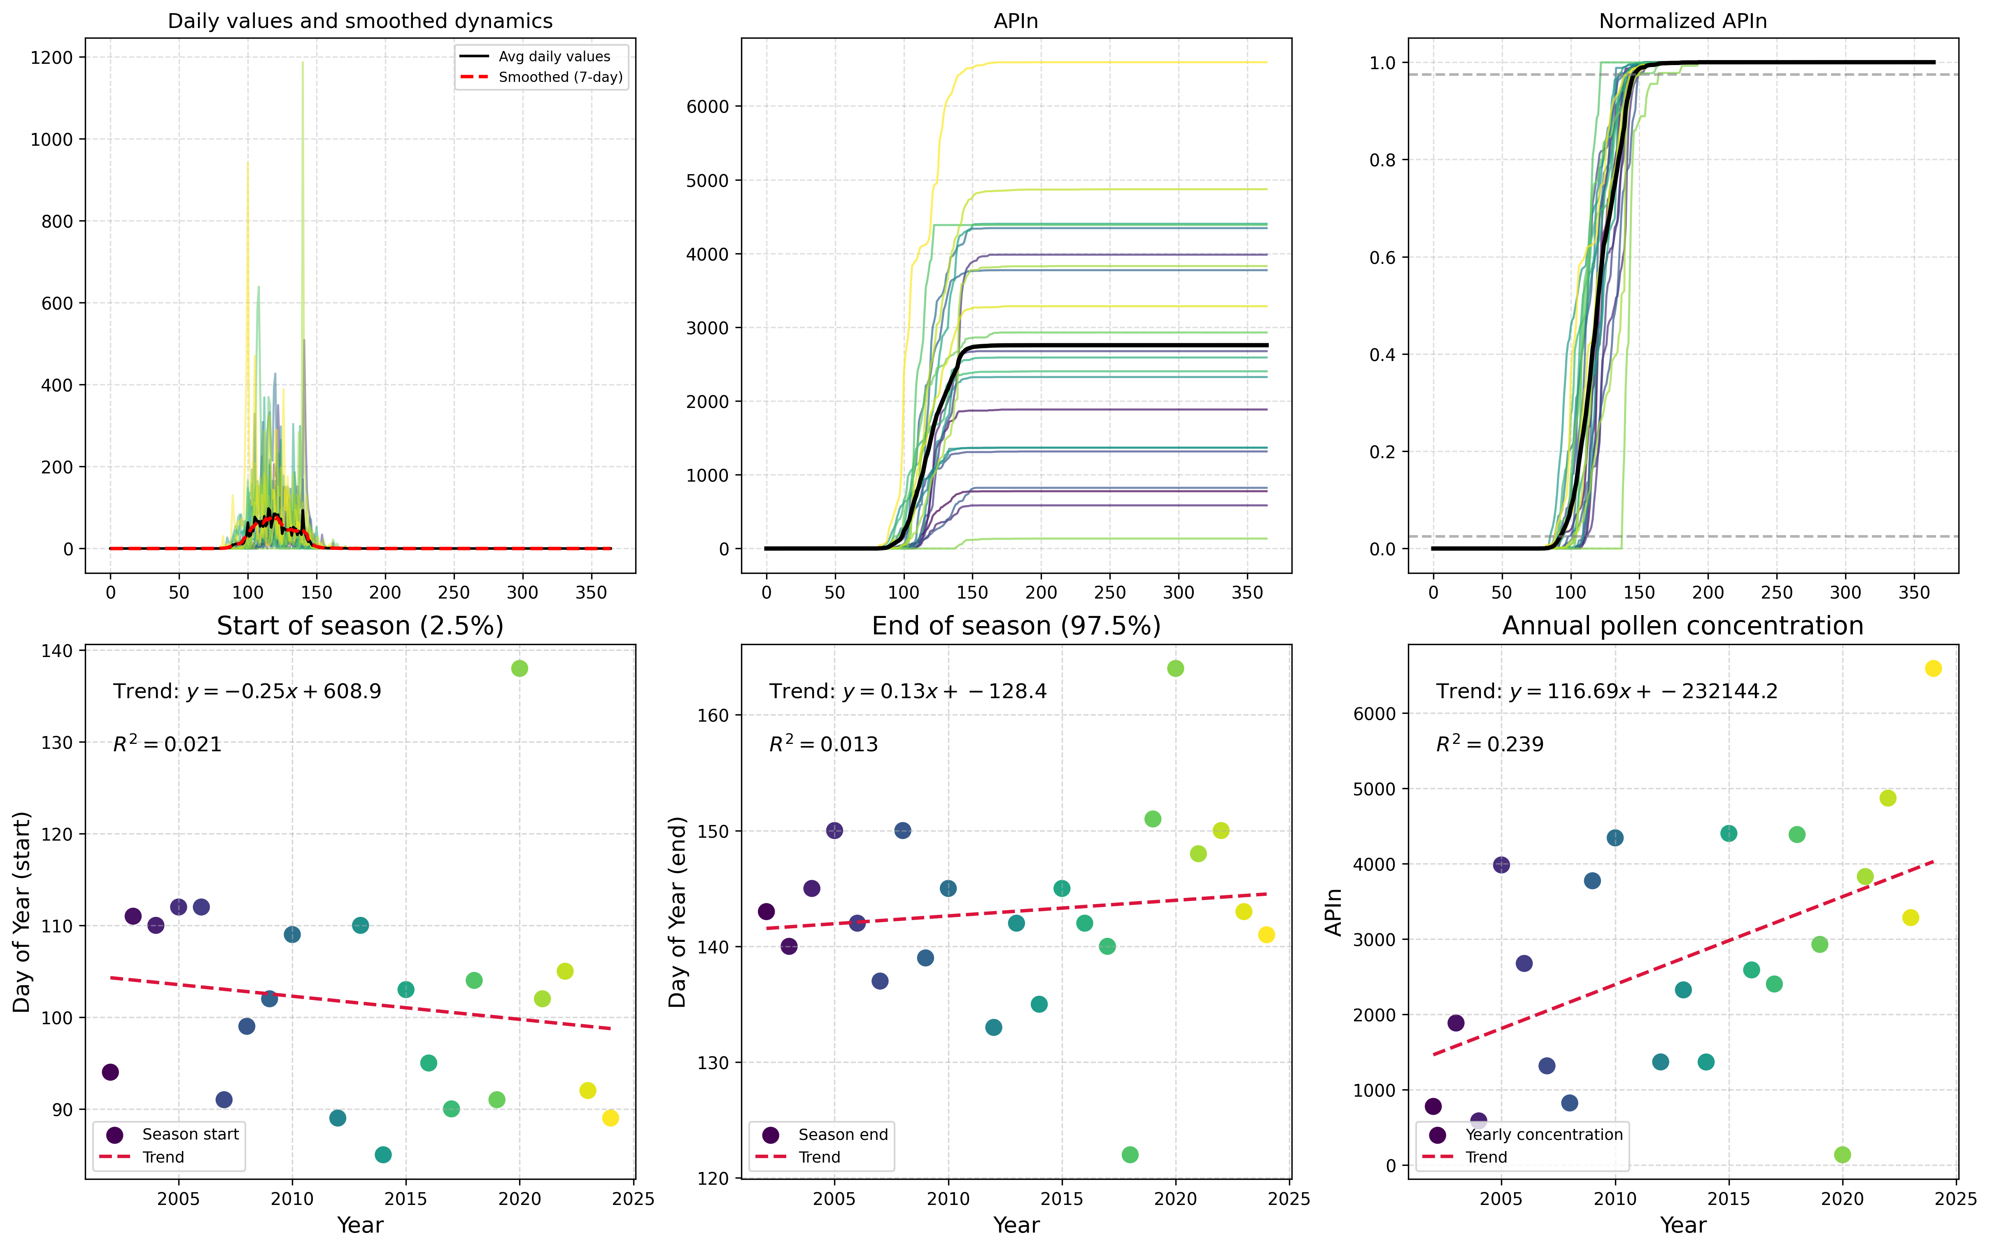

Here is a possible caption: "Figure showing Type-Specific Analysis for Quercus spp. in Primorje, illustrating pollen morphology and quantitative data." Alternatively, if the figure has multiple pane...

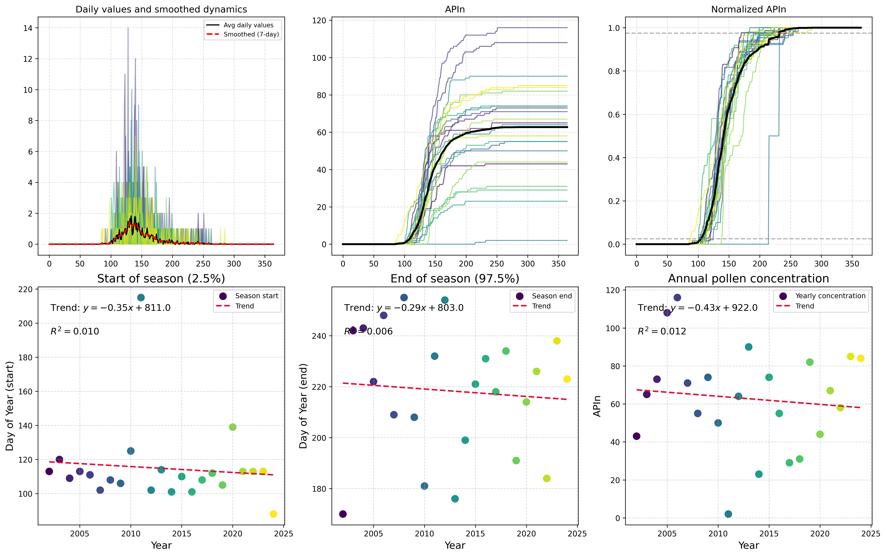

Here is a possible caption: "Figure showing type-specific pollen analysis for Rumex spp. at Primorje, illustrating the presence of multiple species within the same sample." Or, if you'd like to incl...

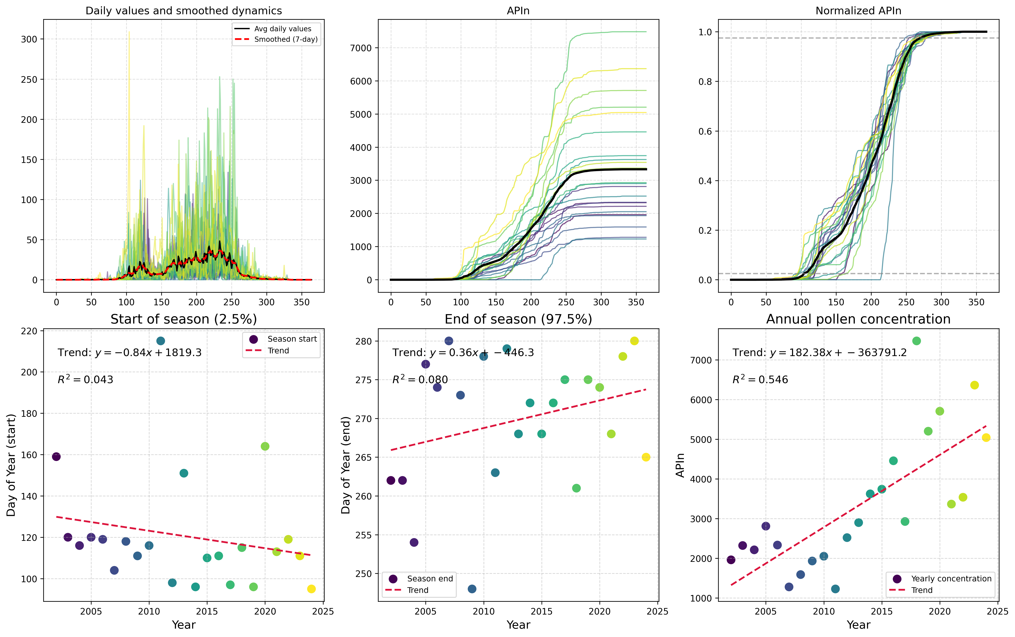

"Figure 1. Type-specific pollen analysis for Primorje, showing characteristic morphological features of Urticaceae pollen grains, including apertures and exine ornamentation." Alternatively, if the f...

# Cross-Regional Correlation Analysis

This section contains correlation analyses between different regions, showing relationships in pollen patterns across Ljubljana, Maribor, and Primorje.

## Regional Correlation Results

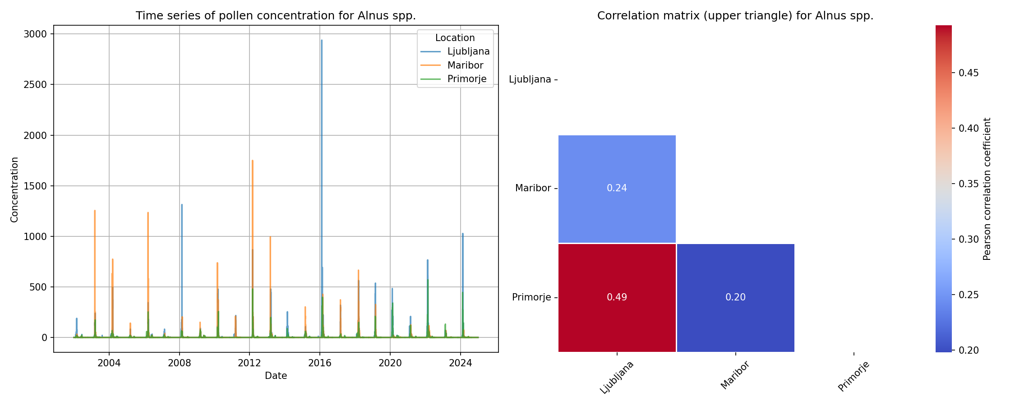

Here is a possible caption: "Figure 1. Regional correlation results for Alnus spp., showing cross-regional correlations between pollen records and climate timescales, highlighting the species' sensit...

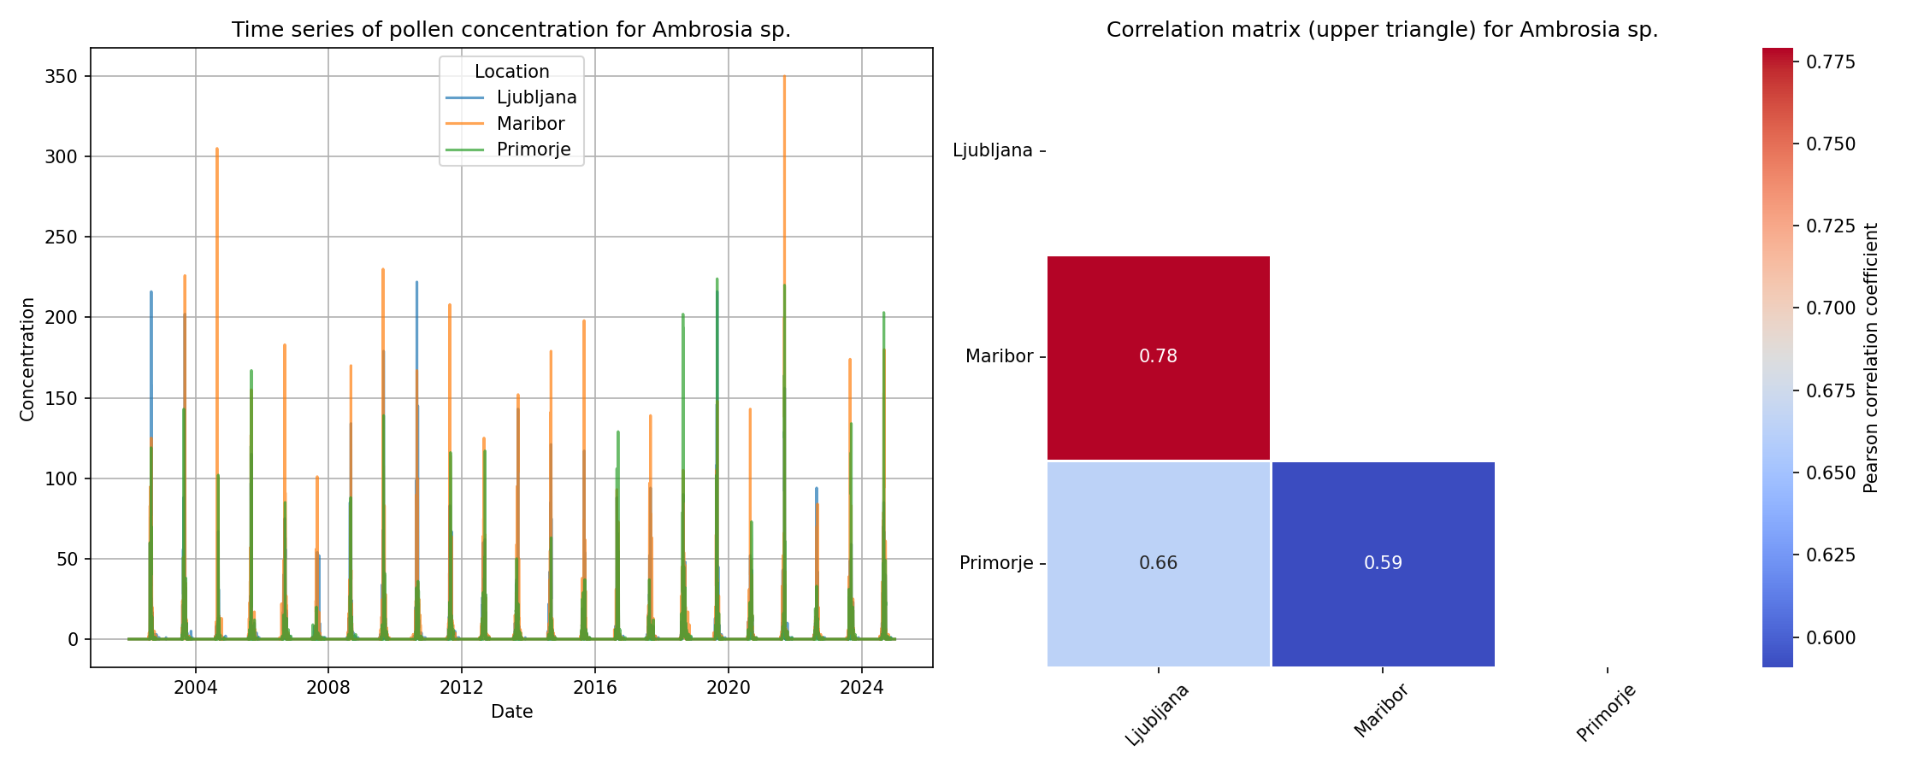

"Figure 1: Regional correlation results for Ambrosia sp. across a cross-regional timescale, highlighting the species' pollen pattern and temporal variability." This caption is concise, factual, and s...

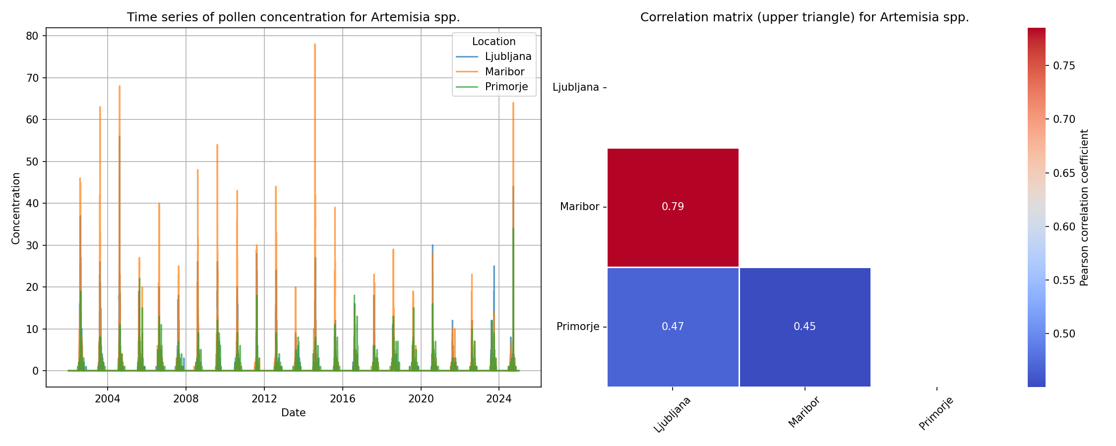

Here's a possible caption: "Figure 1: Regional Correlation Results for Artemisia spp. showing cross-regional pollen correlation patterns over time, highlighting the species' seasonal and annual varia...

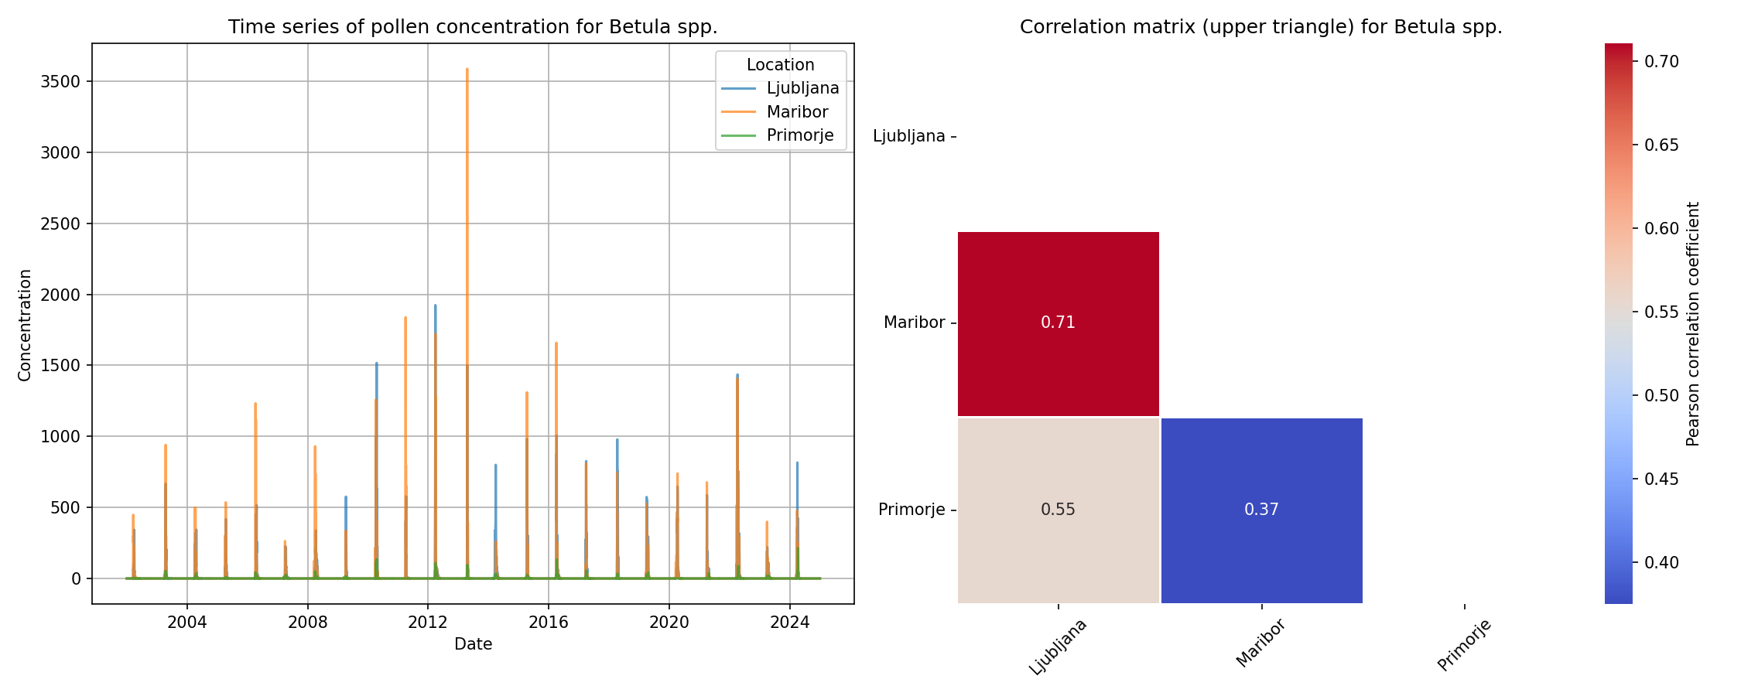

"Figure 1: Regional Correlation Results for Betula spp. across a cross-regional timescale, illustrating the species' pollen correlation patterns with regional climate variability." This caption is co...

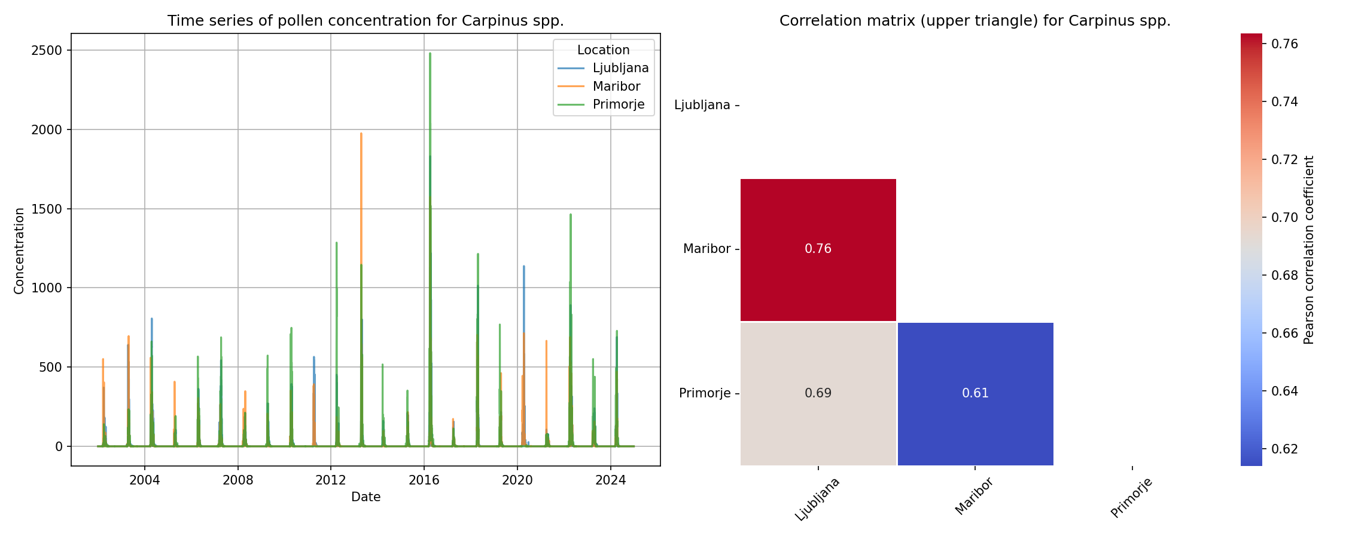

Here is a possible caption: "Figure 1. Regional correlation results for Carpinus spp., showing a cross-regional timeseries analysis demonstrating significant correlations between pollen counts and en...

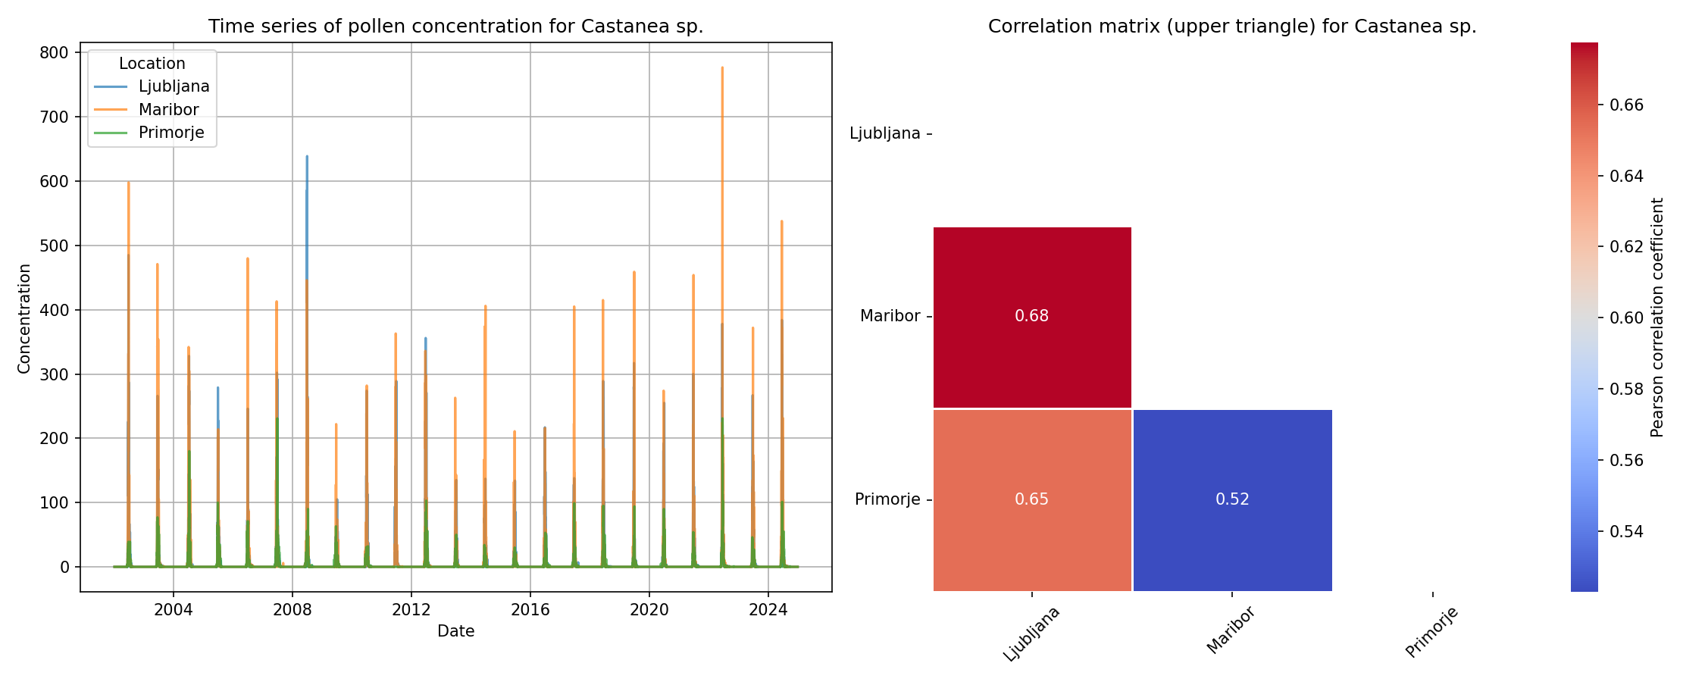

"Figure 1: Regional correlation results for Castanea sp. across cross-regional sites, illustrating temporal patterns of pollen abundance and environmental correlations." Alternatively, if the figure ...

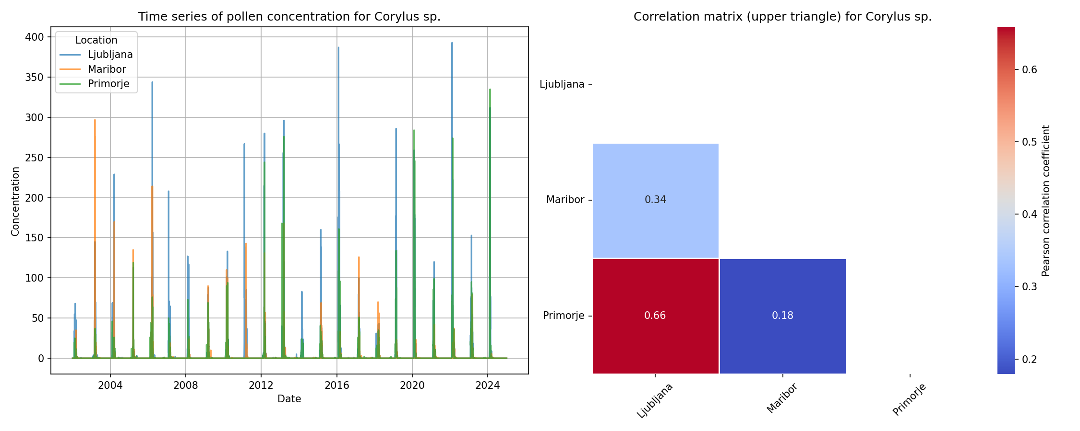

Here is a possible caption: "Figure 1. Regional correlation results for Corylus sp., showing cross-regional patterns of pollen abundance over time, highlighting the species' temporal variability in d...

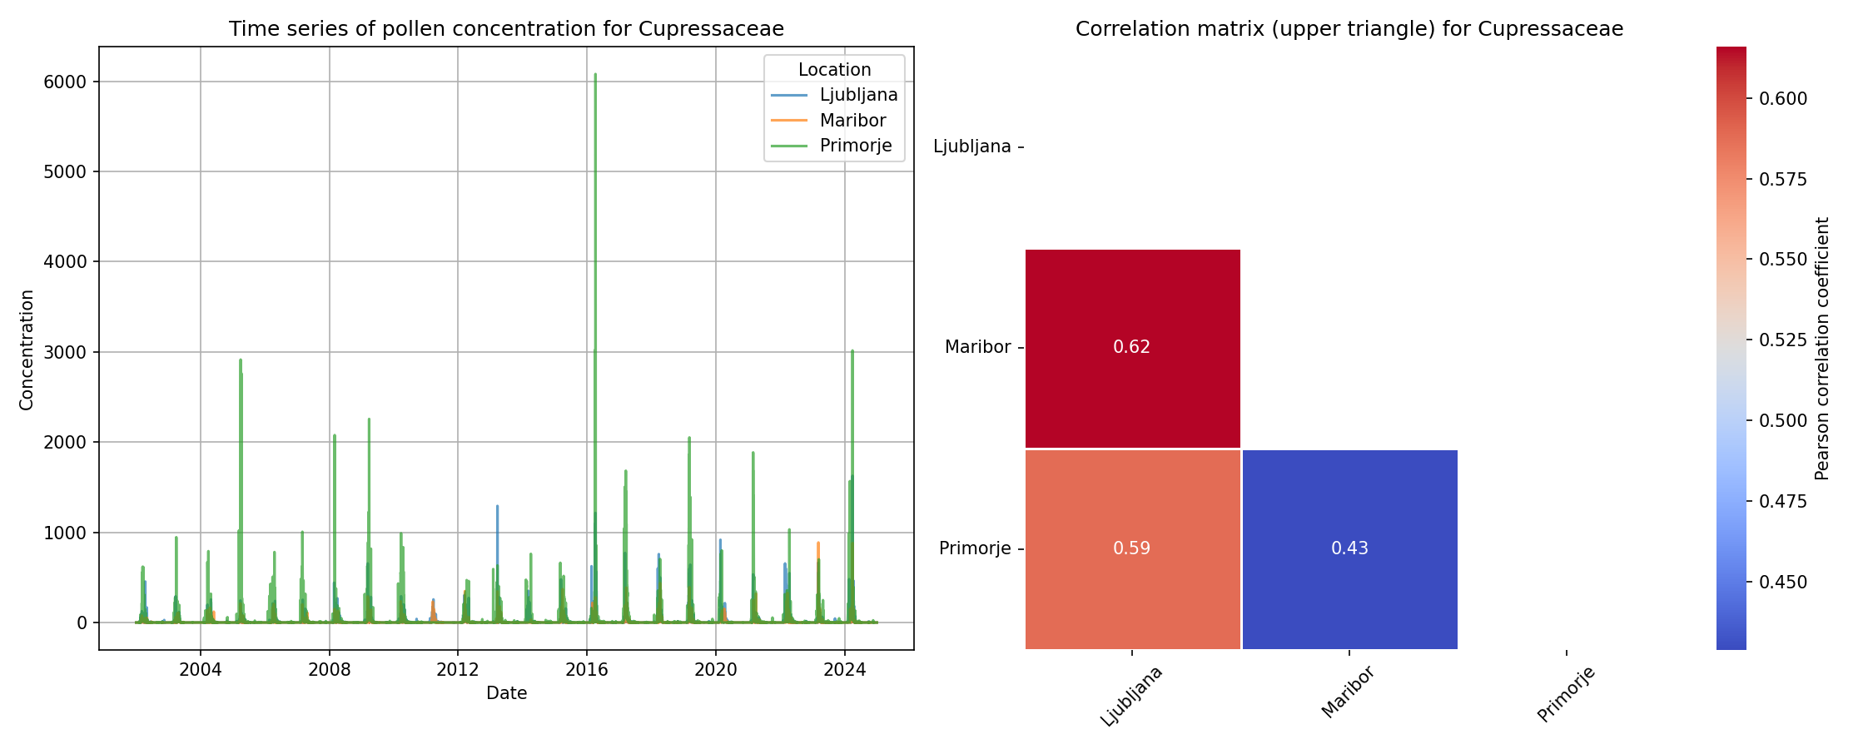

Here is a possible caption: "Figure 1: Regional correlation results for Cupressaceae pollen across multiple time series, highlighting cross-regional patterns of temporal synchrony and asynchrony." A...

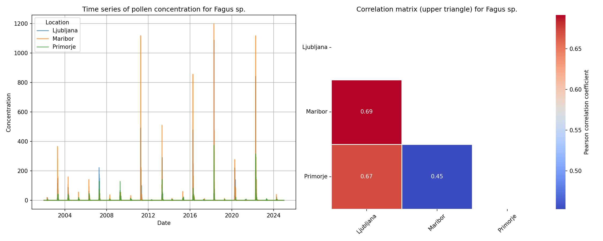

"Figure 1: Regional Correlation Results for Fagus sp., showing cross-regional pollen correlation with timeseries data. The plot illustrates the temporal relationship between pollen counts and environm...

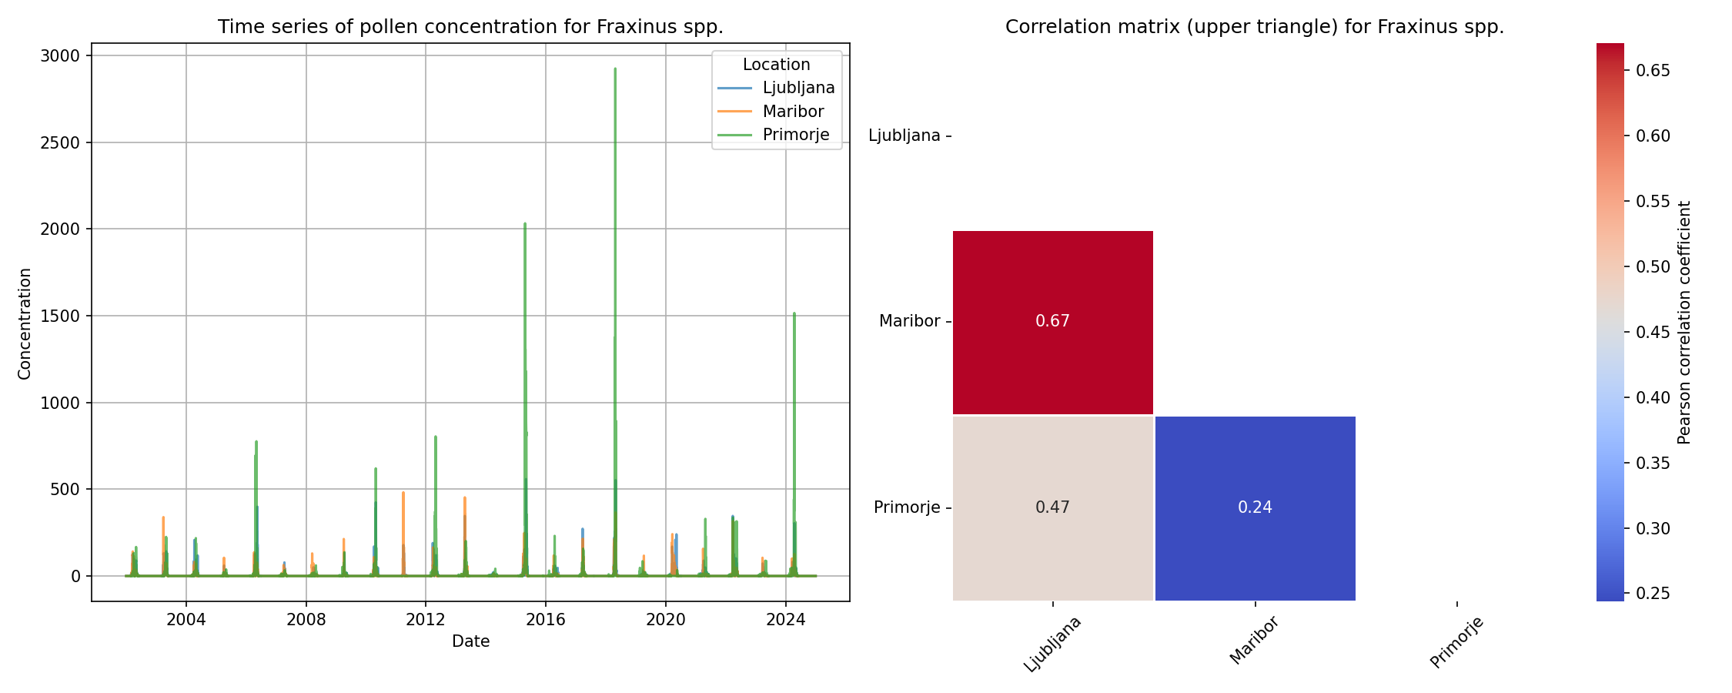

Here is a possible caption: "Figure 1: Regional correlation results for Fraxinus spp. across multiple sites, illustrating the temporal relationships between pollen abundance and environmental factors...

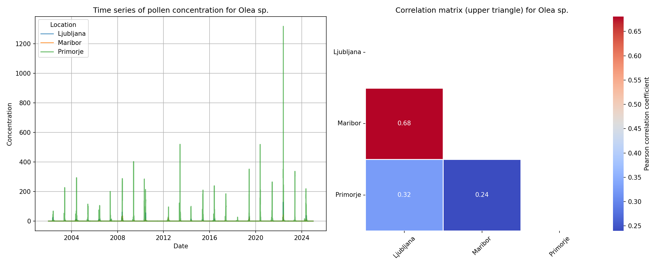

"Figure 1: Regional Correlation Results for Olea sp. across a cross-regional timescale, illustrating the correlation between pollen records and regional climate patterns." Alternatively, if there are...

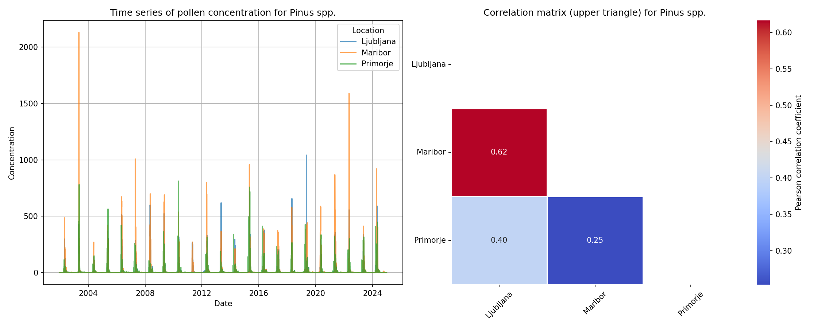

Here is a possible caption: "Figure 1. Regional correlation results for Pinus spp., showing cross-regional patterns of pollen variability over time, highlighting correlations between regional climate...

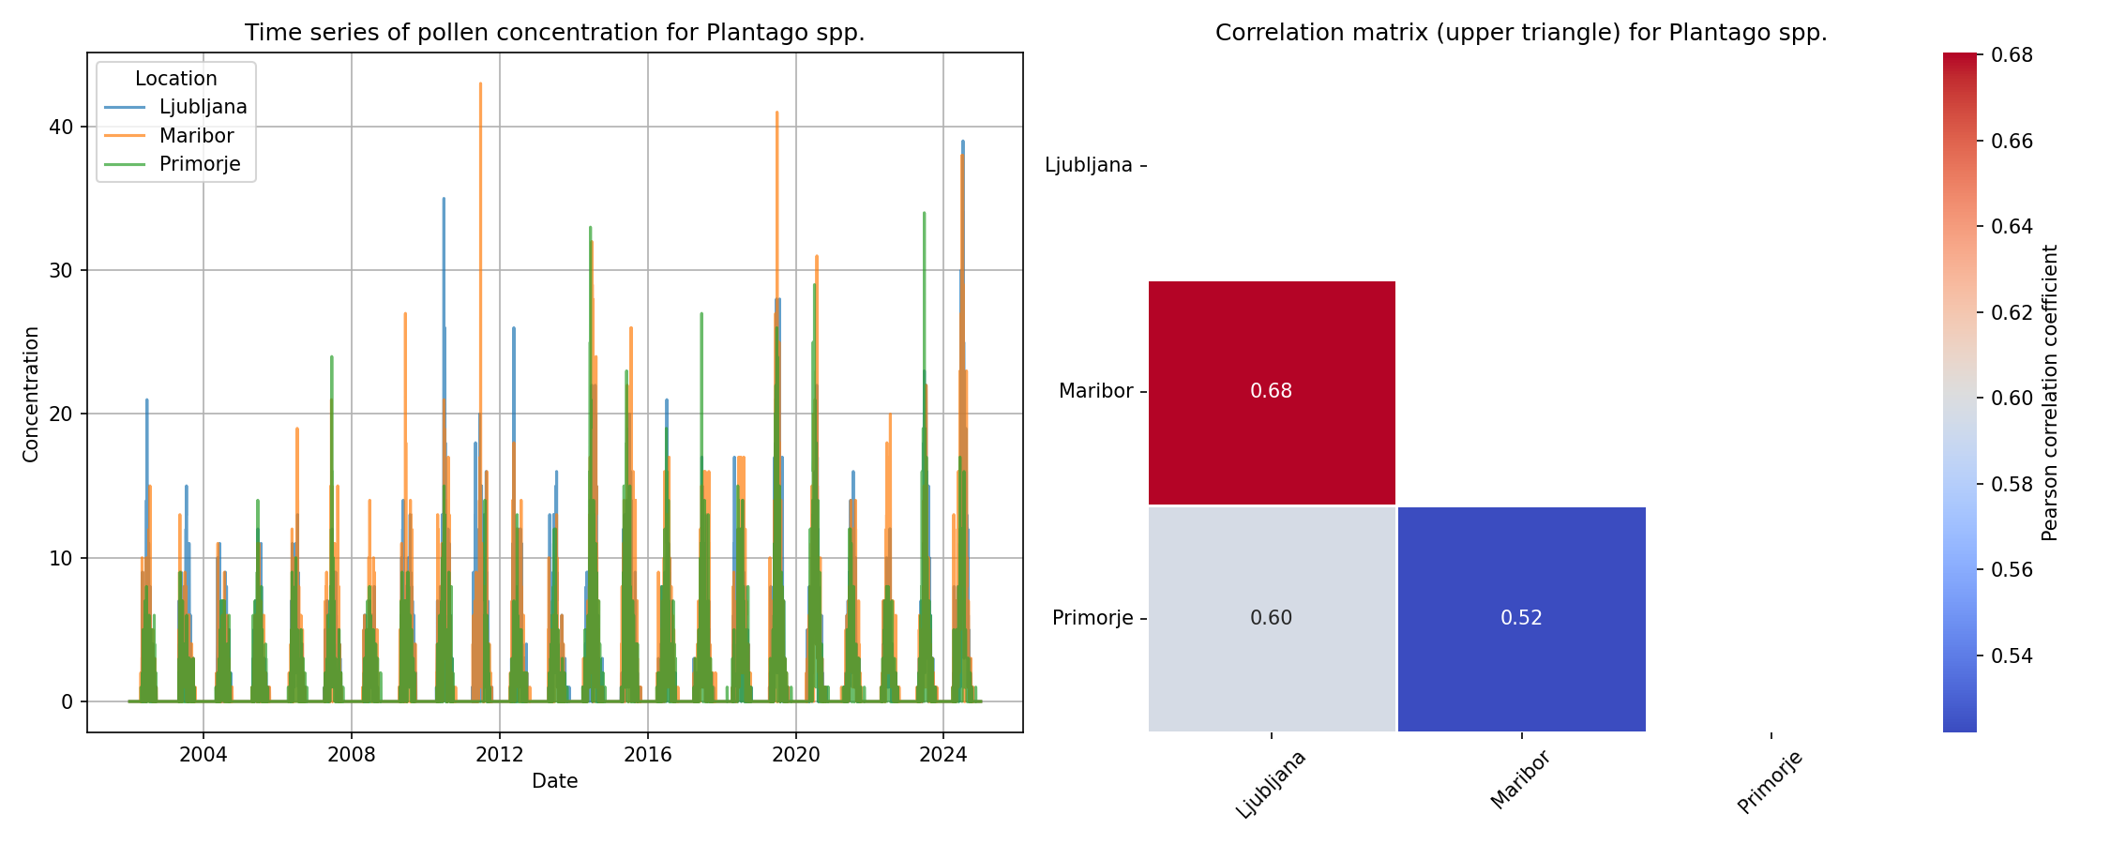

Here is a possible caption: "Figure 1. Regional correlation results for Plantago spp., displaying cross-regional pollen time series correlations, highlighting the species' distribution patterns and t...

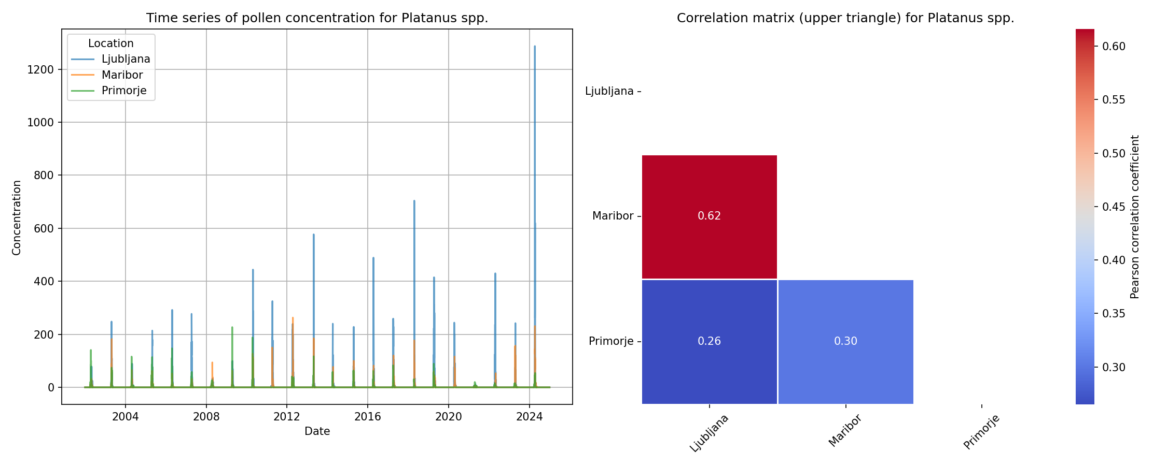

"Figure 1: Regional correlation results for Platanus spp. across a cross-regional timescale, highlighting the species' pollen pattern variability and temporal fluctuations in regional correlations." ...

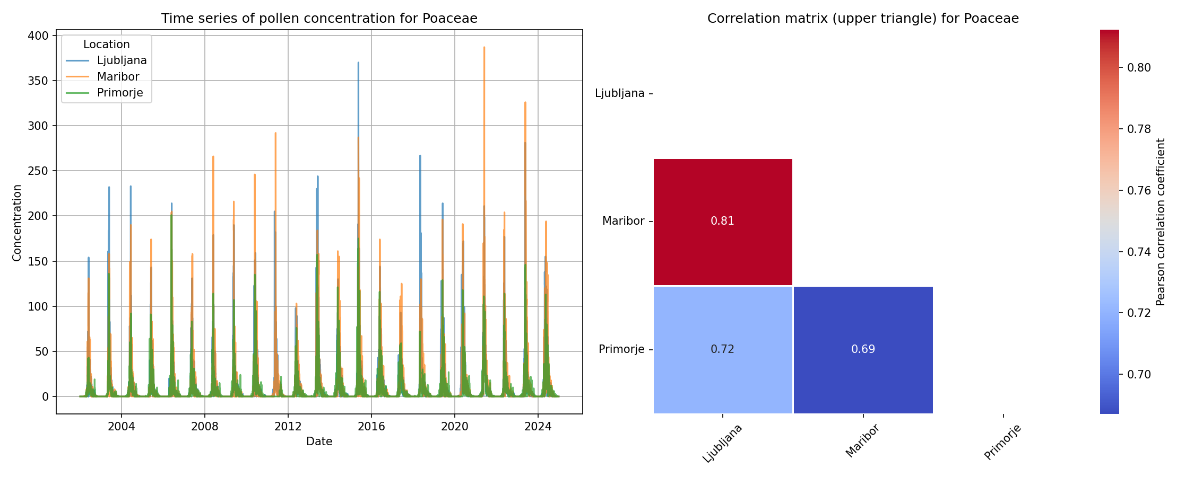

Here is a possible caption: "Figure 1: Regional correlation results showing the temporal relationship between pollen counts of Poaceae species across multiple regions, highlighting cross-regional pat...

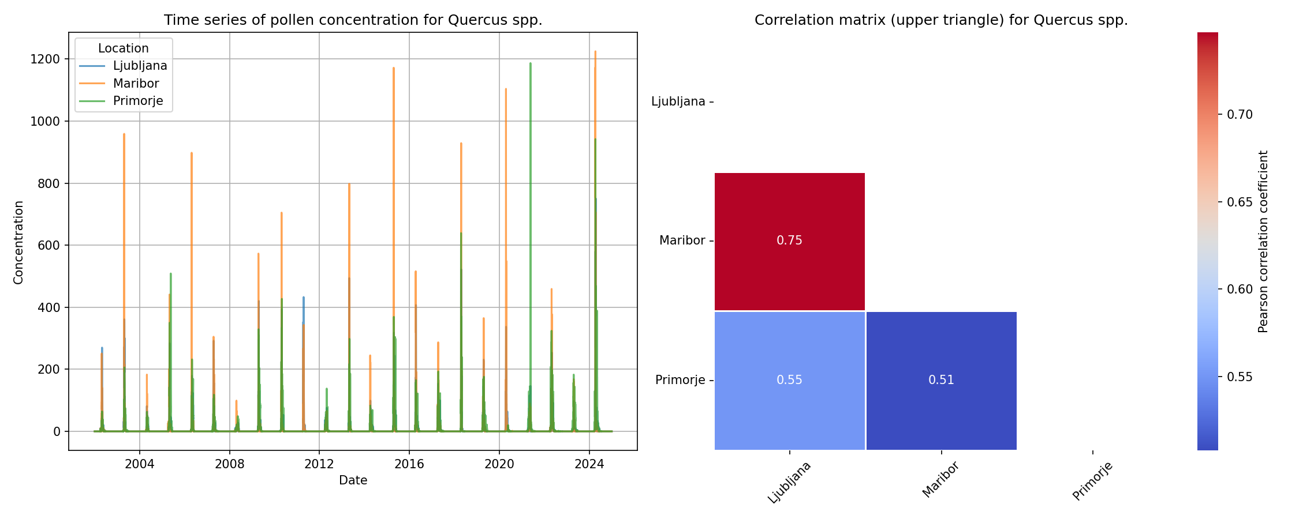

Here is a possible caption: "Figure 1: Regional correlation results for Quercus spp. across multiple locations, illustrating the temporal relationship between pollen abundance and climatic variables....

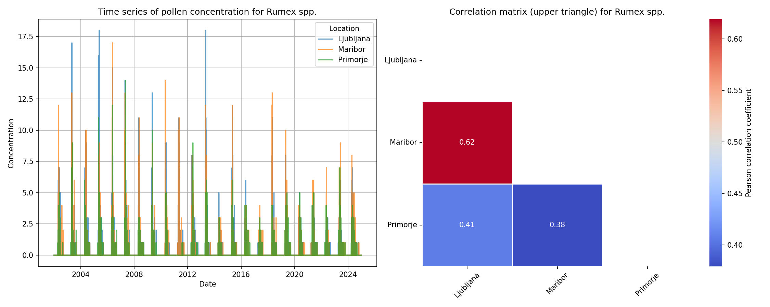

"Figure 1: Regional Correlation Results for Rumex spp. across the cross-regional study area, illustrating temporal patterns of pollen abundance and correlating with regional climate indices." This ca...

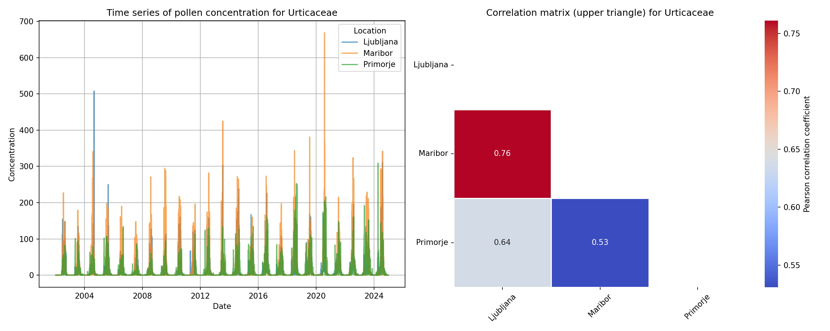

"Figure 1: Regional Correlation Results for Urticaceae pollen across a cross-regional timescale, highlighting the temporal patterns of species-specific abundance and correlations with regional climate...